W/C: 28.09.20 Learning Project - My Family
Age Range: EYFS
Weekly Reading Tasks | Weekly Phonics Tasks
Monday- Owl Babies  Read the story | Monday- Introduce M (RWI)
Tuesday- Owl Babies  Act out the story  Make lollypop stick puppets (rectangles) | Tuesday- Introduce A (RWI)
Wednesday- Owl Babies  Make lollypop stick puppets (Circles) | Wednesday- Introduce S (RWI)
Thursday- Owl Babies  Make lollypop stick puppets (Squares) | Thursday- Introduce D (RWI)
Friday- Owl Babies  Make lollypop stick puppets (triangles) | Friday- Introduce T (RWI)
Weekly Writing Tasks | Weekly Maths Tasks
Monday- Practice writing the letter m  Using RWI practice sheets  Writing names | Monday- Numberblocks S1 E1  https://www.bbc.co.uk/iplayer/episode/b08bzzns/numberblocks-series-1-one  https://www.ncetm.org.uk/media/qs0hhd2b/series_01_episode_01_numberblocks-support-materials_one_april-2018.pptx
Tuesday- Practice writing the letter a  Using RWI practice sheets  Writing names | Tuesday- Numberblocks S1 E2  https://www.bbc.co.uk/iplayer/episode/b08c001f/numberblocks-series-1-another-one  https://www.ncetm.org.uk/media/21tbt5k1/series_01_episode_02_numberblocks-support-materials_another-one_april-2018.pptx
Wednesday- Practice writing the letter s  Using RWI practice sheets  Writing names | Wednesday- Numberblocks S1 E3  https://www.bbc.co.uk/iplayer/episode/b08bzgt8/numberblocks-series-1-two  https://www.ncetm.org.uk/media/ujccaxy5/series_01_episode_03_numberblocks-support-materials_two_april-2018.pptx
Thursday- Practice writing the letter d  Using RWI practice sheets  Writing names | Thursday- Numberblocks S1 E4  https://www.bbc.co.uk/iplayer/episode/b08bzgxx/numberblocks-series-1-three  https://www.ncetm.org.uk/media/q2oj4mhd/series_01_episode_04_numberblocks-support-materials_three_april-2018.pptx
Friday- Practice writing the letter t  Using RWI practice sheets  Writing names | Friday- Numberblocks S1 E5  https://www.bbc.co.uk/iplayer/episode/b08bzh11/numberblocks-series-1-one-two-three  https://www.ncetm.org.uk/media/5mkddxwb/series_01_episode_05_numberblocks-support-materials_one-two-three_april-2018.pptx
Adult led Maths activity
Read ‘The Button Box’ as an intro to the activity
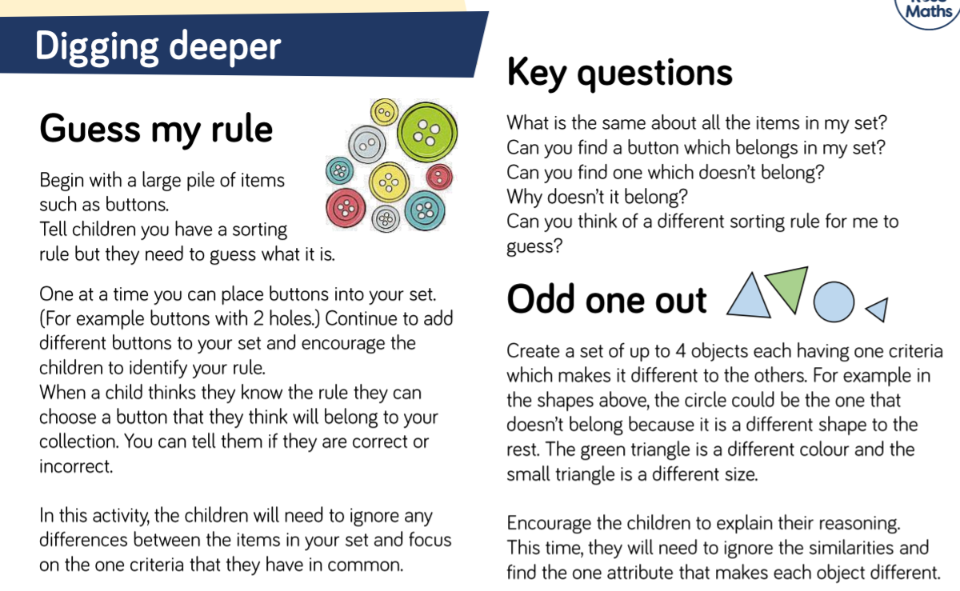

Busy Time - to be done throughout the week
Enhanced Continuous Provision Plan for Reception (‘Busy Time’) - Week Beginning: 28-09-20 Owl Babies

AREA | OBJECTIVE | ENHANCEMENT
Small World Area | AOL: Communication and language: Speaking  EAD Being imaginative  OBJ: I am learning to introduces a storyline or narrative into their play.  I am learning to use available resources to create props to support role play.  FOCUS: Woodland Owl scene.
Malleable | AOL: Physical Development: Moving and handling  OBJ: I am learning to handle tools, objects, construction and malleable materials  safely and with increasing control.  FOCUS: Making owls with playdoh  Fine motor skills – Owl Cover up  Funky fingers – make bird feeders with pipe cleaners and cheerios
Writing area  linked from Assessment. | AOL: Writing  OBJ: I am learning to write my own name.  I am learning to use one-handed tools and equipment  FOCUS: Name writing  Stickers  Dabbers  Blackboard  Highlighters  Magnetic letters
Creative Table  Linked from child interest – | AOL: EAD Exploring and using media and materials  OBJ: I am learning to manipulate materials to achieve a planned effect.  I am learning to experiment to create different textures.  FOCUS: Owl babies cotton wool painting all three small med large  Self – portraits (Mrs Warchal M,T and Th and Weds with Mrs Thomas)
Maths area  Linked from  Assessment – | AOL: Mathematics:  OBJ: I am learning to show an interest in shape and space by playing with shapes or making arrangements with objects.  FOCUS: Matching and sorting objects
Role Play  Home Corner | AOL:EAD Being Imaginative  OBJ: I am learning to engage in imaginative role-play based on own first-hand  experiences.  FOCUS: setting the table, feeding the baby, changing the babies nappy. | Baby  Kitchen  Table and stools
Construction | AOL: KUW: The World  OBJ: I am learning to talk about some of the things I have observed e.g plants, animals, natural and found objects.  I am learning to care and have concern for living things and the environment.  FOCUS:  Using natural material to build nests for the owls.  Using the outdoor blocks to make owl houses.
ICT  Link with Maths | AOL: KUW:Technology and Mathematics  I am learning to counts objects to 10, and beginning to count beyond 10.  OBJ: I am learning to operate simple equipment.  FOCUS: Topmarks – feed the teddy, count under the sea. | IPADs  Topmarks
Water | AOL: EAD Being Imaginative  OBJ: I am learning to introduce a storyline or narrative into my play.  FOCUS: Washing up bowls and plates  Washing and pegging the clothes on the washing line. | Pegs  Washing line  Baby bubble bath  Babies  Plates, bowls
Music | AOL: EAD Exploring and using media and materials  OBJ I am learning to sing a few familiar songs.  FOCUS: Listening to traditional songs on the CD player  Playing with the musical instruments on the stage | Cd Player  Songs

STEM Learning Opportunities #sciencefromhome

