Shortlanesend Primary School

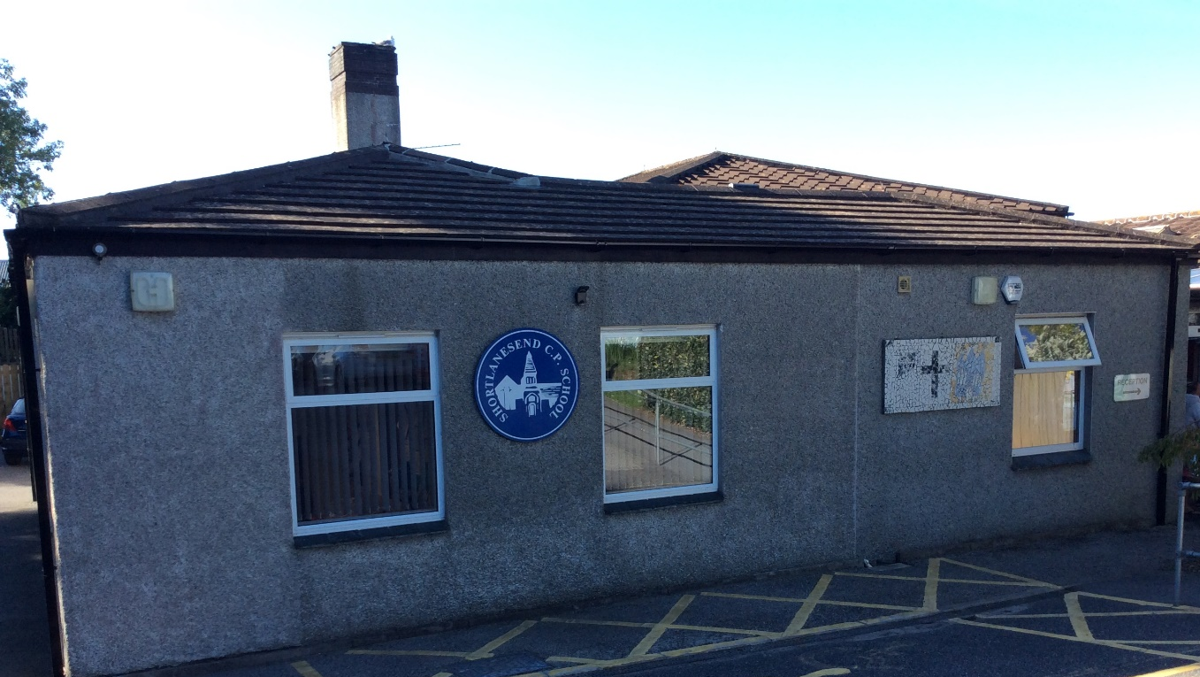

Back to School

I am in Class 3.

We have all been staying at home.
We have stayed at home because of Coronavirus.
At home I have been doing lots of things like playing and learning.
When I go back to school I will see some of my friends and teachers again.
Some things will be the same and some things will be different.
I can do some things to help me get ready to go back to school.
I can get some good rest. I can eat healthy food. I can try on my school clothes.

My Teachers will be….

*Mrs Ashley (Mon- Thurs)
*Mrs Lewis (Fri)

My TA’s will be…
Mrs Woods
Mrs Lowe
Mrs Warchal

They will help me feel safe.

When I return to school my classroom will be Class 3.
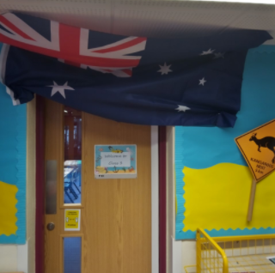
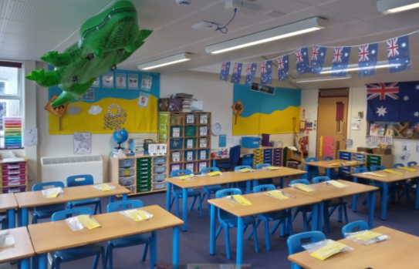

Our classrooms will be called Pods. Staying in our Pods will help to keep me safe and stop germs spreading to other children in other Pods.
When I arrive in the morning I will be shown where I can sit and where I can put my things.
My Classroom will have the same visual timetable on the board that I have seen before. This will help me know what is happening every day.
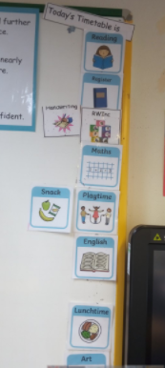

To help me do my learning I will have my own folder on my desk that will have lots of useful things in that I can use.

Just like we did before we left school, we will wash our hands regularly to make sure we wash away any germs.
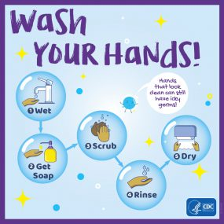

There are toilets near my classroom I can use. I can ask my teacher as I would usually do to use them.

Usually at break time we go out onto the playground altogether. This will be different now.
I will have my break time with my friends and teachers from my Pod at different times from the other Pods in the school.
Usually I have my lunch in the hall. This will be different now. I will have my lunch with my friends and teachers in my Pod classroom unless I am having a hot meal.

Change can make me feel worried, sad or scared sometimes. Everyone has things that make them feel worried.
If I am worried I can always talk to my grown-ups at home or my teachers. They will listen and help me.

We can’t wait to see you all back at school in September in our Pods it’s going to be lots of fun.

