_________________
L.O – I am learning to add equal groups ®
- Complete the sentences.  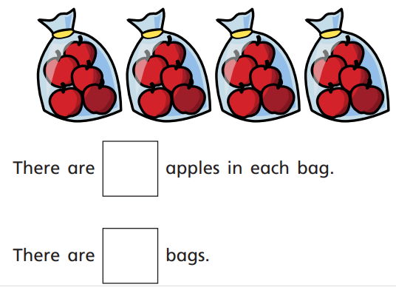  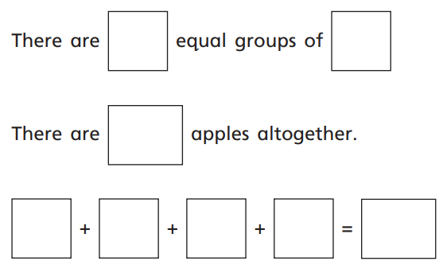 | 4. How many marbles does Mason have?  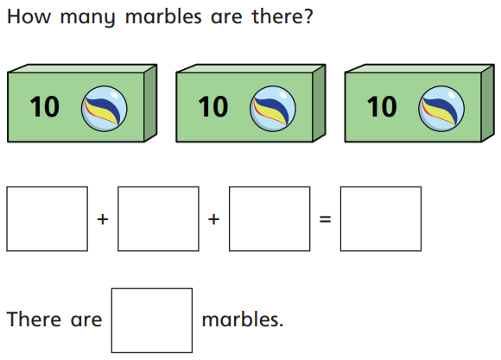
- Connie has these sweets.  Complete the sum and total.  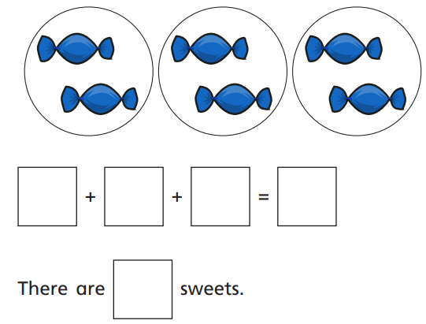 | 5. How many candles does Layla have?  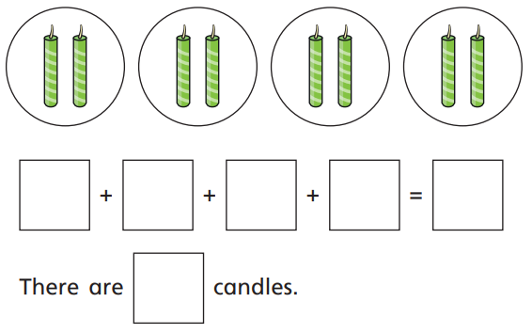
6. Draw counters to show the equal groups.
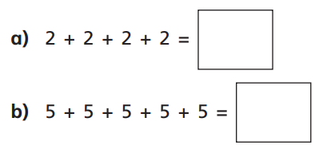
- Jacob has these apples. How many does he have?
Show your workings out.

GDS

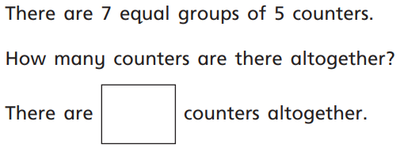
GDS

Mrs Ashley needs 30 apples for class 3.

Apples come in bags of 5.
How many bags will she need.

