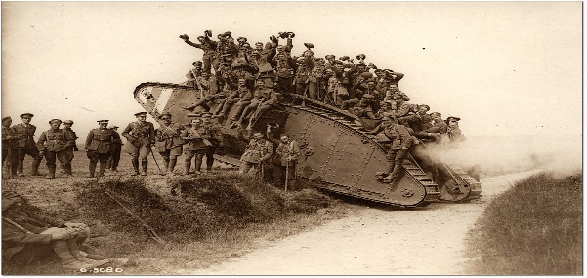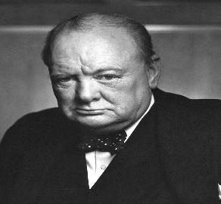
licensed under CC BY-SA
Dear Parents/Carers,
I hope you are all well and looking forward to the Easter break.
Next term, Class 5 will be immersing themselves in the World Wars; how they began, famous people, stories from the warfront and homefront, famous battles, turning points during the conflicts and, ultimately, their endings and a return to peace.
In the first term back, we will be focusing on World War I and the children will be involved in lots of fun learning activities, including
English: non-chronological reports, poetry and letter/diary writing
Maths: number, place value, addition and subtraction
History: All about World War I
Geography: The changing face of Europe during the 20th Century
Art: experimenting with watercolours, inks and pastels
Science, Music: Songfest and music from the period
PE: Athletics-Mondays pm Modern foreign languages, RE and PSHE.
As part of our return to school and our immersive journey back to these times, we would love the children to come dressed as someone living in Great Britain during these times (World War I or II)-maybe a child evacuee?
As always, if you have any questions please let me know.
Kind regards,
Mr Easter & Mrs Light

