DAY 1 L.O – I am learning to add numbers
1. Solve these addition calculations.  13 + 4 =  16 + 20 =  43 + 100 =  141 + 100 =  40 + 45 =  45 + 4 =  Draw the Base 10 if you need to. | 5. Solve these sums  632 + 11 = _______  11+ 632 = _______  Which is the easiest to solve? Why?
2. Solve these addition calculations.  133 + 4 =  216 + 20 =  343 + 200 =  141 + 300 =  40 + 445 =  345 + 4 =  Draw the Base 10 if you need to. | 6. Mrs Woods says that 621 plus 30 is 624.  Is she correct?  Explain your answer.
3. True or false?  246 + 2 = 247  Prove it! | 7. Leon has these place value counters.  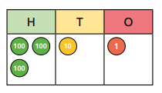  He adds another 24.  How much will he have?  Show your workings out.
4. Elijah has these:  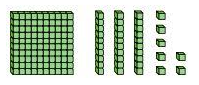  How much more would he need to make 157? Prove it. | GDS  The answer is 253.  What could the subtraction sum be?  Find as many ways as you can.  RULE- you can only take 3 digit numbers from 3 digit numbers.

Day 2 Addition – crossing 10 / 100
1. Solve these addition calculations.  18 + 4 =  16 + 5 =  48 + 6 =  67 + 5 =  146 + 5 =  425 + 8 =  Draw the Base 10 if you need to. | 5. Add another 50 to this number.  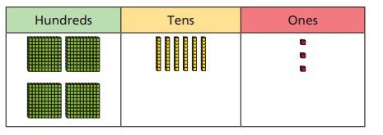  Show the calculation you have completed.
2. Solve these addition calculations.  90 + 40 =  60 + 50 =  67 + 40 =  91 + 30 =  180 + 40 =  395 + 10 =  Draw the Base 10 if you need to. | 6. Mrs Woods needs to add another seven tens to this number.  What will she get?  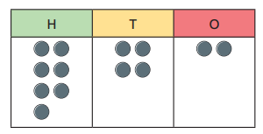  Show your workings out.
3. Sophie has these Base 10.  She adds another 7.  How much will she have?  Show your workings out. | 7. Add 50 to this amount.  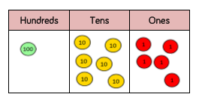  Draw your answer in a place value grid and explain how you worked it out.
4. Mrs Ashley has bought some lollies for class 3.  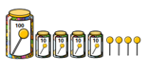  She finds another 8 on her desk.  How many does she have in total?  Prove it! | GDS  Write a story for each of these sums.  129 + 5 =  345 + 80 =
Day 3 – Subtraction
1.Solve these.  21 - 4 =  11 – 3 =  44 - 5 =  62 – 3 =  51 – 4 = | 5. Mrs Woods has some lollies.  She gives 6 away. How many will she have left?  Show your workings out.
2.Solve these calculations.  121 - 3 =  142 – 4 =  131 - 5 =  281 – 3 =  217 – 4 =  722 – 5 = | 6.  Eva has 61 pencils. She lets Eloise borrow 5 pencils. How many will Eva have left?  Show your workings out.
3. Subtract 8 from 24.  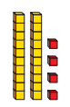  Show your workings out. | 7. Show me how to take 80 from this number.  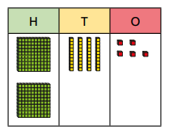
4. Work out 311 – 6 =  Show your workings out. | GDS  Mark my sums. Correct any incorrect answers.  576 – 9 = 567  413 – 7 = 408  425 – 7 = 417  591 – 8 = 577

Day 4 – Subtraction

