W/C: 19.10.20 Learning Project – The Colour Monster
Age Range: EYFS
Weekly Reading Tasks | Weekly Phonics Tasks
Monday- Read The Colour Monster  Talk about the cover. What is the book about? | Monday- RWI introduce the sound e  Recap m a s d t i n p g o c k u b f  Fred talk dog cat tin cup top
Tuesday – Read The Colour monster | Tuesday- RWI introduce the sound l  Recap m a s d t i n p g o c k u b f e  Fred talk tip pot cut dig pig
Wednesday – Read The Colour Monster – joining in with key phrases | Wednesday- RWI introduce the sound h  Recap m, a , s, d, t, i, n, p, g, c, k u b f e l  Fred talk bus leg peg net
Thursday- Read The Colour Monster – joining in with key phrases | Thursday RWI introduce the sound sh  Recap m a s d t i n p, g, c, k, u b f e l h  Fred talk, shut shop net hat
Friday- Watch The Colour Monster on youtube | Friday- RWI introduce the sound r  Recap m a s d t i n p g c k u b f e l h sh  Fred talk hut hot nut bus cup
Weekly Writing Tasks | Weekly Maths Tasks
Monday- Writing emotions  Red – angry, cross, serious, eyebrows, stern  Purple group | Monday- https://www.bbc.co.uk/iplayer/episode/b08dmhm6/numberblocks-series-1-the-terrible-twos  https://www.ncetm.org.uk/media/eylmbdnm/series_01_episode_13_numberblocks-support-materials_theterribletwos_september_2018.pptx  Red group  Introduce the part part whole model  Understand that 2 + 2 is the same as 4.  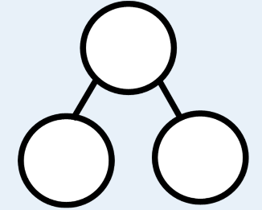  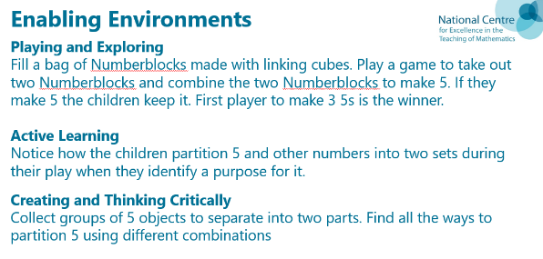
Tuesday- Writing emotions  Yellow – happy, joy, laughing, smiling,  Yellow Group | Tuesday- https://www.bbc.co.uk/iplayer/episode/b08dmjsk/numberblocks-series-1-holes  https://www.ncetm.org.uk/media/el2cvaee/series_01_episode_14_numberblocks-support-materials_holes_september_2018.pptx  Blue group
Wednesday- Writing emotions  Green – calm, quiet, soft, peace, slow,  Green Group  group | Wednesday https://www.bbc.co.uk/iplayer/episode/b08dmn88/numberblocks-series-1-hide-and-seek  https://www.ncetm.org.uk/media/essih4x4/series_01_episode_15_numberblocks-support-materials_hide-seek_september_2018.pptx  Yellow group
Thursday- Writing emotions  Blue – sad, upset, alone, cry, tears,  Blue Group | Thursday- https://www.bbc.co.uk/iplayer/episode/b08pgksd/numberblocks-series-2-six  https://www.ncetm.org.uk/media/gdbpk2ty/series_02_episode_01_numberblocks-support-materials_six.pptx  Green Group
Friday- Writing emotions  Black – fear, scared, worried, frightened, shadows,  Red Group  Funky Finger Friday | Friday- https://www.bbc.co.uk/iplayer/episode/b08pgqt4/numberblocks-series-2-seven  https://www.ncetm.org.uk/media/uppmojbe/series_02_episode_02_numberblocks-support-materials_seven.pptx  Purple group

Busy Time - to be done throughout the week
Enhanced Continuous Provision Plan for Reception (‘Busy Time’) - Week Beginning: 19.10.20
Colour Monster

AREA | OBJECTIVE | ENHANCEMENT
Small World Area | AOL: Communication and language: Speaking  EAD Being imaginative  OBJ: I am learning to introduces a storyline or narrative into their play.  I am learning to use available resources to create props to support role play.  FOCUS: On individual trays children make their own dinosaur lands using pebbles, blocks, pine cones, shells.
Malleable | AOL: Physical Development: Moving and handling  OBJ: I am learning to handle tools, objects, construction and malleable materials  safely and with increasing control.  FOCUS: Making Playdough Monsters. Range of different coloured playdough and accessories to make monsters.
Writing area  linked from Assessment. | AOL: Literacy: Reading  OBJ: Recognises familiar words and signs such as own name and advertising logos.  I am learning to use one-handed tools and equipment  FOCUS: Use different paper to write cvc words to put into the colour pots.
Creative Table  Linked from child interest – | AOL: EAD Exploring and using media and materials  OBJ: I am learning to manipulate materials to achieve a planned effect.  I am learning to experiment to create different textures.  FOCUS: Make colour monsters – cut out ears, eyes, hair to stick on coloured circles
Maths area  Linked from  Assessment – | AOL: Mathematics: SSM  OBJ: Uses familiar objects and common shapes to create and recreate patterns and build models.  FOCUS:
Role Play  Home Corner | AOL:EAD Being Imaginative  OBJ: I am learning to engage in imaginative role-play based on own first-hand  experiences.  FOCUS: Monster Café – place mats, menus, food, plates, cups, jars of different things to cook – shredded paper, string, pom poms, shiny stones.
KUW | AOL: PSED health and self care  OBJ: Shows some understanding that good practices with regard to exercise, eating, sleeping and hygiene can contribute to good health.  FOCUS: Senses – have different smelling pots – children have to guess what is inside the pots. | Senses pots
Funky Fingers | AOL:  OBJ:  FOCUS: Colour monster tracing mats  Rainbows with numicon stackers
ICT  Link with Maths | AOL: KUW:Technology and Mathematics  I am learning to counts objects to 10, and beginning to count beyond 10.  OBJ: I am learning to operate simple equipment.  FOCUS: Topmarks games | IPADs  Topmarks
Outside | AOL: EAD Being Imaginative  OBJ: I am learning to introduce a storyline or narrative into my play.  FOCUS: Colour: Mixing with water colours on tuff spot, dancing with coloured scarves  Colour water pouring (big water tray) | Water colours  Mixing posters  Coloured scarves
Music | AOL: EAD Exploring and using media and materials  OBJ I am learning to sing a few familiar songs.  FOCUS: Listening to traditional songs on the CD player  Playing with the musical instruments on the stage | Cd Player  Songs

STEM Learning Opportunities #sciencefromhome

