CLASS 6 - GANNEL SPRING TERM 2022
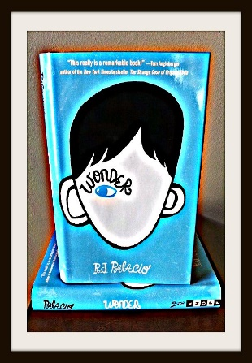
Welcome back!

I hope you have all had a restful Christmas break.
This term we will be ‘LOST IN A BOOK’ where the children will be reading Wonder by RJ Palacio and immersing themselves into the themes and characters the book portrays.
English: Reading and understanding the text will make up a large part of the children’s writing this year, along with comprehension, story writing, character descriptions, diary entries and information texts.
PSHE will be linked to the book, but the children will also be learning more about RSE (information to come out via Arbor).
Maths will be continuing to focus on fractions along with SATS revision and practice. SATs club to begin again next week please-same groups.
PE will be on Tuesdays, so please ensure children wear their PE kit in on that day (please also provide tracksuit trousers/jumper if required).
ICT will continue to look at internet safety and learning how to communicate responsibly.
Spellings set each week and spelling quiz to continue on Wednesdays.
Geography. Place and location knowledge looking at similarities and differences between Truro and Manhattan (where Wonder is set).
Thank you for your continued support and if you require any further information please get in touch,
Kind regards,
Mr. Easter & Mrs. Light

