1.12.20
LO: I am learning to recognise and name 3d shapes.
1.
Match the shapes to the correct label.

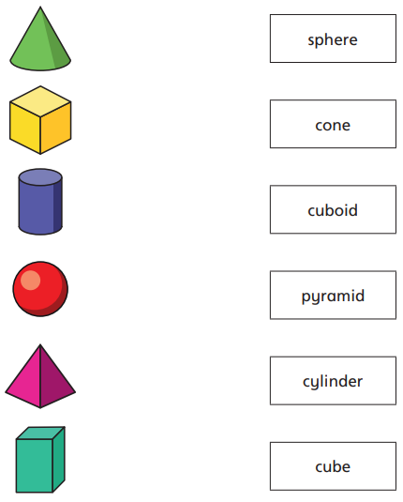
2.
Make this train using 3d shapes.

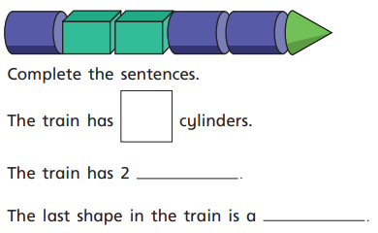

3.
Circle the pyramid.

4.

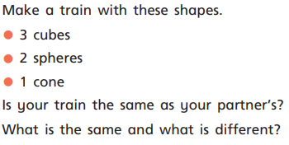

5. GDS

Label the odd one out. Find 2 answers.

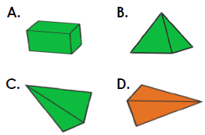

2.12.20
LO: I am learning to sort 3d shapes.

1. Tick the shapes that stack on top of each other.

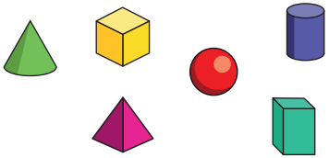

2.
Draw around the odd one out.

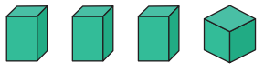

3.
Sort these shapes into the correct groups.

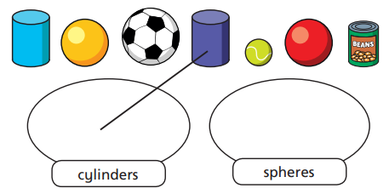

4. Label the odd one out.
pyramid cone cylinder
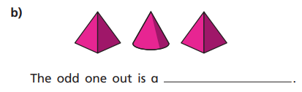

5. GDS

Reuben has sorted these shapes.
Is there another way?
Draw the shpaes in your book to prove it.

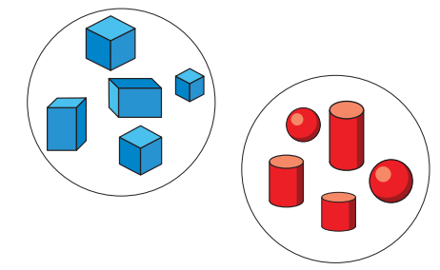

3.12.20
LO: I am learning to make patterns with 2d and 3d shapes.
1.
Draw the next shape.

2.
Match the correct shapes to the gap in the pattern.

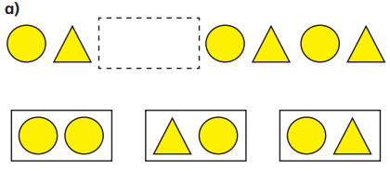

3.
What shape comes next in the pattern? Draw it.

4.
Match the correct shapes to the gap in the pattern.

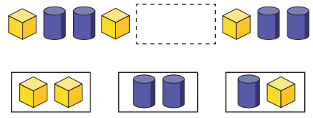

5.
Cut out the shapes. How many patterns could you make?
Make one pattern in your book.
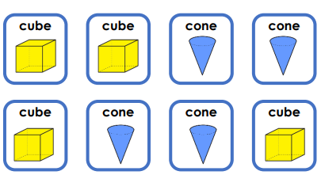

5.
Cut out the shapes. How many patterns could you make?
Make one pattern in your book.

