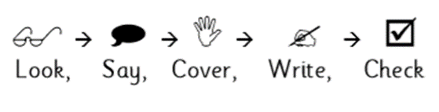
Weekly Spelling

Date: | Monday | Tuesday | Wednesday | Thursday | Friday
kindness
happiness
early
earth
agreement
fairness
enjoyment
hardship
Word list and suffixes: ‘ness’, ‘ment’ and ‘ship’
Weekly Spelling

Date: | Monday | Tuesday | Wednesday | Thursday | Friday
music
magic
library
dictionary
capital
mystical
answer
breath
Word list and suffixes: ‘ic’, ‘al’, ‘ary’

Weekly Spelling

Date: | Monday | Tuesday | Wednesday | Thursday | Friday
house
jump
just
much
must
now
out
school
High frequency
Weekly Spelling

Date: | Monday | Tuesday | Wednesday | Thursday | Friday
what
where
when
who
would
day
naughty
material
High frequency/ word list
Weekly Spelling

Date: | Monday | Tuesday | Wednesday | Thursday | Friday
asked
being
can’t
didn’t
heard
leave
know
goes
High frequency
Weekly Spelling

Date: | Monday | Tuesday | Wednesday | Thursday | Friday
therefore
started
stopped
think
use
although
told
walk
High frequency words
Weekly Spelling

Date: | Monday | Tuesday | Wednesday | Thursday | Friday
special
imagine
heart
fruit
grammar
bicycle
turn
watch
Word list
Weekly Spelling

Date: | Monday | Tuesday | Wednesday | Thursday | Friday
through
rough
enough
would
could
should
sound
found
Common word endings
Weekly Spelling

Date: | Monday | Tuesday | Wednesday | Thursday | Friday
action
question
information
glorious
serious
obvious
fraction
direction
Word endings: ‘tion’, ‘tious’
Weekly Spelling

Date: | Monday | Tuesday | Wednesday | Thursday | Friday
way
away
sleep
asleep
live
alive
long
along
Prefix ‘a’
Weekly Spelling

Date: | Monday | Tuesday | Wednesday | Thursday | Friday
verb
adverb
venture
adventure
addtion
admire
address
adjust
Prefix ‘ad’
Weekly Spelling

Date: | Monday | Tuesday | Wednesday | Thursday | Friday
assembly
assist
assess
attractive
affectionate
afford
attack
assistant
Prefixes: ‘ass’, ‘aff’, ‘att’

