Class 3 Spring Term 2021 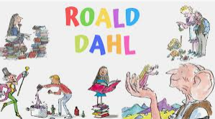
Famous Authors- Roald Dahl
Welcome back to school! This term the school topic is ‘Famous Authors’ and in Class 3 will be reading books written by Roald Dahl. The first story we are going to read together is The Enormous Crocodile and then we will be reading Charlie and the Chocolate Factory.

English- This term we will be continuing to follow the Read Write Inc spelling program and learning to join our handwriting. We will be writing instructions, poems and lots of stories! As a class we will be reading stories written by Roald Dahl and continuing to work on our reading comprehension skills.
Maths- Year 2 will be learning about Multiplication and Division, Data, Shape and Fractions. Year 3 will be learning about Multiplication and Division, Money, Length and Perimeter, Fractions and Statistics.
Art and DT- We will be making enormous crocodiles, sketching, painting and using clay.
Science- Science will be with Mrs Lewis on a Friday, this term Year 3 will be learning about Rocks and Soils and Year 2 will be learning about Materials.
Music- I wanna play in a band- working with others to create music.
PE- PE will be on a Tuesday afternoon, these sessions will be outside as often as possible. Please can the children come into school wearing their PE kit on a Tuesday.

Homework- Homework will start from the 12th January and will continue to be given out on a Tuesday.

Kind regards Mrs Ashley

