Day 2 Subtract a 2 digit number from a 2 digit number – crossing 10 (r)
- Solve these column subtractions.  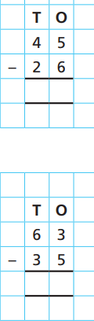 | 4.Elijah is working out 43- 5  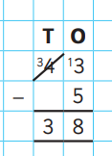  Is his calculation correct?  Show your workings out.
- Mrs Woods is solving this sum.  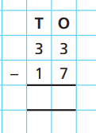  She thinks the answer will be 20. Is she correct? Prove it. | 5.Use column subtraction to solve each sum.  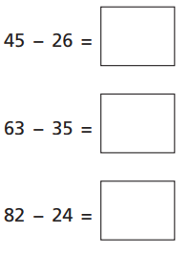
- True or false?  82-24 = 58. Show your workings out.  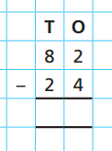 | GDS  Explain how you can subtract 12 from 31.
Day 3 3 digits – 2 digits
- Solve this column subtraction.  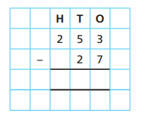 | - Calculate the missing number.  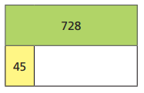  Use column subtraction to show your workings out.
2.  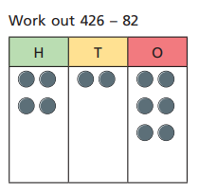  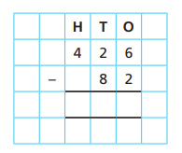 | - Check my calculation.  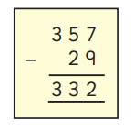  Show your workings out.
3.Work out the subtractions.  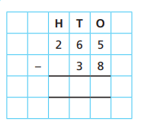  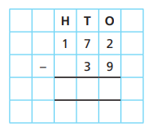 | GDS  Work out the missing numbers.  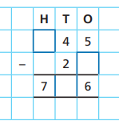  Show your workings out.
Day 4 3 digits – 2 digits
1.Use column subtraction to solve this.  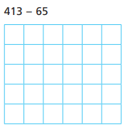 | 4.Calculate the subtraction sum.  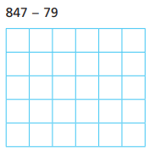  Use column subtraction to show your workings out.
- Alicia is working out 345 – 38. Show how to solve this sum using column subtraction. | 5.Check my calculation.  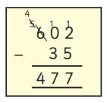  Show your workings out.
3.Check my calculation .  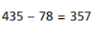 | GDS  Work out the missing numbers.  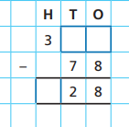  Show your workings out.

