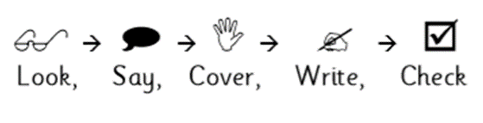
Weekly Spellings

Date: | Monday | Tuesday | Wednesday | Thursday | Friday
said
away
going
about
again
you
because
could
High frequency words
Weekly Spellings

Date: | Monday | Tuesday | Wednesday | Thursday | Friday
must
house
have
down
good
from
first
don’t
High frequency words
Weekly Spellings

Date: | Monday | Tuesday | Wednesday | Thursday | Friday
dinner
riddle
better
bubble
middle
summer
tomorrow
favourite
Word list and double consonants
Weekly Spelling

Date: | Monday | Tuesday | Wednesday | Thursday | Friday
ate
eight
see
sea
their
there
they’re
two
Homophones
Weekly Spelling

Date: | Monday | Tuesday | Wednesday | Thursday | Friday
childhood
motherhood
relationship
ownership
friendship
address
centre
describe
Word list and suffixes: ‘ship’, ‘hood’
Weekly Spelling

Date: | Monday | Tuesday | Wednesday | Thursday | Friday
appear
appears
arrive
arrives
group
grouped
promise
promises
Regular verb endings
Weekly Spelling

Date: | Monday | Tuesday | Wednesday | Thursday | Friday
believe
believed
decide
decided
disappear
disappeared
surprise
surprised
Regular verb endings
Weekly Spelling

Date: | Monday | Tuesday | Wednesday | Thursday | Friday
knowledge
learn
recent
remember
thought
possible
increase
different
Word list
Weekly Spelling

Date: | Monday | Tuesday | Wednesday | Thursday | Friday
build
caught
heard
history
island
purpose
suppose
weight
Word list
Weekly Spelling

Date: | Monday | Tuesday | Wednesday | Thursday | Friday
night
bright
right
fight
fright
sight
might
moonlight
Words ending in ‘ight’
Weekly Spelling

Date: | Monday | Tuesday | Wednesday | Thursday | Friday
circle
February
opposite
through
women
minute
popular
straight
Word list
Weekly Spelling

Date: | Monday | Tuesday | Wednesday | Thursday | Friday
height
interest
important
strange
sentences
experiment
enough
eight
Word list

