Class 4 Homework Grid Spring Term 2022 Dragon Rider
Choose one activity to complete each week. Some activities might need more than one week for you to complete.
This term in school we are going to be making a clay dragon. These dragons are going to need a home. Over this half term I would like you to create a home for your dragon. The dragons will be around 10cm long. Please try to reuse items you have at home to make your dragon’s home. These will need to be brought into school during the week beginning 14th February.
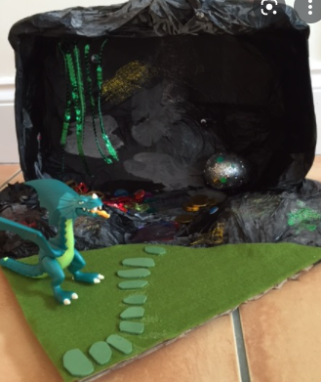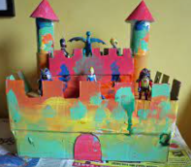
Write a poem about a dragon | Paint a dragon picture. | Write a story that has a dragon in. | Write a fact file about a Komodo Dragon
Science Challenge  How many bones can you name in a human body?  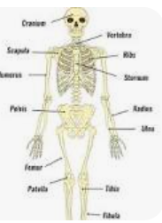 | Geography Challenge  Can you draw a map of your local area?  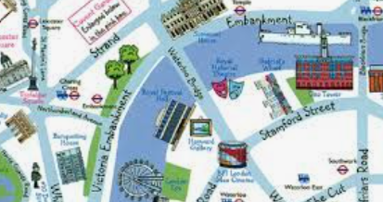 | Maths Challenge  How many x tables can you learn by heart?  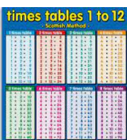 | Reading Challenge  How many stories can you read that have a dragon in?
Homework in Class 4
Reading
Please read at home x5 a week. Remember to talk about what you have read and to discuss any new vocabulary. This really helps to improve your child’s understanding of what they have read. Please remember to sign the reading record every time you listen to your child read. We will count the number of reads at home up to give out reading tokens and keyrings. Once your child has finished a book they can complete a quiz on the book at school. If they score 100% then they can more onto the next level of text.
All quizzes that are passed (over 60%) go towards your child’s total number of words read.
Reading books and Reading Records need to be in school daily.
Spellings
These will be given out weekly to go into the homework books. The words link to the spelling unit that we are currently working on in school in our RWI spelling sessions.
Sums
Each week there will be some arithmetic questions to practise. These help to ensure that your child remembers how to solve different types of sums and to improve the pace and accuracy of their maths.
Homework Grid
Please choose activities to complete at home. You can put work into the homework book or take photos and add them onto the Google Classroom.

Homework Books- These need to be in school every Monday, ready to put the new spellings and sums in.
If you have any questions about homework then please ask at the end of the day.
Many thanks Mrs Ashley

