Kings and Queens
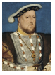 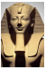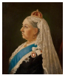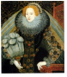 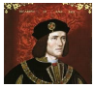 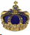 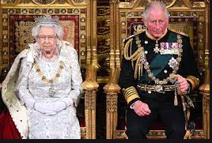 Summer Term Homework Challenges
What rules would you make if you were King or Queen for the day?  Make a list of the rules and explain why you choose those rules. | Design a new crown for Queen Elizabeth II.  Draw it in your homework book. | Write a letter to your favourite member of the Royal family.
Create a list of other countries that have a royal family. What is similar/different about them and our own royal family? Can you plot on a map where they live? | Research a king or queen from Ancient Egypt. You could find out about the food they ate, where they lived, what happened when they died. Or you could come up with your own ideas. | Can you write three facts about a historical monarch or a member of the royal family?
Find up to 5 flowers/ plants in your garden or out on a walk.  Draw pictures of them in your homework book.  Label with their name and parts of the plant. | Do a good deed in your local community or further afield. This could be litter picking, being friendly to your neighbours, etc. | Design a beautiful outfit for a King or Queen.
Paint or draw a portrait of a British King or Queen.  See if Miss Adler can guess who it is! | Kings and Queens have Royal coats of Arms.  Find out about Coats of Arms. Maybe you could design one for your family.  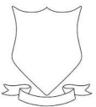 | Can you write Roman numerals for numbers up to 10?

