Day 1 – x 3
- Solve these.  1 x 3 =  2 x 3 =  3 x 3 =  4 x 3 =  5 x 3 =  6 x 3 =  7 x 3 =  8 x 3 =  9 x 3 =  10 x 3 =  11 x 3 =  12 x 3 = | 4. How many bananas are there?  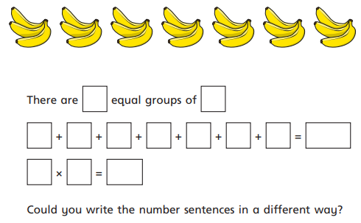
2.  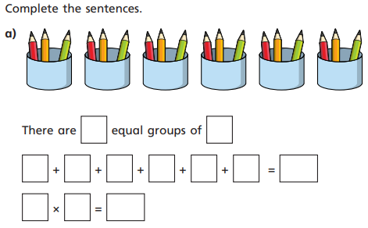 | 5. Complete the two sentences for the array.  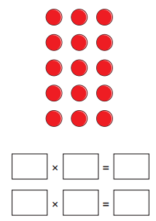
3.How many birds are there?  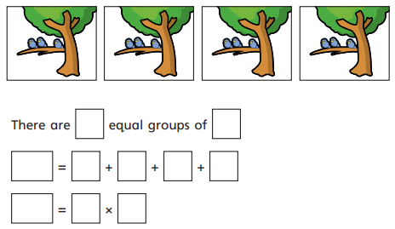 | 6.  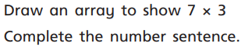  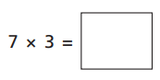

7.Complete the missing numbers.

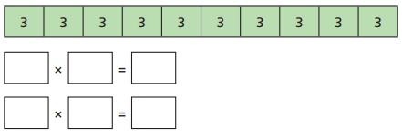
8. True or false?

GDS

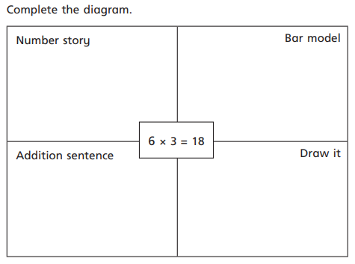

Day 2- Dividing by 3
- Solve these.  12 ÷ 3 =  15 ÷ 3 =  6 ÷ 3 =  18 ÷ 3 =  30 ÷ 3 =  3 ÷ 3 =  21 ÷ 3 =  24 ÷ 3 = | 4  .  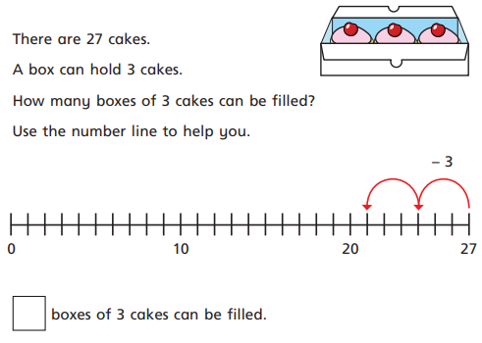
2.  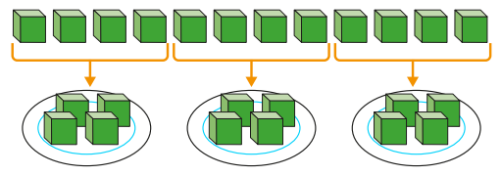  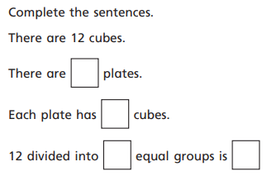 | 5.  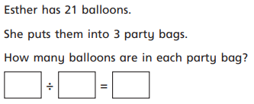
3.Share 15 pencils equally into 3 pots.  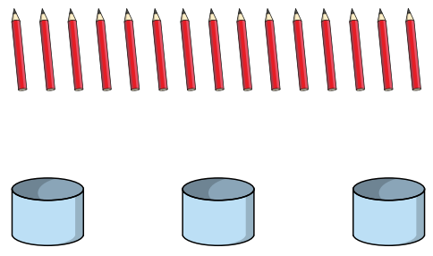  How many will be in each pot? | 6.  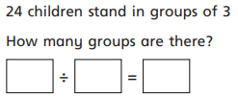

GDS

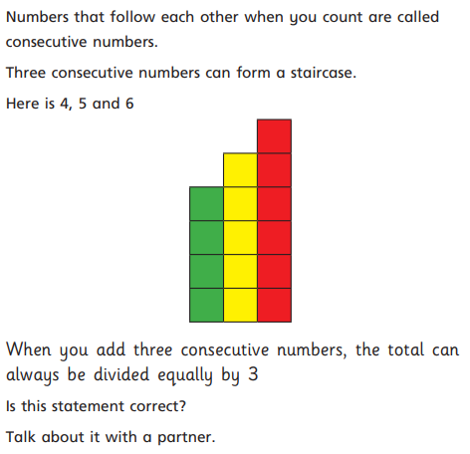

Day 3- x 3 tables

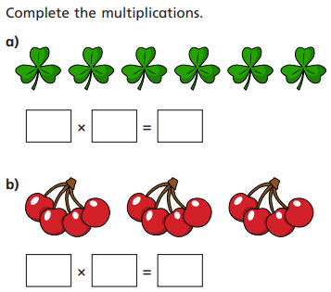 | 4.  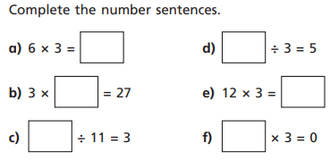
2 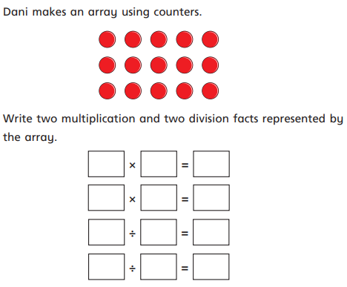 | 5.  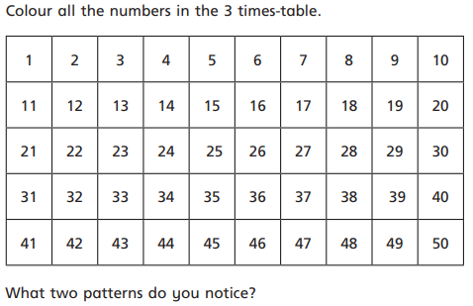
3.Complete the calculations.  1 x 3 =  6 x 3 =  12 ÷ 3 =  21 ÷ 3 =  3 x 3 =  30 ÷ 3 = | 6.  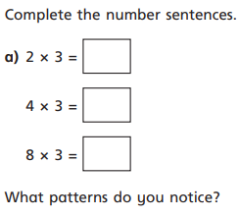

GDS
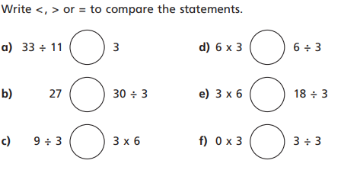

GDS
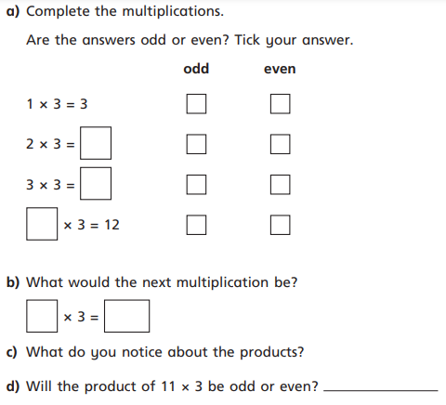

GDS
