Day 1
1. Solve these sums:  133 + 4 =  216 + 20 =  343 + 200 =  141 + 300 =  40 + 445 = | 5. True or false?  342 + 209 = 549  Prove it!
2. Solve these sums:  137 - 4 =  386 - 50 =  443 - 200 =  141 - 100 =  467 - 50 = | 6. Show Kevin how you can take 26 from this.  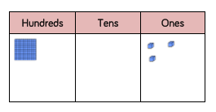
3. Take 128 from this number.  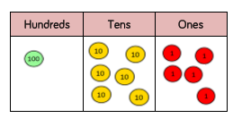  Use column subtraction to solve the sum. | GDS  Which sum would make the lowest number?  673 – 455 =  752 – 339 =  529 – 372 =  Prove it!
4.  Add 238 to this amount.  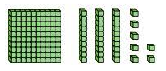  Show your workings out using column addition. | GDS  Sally had 400. She takes away this amount. How much does she have now?  Show your workings out.

Day 2

1. Solve these sums:  115 + 4 =  316 + 30 =  443 + 300 =  501 + 300 =  50 + 147 =  Remember to use column addition if you get stuck. | 5. Wombat has to add 107 to this amount. Show him how to do it.
2. Solve these sums:  116 - 4 =  196 - 50 =  503 - 200 =  491 - 100 =  661 - 50 =  Remember to use column subtraction if you get stuck. | 6. Use column subtraction to solve each sum.  474 - 125 =  245 - 127=  323 - 161=  857 - 181=
3. Double this amount.  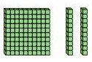  Show your workings out. | 7. Double these amounts  £126  £251  £366
4. Kevin has to take 129 from this amount.  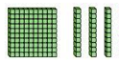  Help him to solve the sum?  Show your workings out. | GDS  Show three different ways to work out  265 + 80.

Day 3

1. Solve these sums.  227 - 5 =  278 + 5 =  672 - 20 =  461 + 20 =  702 - 100 =  621 + 200 = | 4. Kevin has these  How much more would he need to make 258?  Explain how you reached your answer.
2. Use column subtraction to solve each sum.  552 - 123 =  475 - 226=  432 - 361=  632 - 182= | 5. Which sum makes the smallest amount?  964 - 185 =  843 - 128 =  999 – 362 =  Show your workings out.
3. Mrs Woods adds another 127 to this board. How much will there be now?  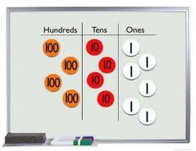  Show your workings out. | GDS  True or false?  872- 489 = 356  Show your workings out.

