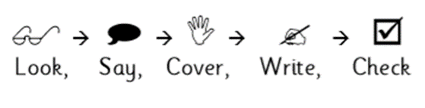
Weekly Spelling

Date: | Monday | Tuesday | Wednesday | Thursday | Friday
said
because
could
would
should
again
house
know
High frequency words
Weekly Spelling

Date: | Monday | Tuesday | Wednesday | Thursday | Friday
ate
eight
see
sea
their
there
they’re
two
Homophones
Weekly Spelling

Date: | Monday | Tuesday | Wednesday | Thursday | Friday
night
bright
right
fright
sight
moonlight
might
knight
Words ending in ‘ight’
Weekly Spelling

Date: | Monday | Tuesday | Wednesday | Thursday | Friday
hundred
thousand
million
eleven
twenty
thirty
forty
twelfth
Numbers
Weekly Spelling

Date: | Monday | Tuesday | Wednesday | Thursday | Friday
suddenly
can’t
important
friends
different
thought
also
animal
High frequency
Weekly Spelling

Date: | Monday | Tuesday | Wednesday | Thursday | Friday
happy
something
dictionary
develop
physical
until
write
excellent
High frequency and word list
Weekly Spelling

Date: | Monday | Tuesday | Wednesday | Thursday | Friday
ought
bought
though
dough
although
cough
rough
enough

‘ough’
Weekly Spelling

Date: | Monday | Tuesday | Wednesday | Thursday | Friday
delicious
infectious
cautious
ambitious
scumptious
malicious
luscious
suspicious
-cious and tious
Weekly Spelling

Date: | Monday | Tuesday | Wednesday | Thursday | Friday
official
special
social
facial
influential
potential
initial
beneficial
‘tial’ and ‘cial’
Weekly Spelling

Date: | Monday | Tuesday | Wednesday | Thursday | Friday
adorable
accessible
changeable
eligible
laughable
reliable
comfortable
enjoyable
‘able’ and ‘ible’
Weekly Spelling

Date: | Monday | Tuesday | Wednesday | Thursday | Friday
sociably
reliably
comfortably
flexibly
possibly
excitably
adorably
responsibly
‘ably’ and ‘ibly’
Weekly Spelling

Date: | Monday | Tuesday | Wednesday | Thursday | Friday
accompany
vehicle
suggest
occur
lightning
shoulder
average
according
Word list

