Date: _________________ Tue
2G–1 LO: I am learning to count sides on 2d shapes.  1. 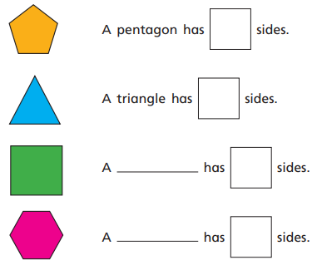 | 4. Complete this table.  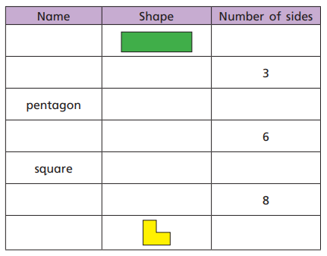
2. Circle the shapes that have 4 sides.  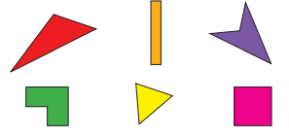 | 5. Jacob says, “This shape is a triangle.”  True or false? Explain your answer.
3. Circle the shapes that have six sides.  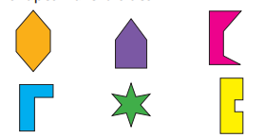 | 6. Draw three shapes using a ruler and only fifteen lines.  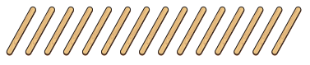

Date: _________________ Wed
2G–1 LO: I am learning to count vertices on 2d shapes.  1. 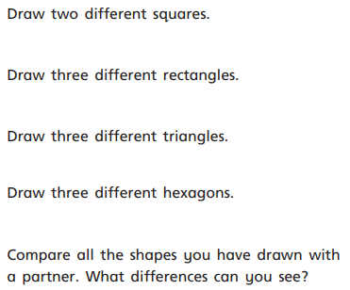 | 5. Circle the shapes with six vertices.  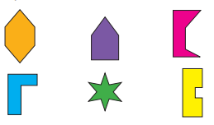
2. 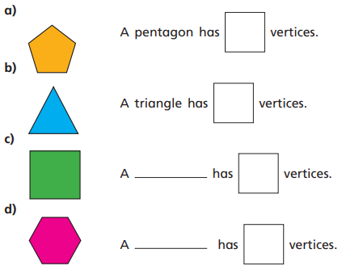 | 6. 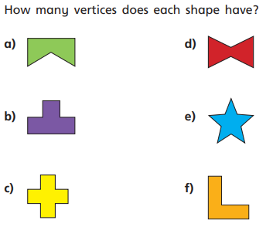
3. Circle the shapes that have 4 vertices.  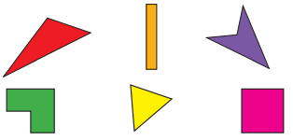 | 7. Ira found a 2d shape. It has four vertices, and it is not a square or a rectangle.  Draw Ira’s shape.
4. Layla found a shape with six vertices. What could it be?  Draw it. | 8. GDS Which is the odd one out? Explain your answer.  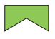
Date:_________________ Thu
2G–2 LO: I am learning to manipulate shapes to place them in particular orientations.  1. Has this shape been rotated?  What is this shape? | 5. Ella wants to rotate this rectangle. Use a ruler to draw the rotated rectangle.
2. 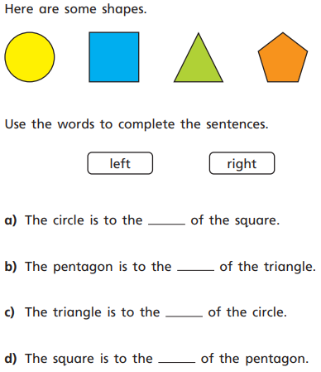 | 6. What is this shape?  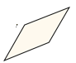_________________  Draw the shape in a different rotation with a ruler.
3.  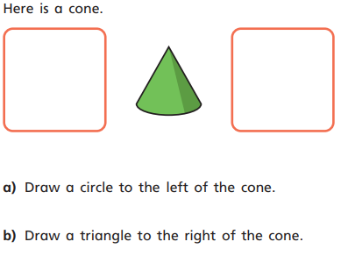 | 7. a) Can you put these shapes together to make a new shape?  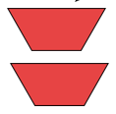  b) Draw the new shape with a ruler.  c) What is the new shape?
4. Use a ruler to draw a cone upside down. | 8. GDS Miss Adler says, “I can make a square out of two triangles.” Is she correct? Prove it!

