Homework Grid 08.11.21 Homework to be handed in on Monday 6th December
4 activities to be completed: 2 from the top line and 2 from the bottom
Design and make an information poster about wildlife, or certain wildlife, found in the UK  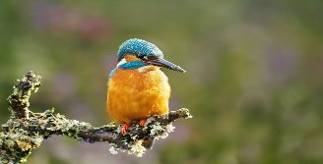 | Using a piece of clay (provided) create a animal or bird found in the UK.  Produce a piece of writing describing the animal (eg, what it looks like, how it moves, feeds etc)  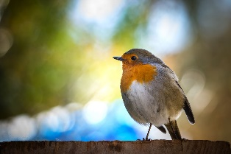 | Write a 500 word narrative about a day in the life of an animal from our class book | Write an impassioned plea to your local MP about climate change issues that you are concerned about
Design and make your own UK wildlife crossword and wordsearch.  Wordsearch and crossword to include at least 15 animals/birds or clues | BAKING CHALLENGE  Bake some flapjacks (teacher needs to test) with a mystery ingredient that MR Easter & Mrs Light can try and guess | Create and make a Christmas card that can be sold at our class Christmas sale  The card must be made of completely recyclable material | BIRD COUNT  Watch and count the birds in you garden (or local area) and produce a tally chart and another representation of the information, eg, bar chart, pie chart, pictogram

