W/C: 23.11.20 Learning Project –
Age Range: EYFS
Weekly Reading Tasks | Weekly Phonics Tasks
Monday- Read Stickman  Talk about the story and characters.  Do they know the seasons? How can they tell what season is which? | Monday – RWI phonics  Group 1 KL masdt – focus on d  Group 2 NP sounds practice 1.1 word time spell words  Group 3 KL sounds practice 1.2. word time spell words
Tuesday – Watch Axel Scheffler reading Stickman  https://www.youtube.com/watch?v=OFhJrLVu3T0&scrlybrkr=cdfac795  Talk about the story and characters.  Do they know the seasons? How can they tell what season is which? | Tuesday- RWI phonics  Group 1 KL masdt – focus on t  Group 2 NP sounds practice 1.2 word time read words  Group 3 KL Sounds practice 1.3 word time read words
Wednesday – Look at a video clip about the seasons to reinforce the themes in Stickman  https://www.bbc.co.uk/bitesize/topics/zkvv4wx/articles/zcx3gk7?scrlybrkr=81262954  Yellow | Wednesdays - RWI phonics  Group 1 KL Inpgo focus on i  Group 2 NP Sounds practice 1.2 word time read words  Group 3 KL Sounds practice 1.3 word time read words
Thursday- Read Stickman  Talk about the story and characters.  Do they know the seasons? How can they tell what season is which?  Blue group | Wednesdays - RWI phonics  Group 1 KL Inpgo focus on n  Group 2 NP Sounds practice 1.2 word time spell words  Group 3 KL Sounds practice 1.3 word time spell words
Friday- Watch Stickman animation.  https://www.bbc.co.uk/iplayer/episode/b06t09rk/stick-man?scrlybrkr=81262954  Red group | Wednesdays - RWI phonics  Group 1 KL inpgo focus on g  Group 2 NP Sounds practice 1.2 word time spell words  Group 3 KL sounds practice 1.3 word time spell words
Weekly Writing Tasks | Weekly Maths Tasks
Monday  Spring, Summer Autumn Winter picture  Children write Spring Summer Autumn Winter using a sound mat.  Purple group  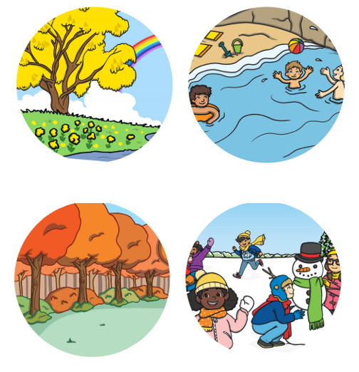 | Monday- Watch numberblocks Series 2 ep 1 Six  https://www.bbc.co.uk/iplayer/episode/b08pgksd/numberblocks-series-2-six?scrlybrkr=81262954  Read the gingerbread man as you read represent the growing pattern of characters using counters/cubes (smartboard resources) Can they see the pattern of 1 more? Can they predict what comes next?  Red group  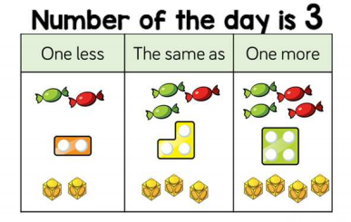  Have a number of the day  Each child to have a one more/the same as grid/ one more grid. Arrange the numberals, objects, counters, cubes and find one more and one less.
Tuesday- Spring, Summer Autumn Winter picture  Children write Spring Summer Autumn Winter if they can.  Green Group | Tuesday – Watch Numberblocks Episode- Series 2 ep 2 Seven  https://www.bbc.co.uk/iplayer/episode/b08pgqt4/numberblocks-series-2-seven?scrlybrkr=81262954  Give each child a five frame. Make a number using counters on the five frame. Can you show me one more? Have a number track underneath the five frame. Can you point to the number you made?  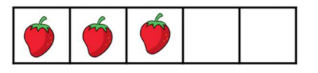  Blue group  Have a number of the day  Each child to have a one more/the same as grid/ one more grid. Arrange the numberals, objects, counters, cubes and find one more and one less.
Wednesday- Spring, Summer Autumn Winter picture  Children write the initial sound and then T to highlight the rest of the word and ch to trace over.  Yellow Group | Wednesday - Watch Numberblocks Episode -series 2 ep 3 eight  https://www.bbc.co.uk/iplayer/episode/b08pgvmb/numberblocks-series-2-eight
Thursday- Spring, Summer Autumn Winter picture  Children write the initial sound and then T to highlight the rest of the word and ch to trace over.  Blue Group | Thursday- Watch Numberblocks Episode – Series 2 ep 4 – nine  https://www.bbc.co.uk/iplayer/episode/b08phbzc/numberblocks-series-2-nine  Give each child a five frame. Make a number using counters on the five frame. Can you show me one less? Have a number track underneath the five frame. Can you point to the number you made?  Green Group Purple group  Have a number of the day  Each child to have a one more/the same as grid/ one more grid. Arrange the numberals, objects, counters, cubes and find one more and one less.
Friday- Spring, Summer Autumn Winter picture  Children write the initial sound and then T to highlight the rest of the word and ch to trace over.  Red Group  Funky Finger Friday | Friday- Play number blocks series 2 just add one  https://www.bbc.co.uk/iplayer/episode/b08q39b4/numberblocks-series-2-just-add-one?scrlybrkr=81262954  Sing 5 currant buns. How many buns are there together? Put the penny in a pot. Repeat. Notice that there is one less bun and one more penny.  Yellow  Have a number of the day  Each child to have a one more/the same as grid/ one more grid. Arrange the numberals, objects, counters, cubes and find one more and one less.
Enhanced Continuous Provision Plan for Reception (‘Busy Time’) - Week Beginning: 23/11/20 Seasons and Stickman

AREA | OBJECTIVE | ENHANCEMENT
Small World Area | AOL: Communication and language: Speaking  EAD Being imaginative  OBJ: I am learning to introduces a storyline or narrative into their play.  I am learning to use available resources to create props to support role play.  FOCUS: Retell the story of Stickman using the puppets. | 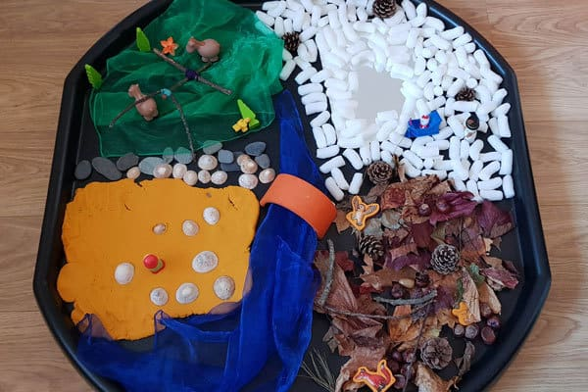
Malleable | AOL: Physical Development: Moving and handling  OBJ: I am learning to handle tools, objects, construction and malleable materials safely and with increasing control.  FOCUS: Have numicon and pebbles to create different numbers. Find the matching number to go with the numicon. Find the right amount of pebbles to match the numicon and number. | 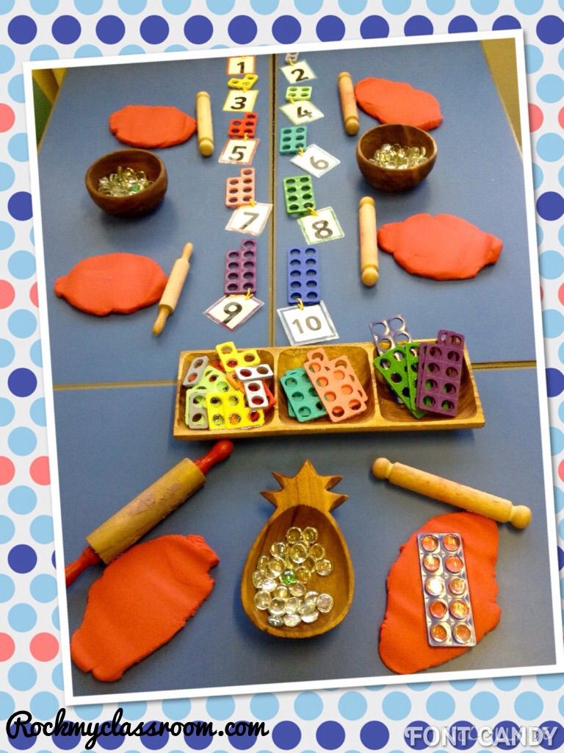
Writing area  linked from Assessment. | AOL: Literacy  OBJ: I am learning to hear and say the initial sound in words.  FOCUS: Practice writing different letters in paint in zippy bags. Have letters on pebbles to copy.  Can children make words using magnetic letters – link to RWI words learning this week. | 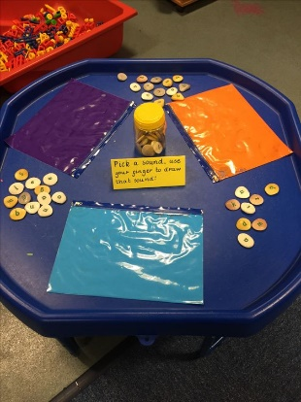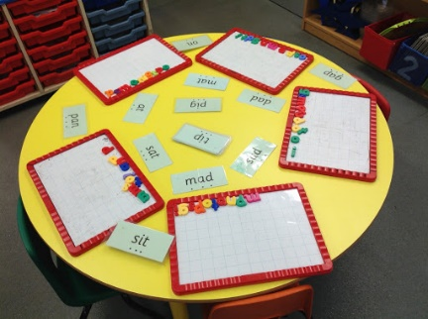
Creative Table  Linked from child interest – | AOL: EAD  OBJ: I am learning to experiments to create different textures.  I am learning to understand that different media can be combined to create new effects.  FOCUS: add different coloured paper to show the different seasons on the trees.  Leaf printing – collect different sized leaves and print onto paper using paint. | 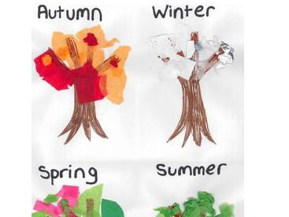
Maths area  Linked from  Assessment – | AOL: Number and SSM  OBJ: I am learning to recognises numerals 1 to 5.  I am learning to count up to three or four objects by saying one number name for each item.  Orders two or three items by length  FOCUS: Can you cut out the different size stickmen and put them in size order?  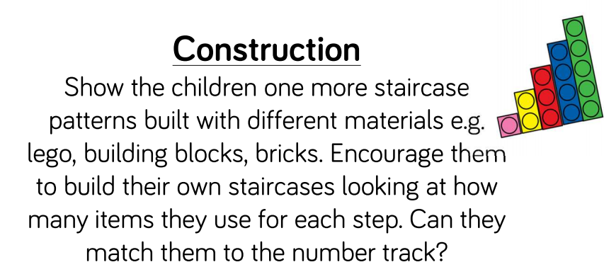 | Ordering stick man pictures in size  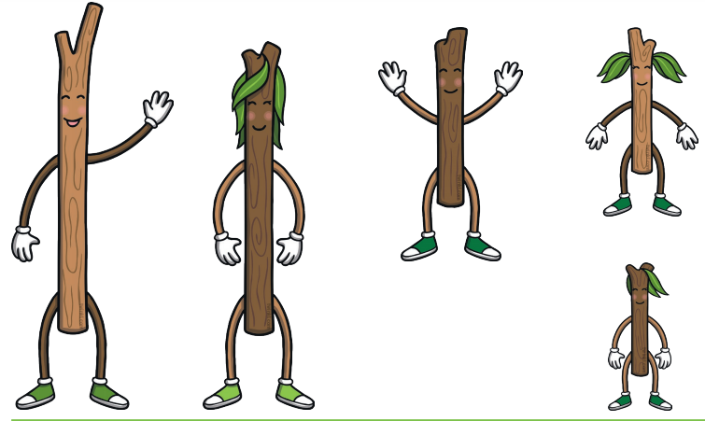
Role Play  Home Corner | AOL:CLL  OBJ:I am learning to introduce a storyline or narrative into their play.  FOCUS: Family Tree. Cover over the floor and cupboards with brown materials and add tree trucks, pinecones and wood to make the family tree. Have chalk boards to draw on and chalks (like the boy stick does in the story) | 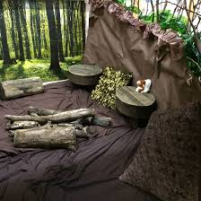
KUW | AOL: KUW  OBJ: Looks closely at similarities, differences, patterns and change.  FOCUS: On prepared tree sheet – children cut out different pictures and stick in the correct sections depending on what season it belongs to. | 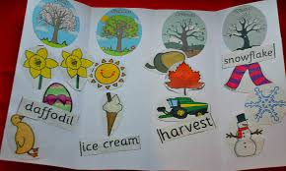
Funky Fingers | AOL: PD  OBJ: I can being to use anticlockwise movement and retrace vertical lines.  FOCUS: Wrapping wool around sticks | 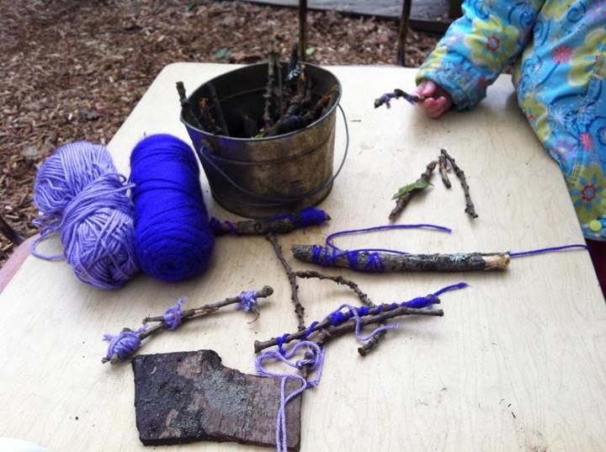
ICT | AOL: KUW: Technology  OBJ: I can select and use technology for particular purposes.  FOCUS: Use the CD player to listen to the story of Stickman | CD Player and Stickman CD
Outside | AOL: KUW, EAD  OBJ: Talks about why things happen and how things work.  Create simple representations of events, people and objects  FOCUS: Can you collect sticks and make stick man?  Can you make stick man travel down the guttering wall like he does when he floats out to sea.  Floating and Sinking – inside – record which floats and sinks  Have a natural small world area with magnifying glasses – draw what they can find. | 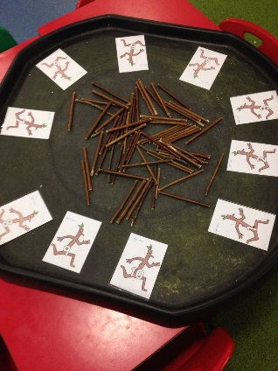  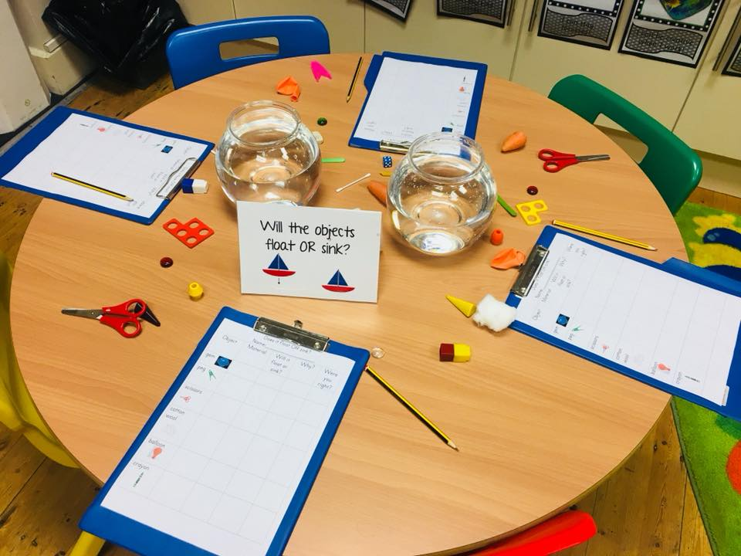  Will the objects float and sink?
Music | AOL: EAD: Exploring and using media and materials  OBJ I am learning to explores the different sounds of instruments.  FOCUS: Play bells that Stickman hears when he is sleeping.  Make musical sounds to feel like you are in the snow or wintery weather. | Instruments  Cd player

