W/C: 09.11.20 Learning Project – Remembrance
Age Range: EYFS
Weekly Reading Tasks | Weekly Phonics Tasks
Monday- Look at Remberance Day powerpoint KS1 on Twinkl.  Discuss that in a couple of days is will be remberance day and this week we will be learning about it. | Monday- RWI introduce the sound ‘sh’  Recap m a s d t i n p g c k u b f e l h  Fred Talk ship, shop, fish, shed, shin
Tuesday – Watch ‘The Poppy Story’ https://www.youtube.com/watch?v=doalcouBKwc&t=9s  This gives the children more understanding about what Poppy Day is all about. | Tuesday- RWI introduce the sound z  Recap m a s d t i n p g o c k u b f e, l, h, sh  Fred talk zip, zag, zig, zoo, zap
Wednesday – Watch https://www.youtube.com/watch?v=wOT5CDnYHEs  Cbeebies video of ‘Poppies’. Watch just before 11 o clock and then do 2 minutes silence. | Wednesday- RWI introduce the sound ch  Recap m, a , s, d, t, i, n, p, g, c, k u b f e l, h, sh, z  Fred talk choc, chin, chat, chon, chib
Thursday- Look at pictures from the Twinkl – KS1 Photos powerpoint. Ask the children to explain what they are looking at e.g. medals of soldier from the war, poppy fields, soldiers, marching – ask children to march like a solider. | Thursday RWI introduce the sound q  Recap m a s d t i n p, g, c, k, u b f e l h, sh, z, ch  Fred talk, queen, quit, quick, quig, quib
Friday- Share and read our favourite poems after listening to ‘In Flander Fields’ | Friday- RWI introduce the sound x  Recap m a s d t i n p g c k u b f e l h sh , z, ch, q  Fred talk box, fox, mox, hox
Weekly Writing Tasks | Weekly Maths Tasks
Monday  Yellow Group  Talk to the children about what they are thankful for. Brainstorm this on a large piece of paper – writing all their ideas down. Explain why we are thankful for the people who fought in the war for us and that we are safe and we have freedom.  Get the children to write down a couple of words what they are thankful for. E.g. chocolate, sunshine, mummy, daddy, guinea pigs! Etc..  Collect writing together to make a Thankful book. | Monday-  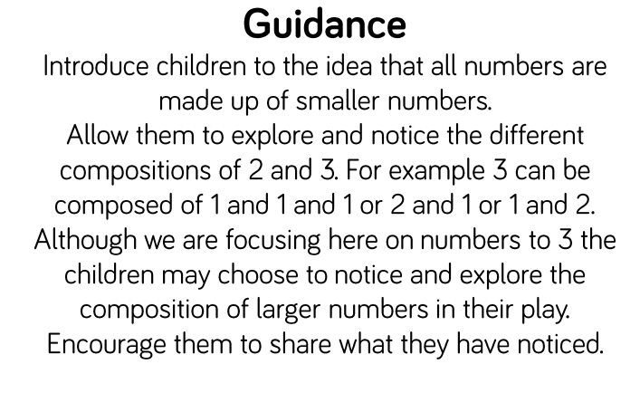  Watch Numberblocks Episode – Blast off  Have 3 billy goats gruff puppets and 2 fields. Ask the children how many goats could go in each field. Can they find different ways to do this? What if they had 1 or 2 animals?  Red group – Dominos activity. – can they find a domino that shows 1,2 and 3 on. Ask the children to count what they have found.  On white boards draw around the domino and draw the dots 1,2 or 3.
Tuesday-  Green Group  Talk to the children about what they are thankful for. Brainstorm this on a large piece of paper – writing all their ideas down. Explain why we are thankful for the people who fought in the war for us and that we are safe and we have freedom.  Get the children to write down a couple of words what they are thankful for. E.g. chocolate, sunshine, mummy, daddy, guinea pigs! Etc..  Collect writing together to make a Thankful book. | Tuesday – Watch Numberblocks Episode - Counting Sheep  Give each child 3 double sided counters, ask them to shake them and drop them on the floor in front of them. How many are red? How many are yellow? Can they get all red or all yellow?  Blue group Yellow  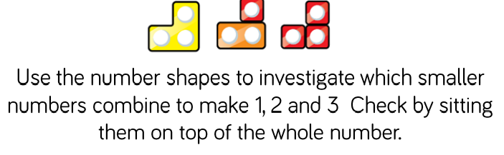
Wednesday-  Blue Group  Talk to the children about what they are thankful for. Brainstorm this on a large piece of paper – writing all their ideas down. Explain why we are thankful for the people who fought in the war for us and that we are safe and we have freedom.  Get the children to write down a couple of words what they are thankful for. E.g. chocolate, sunshine, mummy, daddy, guinea pigs! Etc..  Collect writing together to make a Thankful book. | Wednesday - Watch Numberblocks Episode – Double trouble
Thursday-  Purple group  Talk to the children about what they are thankful for. Brainstorm this on a large piece of paper – writing all their ideas down. Explain why we are thankful for the people who fought in the war for us and that we are safe and we have freedom.  Get the children to write down a couple of words what they are thankful for. E.g. chocolate, sunshine, mummy, daddy, guinea pigs! Etc..  Collect writing together to make a Thankful book. | Thursday- Watch Numberblocks Episode – The Three Threes  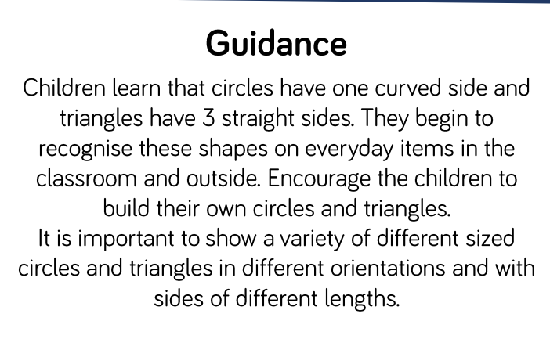  Show the children a variety of circles and triangles in different sizes and orientations. Choose one of the shapes. Ask the children to tell you what they notice. Are the side straight or curved?  Can they see another shape like this?  What is we turn it around is it still the same shape?  Can they find a different shape? Why is it different?  Green Group – Sorting circles and triangles into two different groups.  Using pictures of objects that are triangle and circle shape cut out and stick in the right section.
Friday-  Red Group  Talk to the children about what they are thankful for. Brainstorm this on a large piece of paper – writing all their ideas down. Explain why we are thankful for the people who fought in the war for us and that we are safe and we have freedom.  Get the children to write down a couple of words what they are thankful for. E.g. chocolate, sunshine, mummy, daddy, guinea pigs! Etc..  Collect writing together to make a Thankful book.  Funky Finger Friday | Friday- Watch Numberblocks Episode – Odds and Evens  Show the children a picture which has been made of different shapes e.g. boat, a rocket, a house. What shapes can you see int eh picture?  How many triangles can you count?  Can you make your own picture using the shapes?  Go on a shape hunt. Where can you see circles and triangles?  Purple group – Sorting circles and triangles into two different groups.  Using pictures of objects that are triangle and circle shape cut out and stick in the right section.  Extend to other shapes and talk about how many sides they have.

AREA | OBJECTIVE | ENHANCEMENT
Small World Area | AOL: Communication and language: Speaking  EAD Being imaginative  OBJ: I am learning to introduces a storyline or narrative into their play.  I am learning to use available resources to create props to support role play.  FOCUS: Create a everyday town scene – carpark, woods, town building etc for the children to explore familiar experiences that they can talk about. | 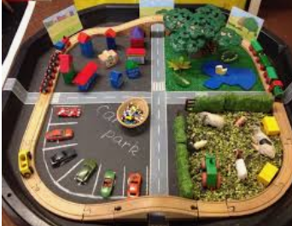
Malleable | AOL: Physical Development: Moving and handling  OBJ: I am learning to handle tools, objects, construction and malleable materials  safely and with increasing control.  FOCUS: Make a poppy field from playdough, buttons and pipe cleaners.  Use twinkl playdough mats to make poppies | 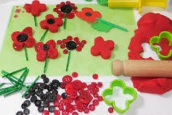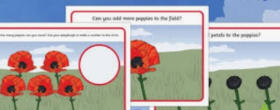
Writing area  linked from Assessment. | AOL: Literacy  OBJ: I am learning to hear and say the initial sound in words.  FOCUS: initial sound peg cards, writing the initial sounds on whiteboards  Tracing over letters – using RWI sheets and fancy pens. | 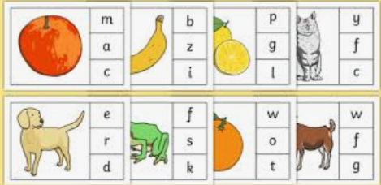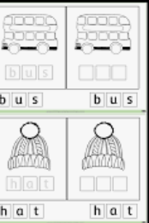
Creative Table  Linked from child interest – | AOL: EAD  OBJ: I am learning to experiments to create different textures.  I am learning to understand that different media can be combined to create  new effects.  FOCUS: paper plate poppies, poppy collage, poppy handprints.  Flowers from bun cases  Make medals  Children in need activities and craft. | 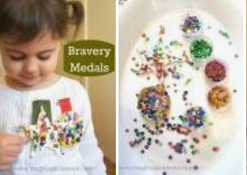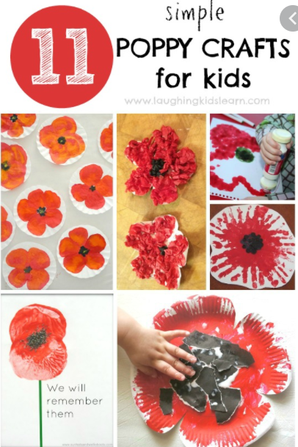  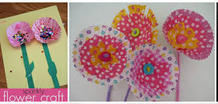
Maths area  Linked from  Assessment – | AOL: Number  OBJ: I am learning to recognises numerals 1 to 5.  I am learning to count up to three or four objects by saying one number name for each item.  FOCUS:  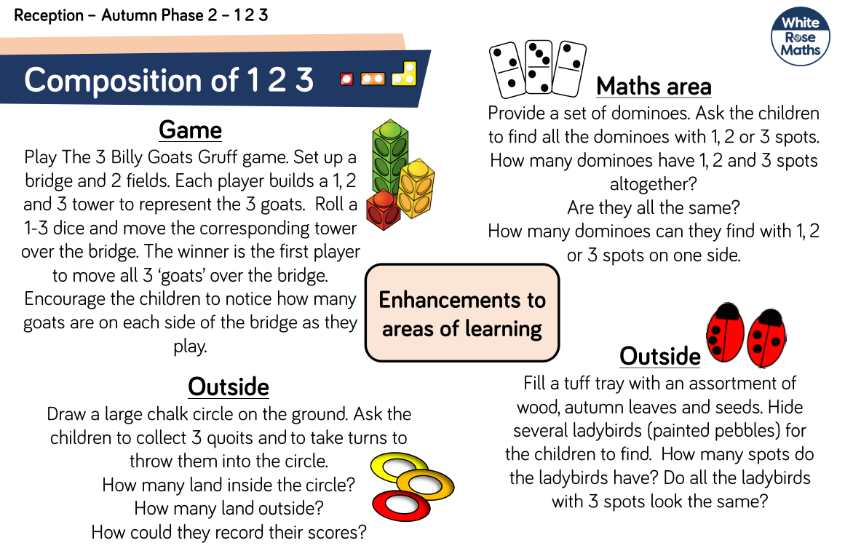
Role Play  Home Corner | AOL:CLL  OBJ:I am learning to introduce a storyline or narrative into their play.  FOCUS: Bonfire Night Food Stall  BBQ, bonfire, toasting marshmallows, taking orders, putting food into take away containers, paying for food using the till, writing orders down. | 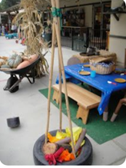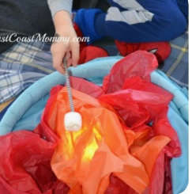
KUW | AOL: KUW CLL  OBJ:  FOCUS: Thinking about Remembrance Day. Show PPT/video and then play a memory game.  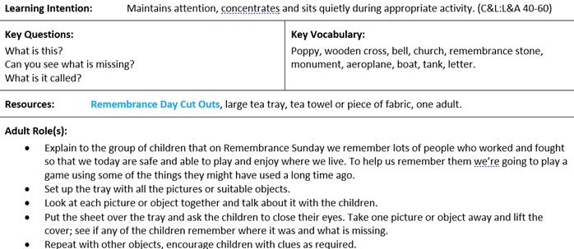 | 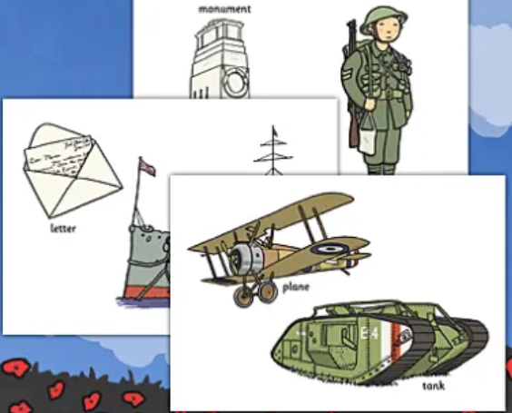  Remembrance Day cuts out to print and laminate.
Funky Fingers | AOL: PD  OBJ:  FOCUS:  Threading activities with black and red bead.  Tweezers and poppy seeds  Making poppies from buttons  Marching like soldiers to and from the playground. | 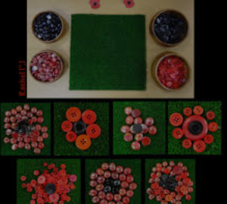
ICT  Link with Maths | AOL: KUW: Technology  OBJ: I am learning to interact with age-appropriate computer software  FOCUS: Topmarks games on the interactive w/b  EYFS games on the ipad.  Use a drawing program on the IPAD and see if they can draw different flowers.
Outside | AOL: KUW, Mathematics  OBJ:  FOCUS: Maths and numbers 1, 2, 3  Bonfire role play area.  Water: fishing game with numbers. Can they record the numbers? | 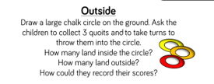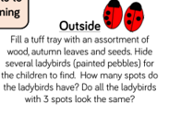
Music | AOL: EAD: Exploring and using media and materials  OBJ I am learning to explores the different sounds of instruments.  FOCUS: Provide a range of percussion instruments for children to use to create sounds to represent marching and holding a steady beat march to like soldiers.
Enhanced Continuous Provision Plan for Reception (‘Busy Time’) - Week Beginning: 09/11/20

