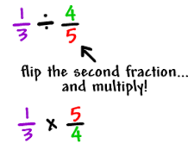
- Calculate:  $\frac{1}{3}$ ÷ $\frac{2}{1}$ | - Calculate:  $\frac{1}{3}$ $÷$ 2  What is the same and what is different about this calculation and Q1?
Question 3  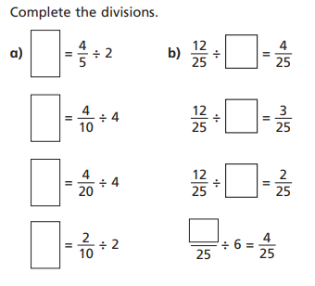  Remember to write the answer in its simplest form | Question 4  Write 2 divide calculation for your partner to work out
- Complete 4 calculations from the Target Maths page 47. (Questions 9-16) | - Complete Part C of Target Maths.
Q3 = a=2/5, 1/10, 1/20, 1/10 b= 3, 4, 6 & 24/25

LO: IALT divide fractions
Question 1  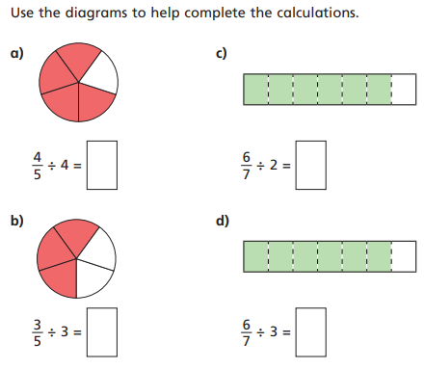 | Question 2  Joe works out 10/25 ÷ 5 = 2/5  What mistake has Joe made?  Can you draw a diagram to prove his mistake?
Question 3  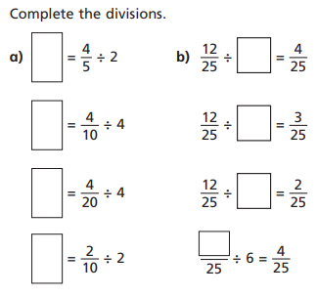 | Question 4  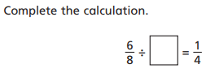  Find the missing numbers to make this division correct. Sophie thinks its 20-is she correct?  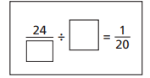
Question 5  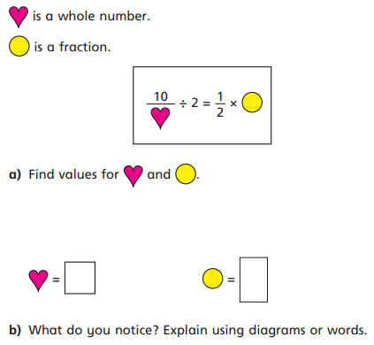 | Question 6  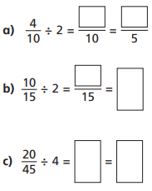  Complete the calculations giving your answer in its simplest form.

