Year 5 Multiplication Finding multiples
Question 1  What is multiplication?  ×  Write your answer in a full sentence. | Question 2  What other words could you use instead of multiplication?
Question 3  What is a multiple?  I think it is a number that does not appear in a number’s times table.  Eg 24 is a multiple of 5  What do you think? Am I correct or not? | Question 4  Find the first 12 multiples of 4  Find the first 5 multiples of 9
Question 5  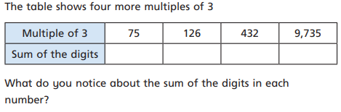 | Question 6  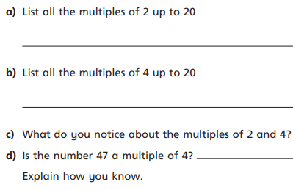
Question 7  GDS  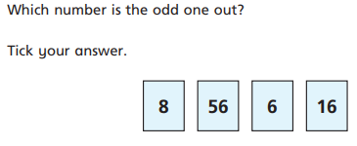  Explain you answer | Question 8  GDS  Mark my work  The seventh multiple of 9 = 54  The fourth multiple of 7 = 35  The eleventh multiple of 12 = 122
Question 9  GDS  What multiple of 12 is also a multiple of 4 and 8?  Is there only one? Elsa thinks there might be another......do you agree? | Question 10  GDS  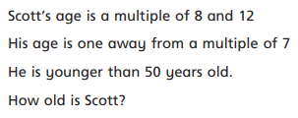

Finding Factors
Question 1  What is a factor?  Explain in a full sentence using examples. | Question 2  Using arrays, show me all the factors for the number 18
Question 2
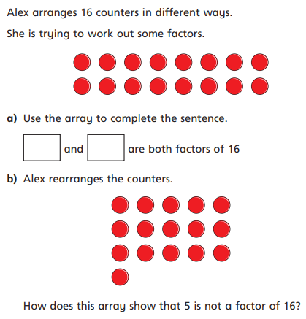

Question 3  Find all the factors of each of the following numbers  - 6 b) 12  c)9 d) 5 | Question 4  2,3 and 4 are some of the factors of which number?  Show me your calculations.
Question 5
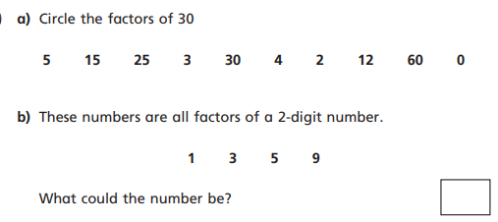

Question 6
Always, Sometimes or Never

A number will always have an even number of factors because factors come in pairs?

Explain your answer/reasoning using examples

Question 7

Using the templates provided, make factor flowers for any number up to 100

Remember to include all the factors.

LO: IALT identify common factors
Question 1
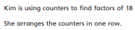
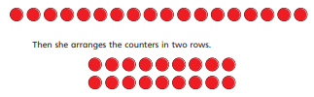
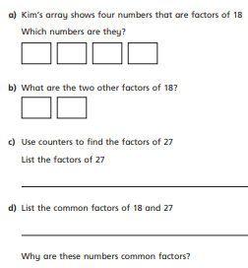

Question 2  What is a common factor?  Full sentence | Question 3  Find the factors of 9 and 12  Mrs Light thinks the common factors in these numbers are 1 and 4. Is she correct?
Question 4  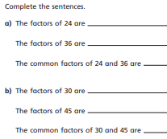 | Question 5  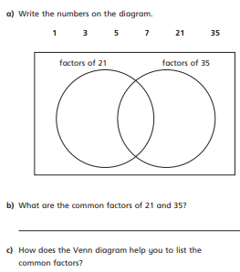
Question 6  GDS  What are the common factors in 48 and 64?  I think they are 1, 2, 4, 8 and 16. Do you agree?  Show me | Question 7  GDS  PROVE IT  I don’t think there are four numbers that have 5 or more common factors. Do you?
Question 8  GDS  Two numbers have common factors of 1 and 5. What are they?  Show me | Question 9  GDS  Two numbers have common factors of 1, 2 and 5.  What are they?  Show me
Question 11  GDS  Finding factors pg 124 | Question 12  GDS  I am thinking of 2 numbers between 70 and 80.  The common factors are 1, 2, 4 and 8  What are the 2 numbers I am thinking of?

Prime Numbers
Question 1  What is a prime number?  Full sentence | Question 2  What are the first 3 prime numbers?  What makes them prime numbers?
Question 3  number factors  5 1 and 5  7 1 and 7  4 1, 2 and 4  9 1, 3 and 9  6 1, 2 3 and 6  8 1, 2,4 and 8  What does the table above show us?  Can it help in identifying prime numbers? How? | Question 4  Draw your own table to show me all the other prime numbers less than 20.  Remember, they will only have 2 factors.
Question 5  Using arrays can help identify prime numbers.  EG. The number 6 can be shown in 3 ways.  As you can see, the number 6 fits neatly with no odd rows.  Use this method to decide whether the following numbers are prime numbers or not  2 10 14 19 27 31 | Question 6  True or false  All multiples of 2 are not prime numbers?  Prove it using examples
Question 7  GDS  What is a composite number?  Explain using examples | Question 8  GDS  Pg 124

Finding square and cubed numbers
Question 1  What is a squared number?  What is a cubed number?  Use examples | Question 2  Build cubed squares for the following numbers  - 4  - 9  - 16  - 18  How can this strategy help us with squared numbers?
Question 3  How do we write a squared number and what does it represent/show us?  I think it is like this…………9 = 3(2)  What do you think? Explain | Question 4  Build a cube. How many cubes are in your ‘big’ cube.  Does this mean your number is a cubed number?
Question 5  Build cubes for the following number and then decide if it is cubed or not.  8 | Question 6  How do we write a cubed number and what does it represent/show us?  Show me examples
Question 7
GDS

Number square game pg 128

Year 5 13.11.18 LO: I am learning to answer a variety of questions based on factors, multiples, squared and cubed numbers and prime numbers QUIZ
Question 1  Mark my work  The seventh multiple of 9 = 64  The fourth multiple of 7 = 42  The seventh multiple of 12 = 74 | Question 2  48 is a multiple of 12. Is it a multiple of any other number?  Prove it and show me
Question 3  What is a factor?  Explain in a full sentence | Question 4  2,3, 4 and 5 are some of the factors of which number?
Question 5  What are the factors of 28?  What are the factors of 34?  Show me using examples | Question 6  What is a common factor?  SHOW ME USING EXAMPLES
Question 7  What is a prime number?  Show me using examples | Question 8  How do we write a cubed number and what does it represent/show us?  2  I think it looks like this 125 = 5
Question 9  How do we write a squared number and what does it represent/show us?  I think it is like this…………25 = 5(2) | Question 10  I think 16 is a squared number. Do you?  Prove it
Question 11  What is 3 cubed?  What is 4 cubed? | Question 12  List all the prime numbers below 100

Year 5 14.11.18.....Patterns with prime numbers worksheet, prime number bingo

YEAR 5 15.11.18 lo: I AM LEARNING TO MULTIPLY A 4 DIGIT NUMBER BY A 1 DIGIT NUMBER
Question 1  What is multiplication and what else could we call it?  Use examples to illustrate | Question 2
Question 3 | Question 4
Question 5 | Question 6
Question 7 | Question 8
Question 9 | Question 10
Question 11 | Question 12

Question 1 | Question 2
Question 3 | Question 4
Question 5 | Question 6
Question 7 | Question 8
Question 9 | Question 10
Question 11 | Question 12

Question 1 | Question 2
Question 3 | Question 4
Question 5 | Question 6
Question 7 | Question 8
Question 9 | Question 10
Question 11 | Question 12

