Day 1 Add and subtract multiples of 100
Solve these sums:  100 + 400 =  200 + 200 =  300 + 200 =  300 + 300 =  400 + 500 = | 5. Isabelle has these Base 10.  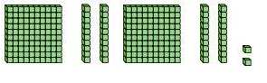  Subtract 100.  Show the sum that you have completed.
Solve these sums:  500 - 400 =  300 - 100 =  400 - 200 =  700 - 100 =  800 - 500 = | 6. Mrs Woods says that 651 plus 400 is 691.  Is she correct?  Explain your answer.
- Leon has these Base 10.  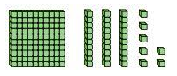  Add another 100.  Write the sum you have completed. | 7. Oliver has 400 pencils.  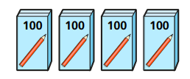  He buys another 5 packets. How many pencils will he now have?  Show your workings out.
- True or false?  Check my sums.  Correct any that I have got wrong.  300 + 500 = 700  300 + 300 = 600  240 + 300 = 340  300 + 250 = 450  329 + 300 = 629  400 + 231 = 621 | GDS  The answer is 888.  What could the addition sum be?  Find as many ways as you can.  RULE- you can only add 3 digit numbers.

Day 2 Recap Lesson Add and subtract 1s
1.  Solve these sums:  14 + 4 =  28 + 2 =  37 + 2 =  356 + 3 =  412+ 5 = | - Add in the missing numbers.  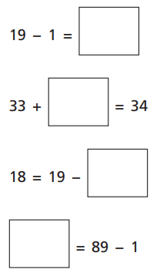
2. Solve these sums:
5 - 4 =
30 - 5 =
47 - 2 =
123 - 1 =
- - 5 =
3. Keaown has some cookies.  He eats three. How many does he have left?  Show the sum you have done. | GDS  True or false?  Check the number sentences.  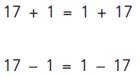  Explain your answer.
4.Complete the number tracks.

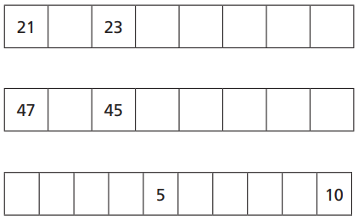

Day 3 Add and subtract 3 digit and 1 digit numbers – not crossing 10
- How many candles are there?  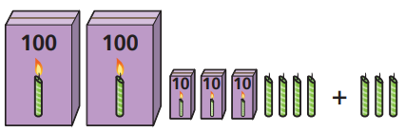 | 5.Alicia has been collecting stamps.  She has 543. She buys another 3.  How many does she have now?
- Eloise has these Base 10.  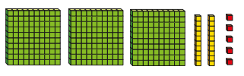  She takes away 3 ones.  What will she have left?  Write a sum to show what you have done? | - Elijah has this number.  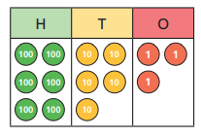  He adds another 4 ones.  What will he have now?
- Complete these calculations.  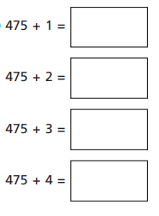 | - Put the digit cards in the correct place to solve the sums.  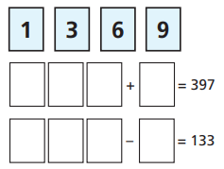
4 . Calculate the missing numbers.  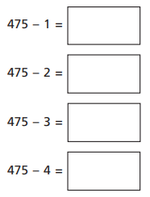 | GDS  Complete the missing numbers  .  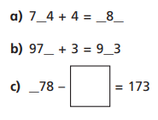  Prove it!
Day 4 Add a 2 digit and a 1 digit number – crossing 10. (Recap lesson)
- Solve these.
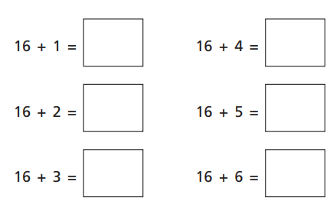

- What is sixteen add seven?  Explain how you solved the sum. | 4.Complete this addition.  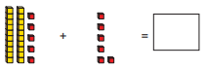
- Use number bonds to complete these numbers.  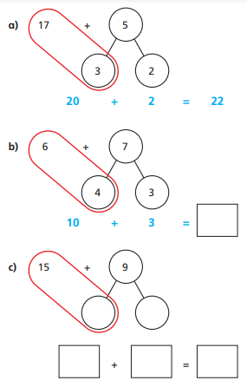 | 5.Solve these calculations.  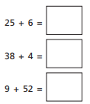
GDS

True or false?
The ones number can never be higher than 9.

Prove it!

