Autumn Term Homework
Homework will be given out on a Tuesday and returned by the following Monday.
The children will receive Maths and Spellings each week.
This will be based on the work that the children have done during the week.

Oceans Around our World
During this term, please complete as many of these tasks as you would like.
When you complete one, either stick it in your homework book (pictures/photos) or bring in something to show us! Once a challenge is complete, ask an adult to sign it.

Use the internet to find out five facts about the Pacific Ocean. | Take a picture of an activity you do at the weekend with your family. | Create your own sea creature using recycled materials.  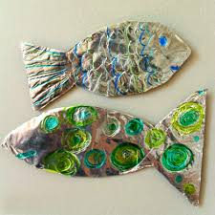
Can you list the five oceans of the world? | Make a collage with things you might find at the beach (sand, shells, seaweed, driftwood etc.)  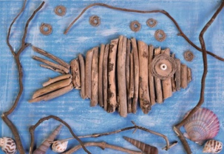 | Send in a photo of you reading a book in an interesting place.
Make a Christmas decoration for the class tree. | Draw and label a picture of your favourite sea animal. | What job would you like to do when you grow up? Why?

