Year 4/5 Maths
Column Subtraction-no exchanging
Question 1  What does the symbol below mean?  Write 4 different words! | Question 2  You have been asked to go to Class 1 and tell a group what subtraction means. What would you say? In a sentence please using the proper vocabulary.
Question 3  What numbers do the base ten blocks below represent?  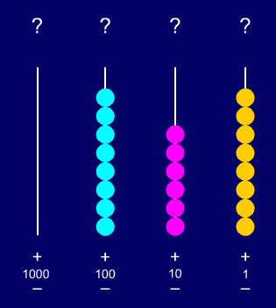  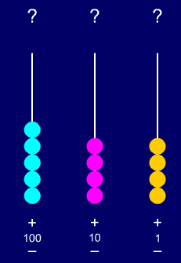  Complete the subtraction | Question 4  10  1  1  1  10  10  1  1  10  10  10  10  What numbers are represented above?  Calculate the answer  1  1  1  1  1  10  10  10
Question 5  What is 6657 -4324?  6000+ 600 + 50 + 7  - 4000 + 300 + 20 + 4  Question 7  GDS  Mrs Edwards has been practicing her expanded column subtraction-mark her work. Please can you show her what to do if she has made a mistake?  4000 + 700 + 70 + 9  - 2000 +400 + 80 + 8  2000 +300_+ 10 __+_1  Answer = 2311 | Question 6  What is 8796 – 653?  8000 +700 + 90 + 8  - 600 + 50 + 3  Question 8  GDS  Are the 2 questions below the same?  9000 + 700 + 70 + 7  - 6000 + 500 + 40 + 3  ____________________  97770  - 6543  How are they the same and how are they different?
Question 9  GDS  Jayden and Declan think the answer is 3535 but I think the answer is 3635. Who is right? Why?  9797  - 6262  ____ | Question 10  GDS  Convince me that  7879-6673 =209
Question 11 (ncetm)  GDS  Complete the following calculations  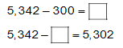 I think the answer to both calculations is 40. What do you think? Show me. | Question 12 (ncetm)  GDS  Mark my work  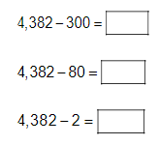  What about these calculations.  Do you see a pattern that might help you?
Question 13 (ncetm)
GDS
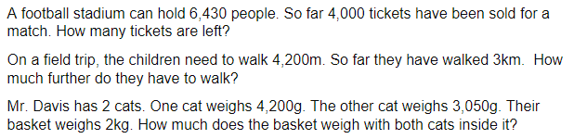

09.05.17-Introduce exchanging
Question 1  When we subtract 4 digit numbers, Mrs Light says we always start with the thousands first.  Mrs Edwards thinks we start with the units. Who is right?  Explain using an example | Question 2  Elsa is learning to use the expanded method for subtraction.  Check her work and correct any mistakes if there are any.  4000 + 300 + 60 + 9  - 2000 + 100 + 80 + 7  2000 + 300_+_ 20 +_ 2
Question 3  Try the following subtraction  8989 – 6139 =  Use expanded or compact to solve the question | Question 4  Mark my work  61839 – 2528 = 45301  77698 – 55477 = 22201  44949 – 11739 = 33210  I think they’re all correct………do you?  Use your preferred method to help you……show me
Question 5  4 98  - 3 ? 93  42_ _  Fill in the missing numbers  Question 7  The Caribbean island of Barbados has a diameter of 95879 km’s. The smallest isalnd in the Caribbean has a diameter of 13768 km’s.  What is the difference between the 2.  Mrs Light thinks it is 82123 km’s. I think she is wrong  Is she right?  Show me | Question 6  There are 87889 coconuts floating in the Caribbean Ocean. One day 54769 of them wash up on a beach.  How many coconuts are left?  Show me your workings  Question 8  Mark my work  - 0 + 800 + 60 + 9  - 5000 + 400 + 70 + 8  2000 + 600 + 10 + 2  7869 – 5478 = 2612
Question 9  GDS  Mrs Holroyd has 107863 bananas and Mr Light has 63585.  What is the difference between the 2? | Question 10  GDS  48827 – 17493 =  Write a word problem for the calculation above and then answer it.
Question 11  Can we take 708 from 338 and still have a positive number  Explain | Question 12  GDS  Sometimes, always or never  If our top number is lower than the bottom number, we just do a normal subtraction  Eg 337 – 409 = 72
Question 13  GDS  Look at the calculation below and tell me if it is right. Explain your answer  333 or 300+30+3  - 666 - 600+60+6  = 333 300+30+3 | Question 14  GDS  When the top number in a subtraction (units, tens, hundreds, thousands columns) is lower than the number below it, what do you need to do?  Explain and show an example

10.05.17
Column subtraction inc exchanging
Question 1  Look at the figures below  Take away/minus/subtract  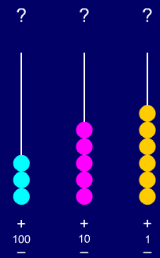  Can I carry out a straight forward subtraction or do I need to exchange  SHOW ME | Question 2  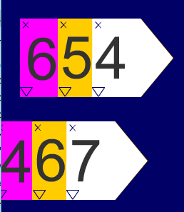  Mr Wilson has carried out the subtraction above  600 + 50 + 4  - 400 + 60 + 7  = 200+ 10 + 3  Is he right?  SHOW ME
Question 3  Sometimes, always or never  When you subtract a smaller number by a bigger number your answer will always be a positive number.  Explain  Eg 3 -7 | Question 4  Mr Easter thinks that 77845 take away 54694 is 33251……….  Is he right?
Question 5  Mrs Light has made some paper stars and says she would like to give all the children in the class 2 each (1336 children in the school). She has made 3922 stars. How many will she have left?  Prove it | Question 6  The number of visitors, coming to school this year, is 72834 strong. This school has only got room for 61733 children. How many more children coming are there?  Show me
Question 7  GDS  Write your partner a subtraction question which involves exchanging in the tens column.  Show me | Question 8  GDS  The children in Class 4 can run at 1,897 km's per hour. Mrs Light can only run at 648 km's per hour.  What is the difference in the 2 speeds  Show me
Question 9  GDS  There are 1,998,276 pencils in the school, 676,675 are blunt.  How many are not?  Show me | Question 10  GDS  Mark my work  701,937 – 583,657 = 235,320  666,759 – 595,296 = 111,543  2,908,9175 – 1,058,756 = 1,192,200

