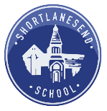
Class/Year Group: Class 2 - Year 1 & 2 Week Beginning: 29.3.21
Sue Hendra 12
Weekly Reading Tasks | Weekly Spelling Tasks
Monday  Individual Reading with an adult  Whole class- Double Dave  RWI groups | Monday  RWI Spellings  Y2- spelling with Mrs Woods  Handwriting:  Y1- Handwriting tracker  Y2- Handwriting tracker
Tuesday  Individual Reading with an adult  Whole class- Gordon’s great escape  RWI groups | Tuesday  RWI Spellings  Y2- spelling with Mrs Woods  Handwriting  Y1- Common exception word spellings  Y2- Common exception word spellings
Wednesday  Individual Reading with an adult  Whole class- Egg  RWI groups | Wednesday  RWI Spellings  Y2- spelling with Mrs Woods  Handwriting  Y1- Nelson Handwriting Workbook 1A p.16  Y2- air join- air, fair, lair, pair, chair
Thursday  Individual Reading with an adult  Whole class- Doug the bug that went boing  RWI groups | Thursday  RWI Spellings  Y2- spelling with Mrs Woods  Handwriting  Y1- Nelson Handwriting Workbook 1A p.17  Y2- le join- leapt, angle, bangle, rectangle
Friday | Friday
Weekly Writing Tasks  Focus: Story writing | Weekly Maths Tasks  Focus: Place value
Monday- Story Build up – hot write as we go along  Year 1 – LO: I am learning to sequence sentences to form short narratives.  IEP: LO: I am learning to link sounds to letters, naming the letters of the alphabet.  Do this through phonics and CVC word writing from pictures.  Year 2 – LO: I am learning to write a narrative.  Afternoon  Easter cards & Computing – (see below) | Monday  10.30-10.45: Y1 & 2 Number sense Stage 2 book 1  Year 1: LO: I am learning to compare numbers using <, > and =.  RA with Y1  IEP: LO: I am learning to order two or three things by length and height.  Do this with cubes – take photos  Year 2:  LO: I am learning to count forwards in tens from any given number within 100.  KA with Y2
Tuesday – Story Problem – Hot write as we go along  Year 1 – LO: I am learning to sequence sentences to form short narratives.  IEP: LO: I am learning to give meaning to the marks I make.  Outside, with a wet paint brush and chalks – write letters, draw a picture of yourself, draw an easter egg etc. Take photos  Year 2 - LO: I am learning to write a narrative.  Afternoon  Hot write – story problem  Common exception word spellings | Tuesday  10.30-10.45: Y1 & 2 Number sense Stage 2 book 2  Year 1:  1NPV–1 LO: I am learning to count backwards within 100, starting with any number.  RA with Y1  IEP: LO- I am learning to describe my relative position using ‘next to’ and ‘behind’.  Use the picture cards to do this and talk about where you are in relation to objects  Y2 – LO: I am learning to count backwards in tens from any given number within 100.  KA with Y2
Wednesday – Story resolution and ending  Year 1 – LO: I am learning to sequence sentences to form short narratives.  IEP: LO: I am learning to hold a book the correct way up and turn the pages.  Choose a book from the book corner – Egg could be a nice one. Read this together and discuss what could be happening. Take photos for writing book.  Year 2- LO: I am learning to write a narrative.  Afternoon: Easter crafts | Wednesday  10.30-10.45: Y1 & 2 Number sense Stage 2 book 3  Year 1: 1NPV–1 LO: I am learning to count forwards within 100, starting with any number.  SE with Y1  IEP: LO- I am learning to talk about the shape of everyday objects e.g., ‘round’ or ‘tall’.  Take a tour around the classroom and the hall- describe what you see using this vocabulary – tall, round, short, flat, solid. Label shapes with the appropriate words in your book.  Year 2: LO: I am learning to solve subtraction facts within 20.  RA with Y2
Thursday – Finish hot write  Year 1 – LO: I am learning to sequence sentences to form short narratives.  IEP: LO: I am learning to write my name.  Practice on name card then copy into writing book.  Year 2 – LO: I am learning to write a narrative.  Afternoon  Watch an Easter film! | Thursday  10.30-10.45: Y1 & 2 Number sense Stage 2 book 4  Year 1: LO: I am learning to play games that involve moving along a numbered track and understand that larger numbers are further along the track.  SE with Y1 – practical maths – maths games, snakes & ladders etc.  Take one photo of the whole class for books.  IEP: LO: I am learning to order two items by weight.  Make ‘light’ and ‘heavy’ labels. Compare weights or objects from the classroom.  Year 2: LO: I am learning to solve addition facts within 20.  Include addition and subtraction problems – Easter themed activities.  RA with Y2
Friday – Good Friday – Not at school | Friday

Afternoon activities
Art & DT: – Monday afternoon: Easter cards/ Sue Hendra character (oil pastels) – best sketch books
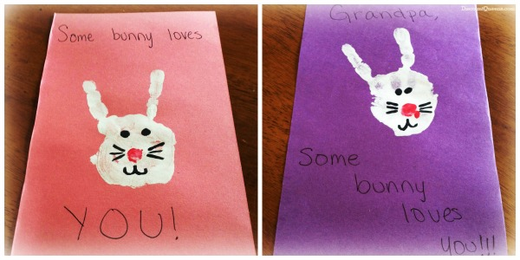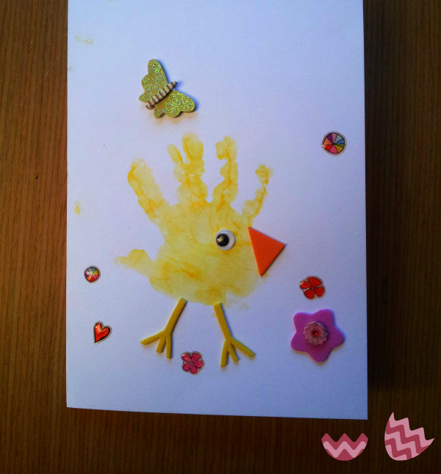

History: Wednesday afternoon– Easter crafts – egg decorating
RE: LO: I am learning to discuss and apply some features of religious rituals.
PE/ Gymnastics: Thursday afternoon – Team games
SPaG: Tuesday & Thursday afternoon:
PSHE: Friday afternoon:
Music: Friday afternoon – Charangra – COVID Scheme – Y1 Spring 2 – Lesson 6
Computing: Monday & Friday Sumdog spellings & maths, MyON reading.
STEM Learning Opportunities #sciencefromhome
Some fun experiments to try: https://www.sciencefun.org/kidszone/experiments/
Additional learning resources parents may wish to engage with
- Times Table Rockstars and Numbots. Your child can access these programmes with their school logins. On Times Table Rockstars, children should aim to play Soundcheck for 20 minutes daily.
- CODE Maths Hub Daily Fluency Activities
- https://www.topmarks.co.uk/maths-games/daily10 - arithmetic challenges
- Sumdog: https://pages.sumdog.com/
- BBC Bitesize - Lots of videos and learning opportunities for all subjects.
- MyON – lots of eBooks available. Search for your AR level, enjoy reading the book and take the quiz!

Friday 26th March
L.O: I am learning to use a food chain to show how animals get their food.

Friday 26th March
LO: I am learning to explain the difference between a secret and a nice surprise.

