__________________
L.O – I am learning to add a 2 digit and a
1 digit number – crossing ten
- Solve these.  17 + 1 = 62 + 3=  12 + 2 = 40 + 1 =  - + 2 = 25 + 2 =  25 + 3 = 51 + 4 = | 3.Complete the calculations.  Draw the Base 10 to help you.  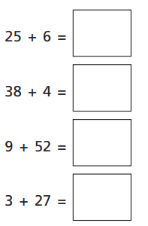  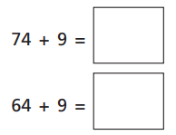
- Use the number line to help you to solve the sums.
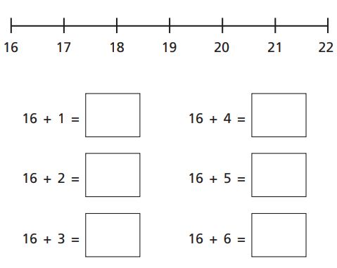

- Complete these additions.  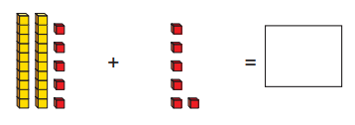  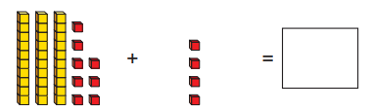 | GDS  Using only these numbers,  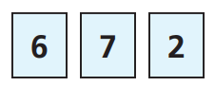  How many different sums can you make?  Solve them.
__________________
L.O – I am learning to add a 2 digit and a
1 digit number – crossing ten
- Solve these.  10 + 1 = 42 + 2=  - + 2 = 35 + 1 =  47 + 2 = 25 + 2 =  25 + 3 = 51 + 4 = | 3.Complete the calculations.  Draw the Base 10 to help you.  19 + 4 =  66 + 5 =  36 + 6 =  - + 7 =  38 + 4 =
- Solve this addition.
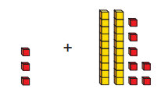

- Layla says this shows 9 + 52  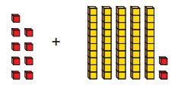  Is she correct?  Solve the addition. | GDS  Solve these.  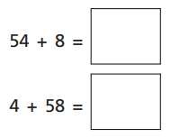  What was the same and what was different about how you solved them?

__________________
L.O – I am learning to subtract –
Crossing 10 ®
- Complete the calculations.  15 - 1 = 45 – 1 =  17 - 2 = 46 – 1 =  24 - 1 = 46 – 2 =  15 - 3 = 19 – 4 = | 5.Samuel has made 32 with Base 10. He has to take 5 away.  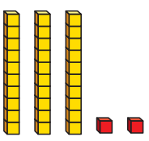  What will the answer be?
- Maize has been baking cakes.  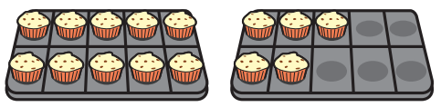  She gives 6 away to her friends.  How many does she have left? | 6. True or false?  43 – 4 = 29  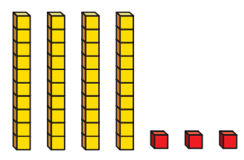  Prove it!
- Harvey has 12 cookies.  He gives four to Mason.  How many does Harvey have left?  Show your workings out? | 7. Use the number line to solve the calculation.  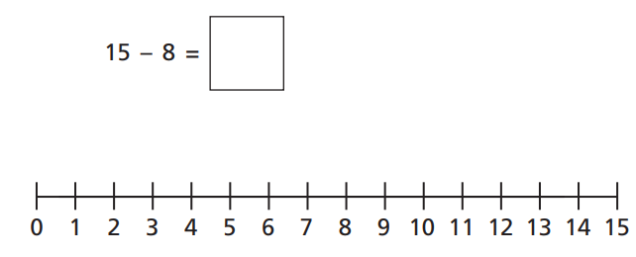
- Use the number line to solve the calculation. | GDS  What is the missing number?  Prove it!

__________________
L.O – I am learning to subtract a 1 digit
number from a 2 digit number- crossing 10
- Use the number line to solve the sums.  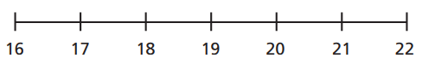  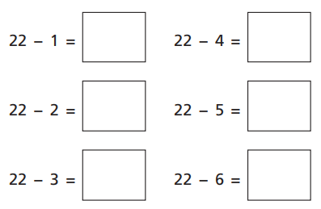 | - Complete the subtractions.  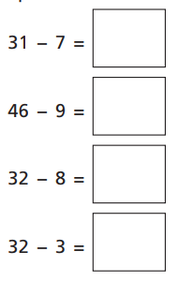
- Using the Base 10 solve these.
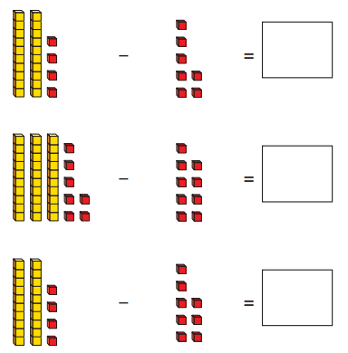
- Mark my sums.

23 – 4 = 19

33 – 5 = 28

31 – 2 = 19

65 – 7 = 72

- True or false?  21 – 4 = 16  Show your workings out. | GDS  The answer is 20.  What could the subtraction sum be?  How many different sums can you think of?

