4.11.20
LO: I am learning to understand 2d and 3d shape facts (hot assessment).
1.  Match each shape to its name.  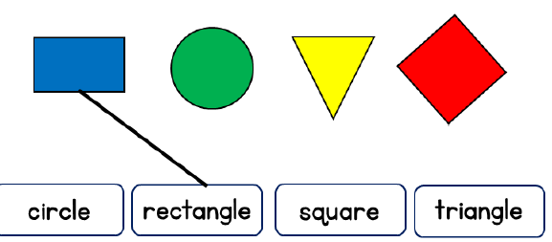 | 2.
3.  Match each shape to its name.  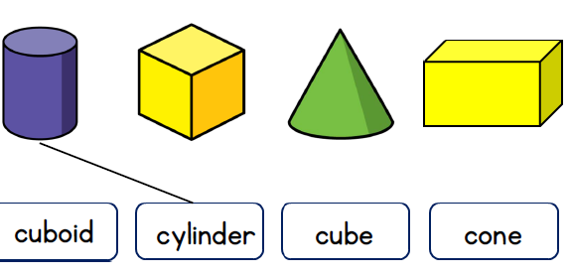 | 4.  Circle the pyramids.  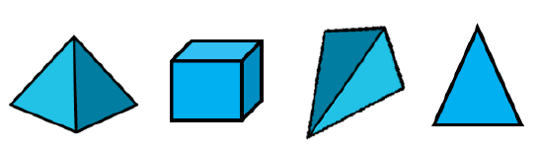
5.  Draw the next 2 shapes in the pattern.  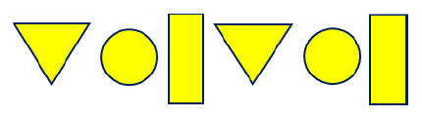 | 6.  Draw around the shape in the wrong group.  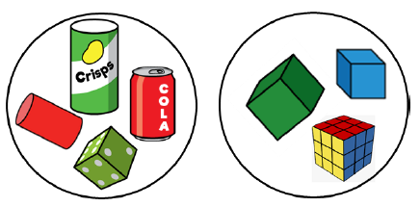
7.  Circle the shape which is not a triangle.  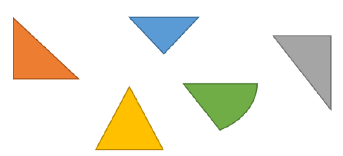 | 8.  Part of this shape is covered.  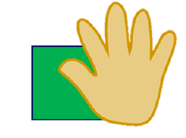  Tick all the possible answers.  