23.6.21  LO: I am learning to select, rotate and manipulate shapes for a particular purpose.  1. Has this shape been rotated?  What is this shape? | 5. Ella wants to rotate this rectangle. Use a ruler to draw the rotated rectangle.
2. 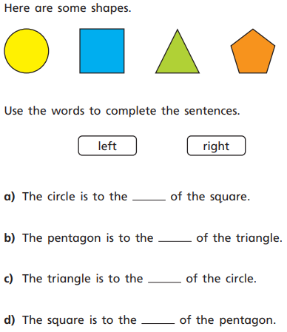 | 6. What is this shape?  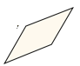_________________  Draw the shape in a different rotation with a ruler.
3.  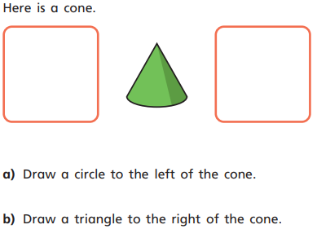 | 7. a) Can you put these shapes together to make a new shape?  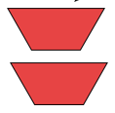  b) Draw the new shape with a ruler.  c) What is the new shape?
4. Use a ruler to draw a cone upside down. | 8. GDS Miss Adler says, “I can make a square out of two triangles.” Is she correct? Prove it!

24.6.21  1G–2 LO: I am learning to compose 2D and 3D shapes from smaller shapes.  1. What 2d shape could you make out of these two shapes?  ______________ | 5. Evie has made a building. She has used four 3d shapes. What are their names?  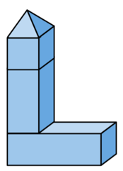
2. What shape could you make if you put these three cubes together? | 6. What shape could you make with all of these triangles?  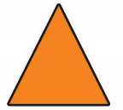
3. Draw another triangle onto this to make a diamond.  _____________ | 7. Louie says, “I can make a square out of two of these shapes.”  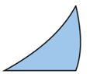  True or false?  Prove it!
4. Using a ruler, draw a picture using these shapes. | 8. GDS Joshua has these shapes. Which is the odd one out?  Explain your answer.  Which shape does not stack?

