__________________
L.O – I am learning to subtract
numbers – not crossing ten
1.Solve these.  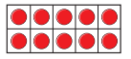  Use the counters if you get stuck.  10 - 1 =  10 - 2 =  10 - 3 =  10 - 4 =  10 - 5 =  10 - 6 =  10 - 7 =  10 - 8 =  10 - 9 = | 5. Subtract 3 from this number.  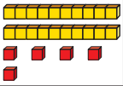  Write the sum you have completed.
2. Solve these subtractions.  15 - 1 = 17 – 2 =  34 - 2 = 34 – 1 =  65 - 3 = 46 – 2 =  77 - 4 = 47 – 5 = | 6. Ella has some balloons. She gives two packs away. How many will she still have?  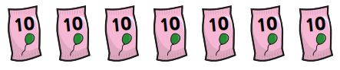
3. True or false?  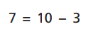  Explain your answer. | 7. Complete the missing number.  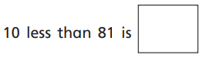
4. Samuel has completed this.  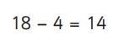  Is he correct?  Prove it. | GDS  How many different subtraction sums can you make using these cards?  Solve your sums.  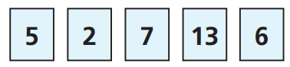

__________________
L.O – I am learning to subtract
numbers – crossing ten
1.Quickly solve these.  16 - 1 = 16 – 2 =  35 - 2 = 24 – 1 =  35 - 3 = 48 – 2 =  57 - 4 = 49 – 5 = | 5. True or false?  46 – 17 = 39  Show your workings out.
2. Use column subtraction to solve these sums.  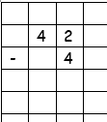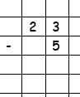 | 6. How can you subtract 25 from 53?  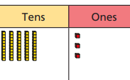  Show your workings out.
3. Solve this using column subtraction.
35 – 8 =

4. True or false?
Miss Adler says you can take 2 from this number.
Is she correct?
How could you solve the sum?
