Class 4 Homework Grid Autumn Term 2021 Forests
Choose one activity to complete each week. Some activities might need more than one week for you to complete.
Make a list of the different animals that live in the woods.  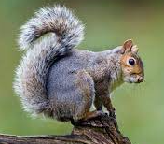 | Go on a walk and see how many different trees you can spot and name.  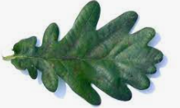 | Collect leaves to make a collage.  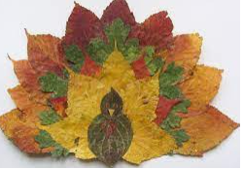 | Write a story that is set in a forest.
Write a poem about a woodland animal.  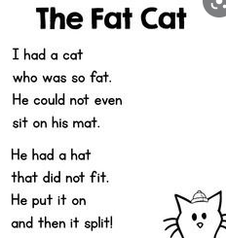 | Paint a forest picture. | Make a model of a forest.  You could also include some forest animals.  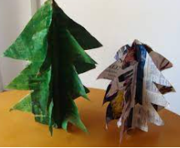 | Write a fact file about a woodland animal.  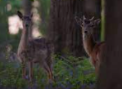
Science Challenge  Can you describe the life cycle of an oak tree?  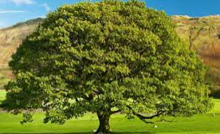 | Geography Challenge  Are all forests the same around the world? | History Challenge  How have forests helped people to survive in the past?  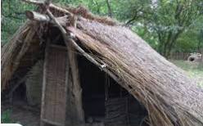 | Reading Challenge  How many stories can you read that are set in a forest?  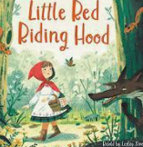
Homework in Class 4
Reading
Please read at home x5 a week. Remember to talk about what you have read and to discuss any new vocabulary. This really helps to improve your child’s understanding of what they have read. Please remember to sign the reading record every time you listen to your child read. We will count the number of reads at home up to give out reading tokens and keyrings. Once your child has finished a book they can complete a quiz on the book at school. If they score 100% then they can more onto the next level of text.
All quizzes that are passed (over 60%) go towards your child’s total number of words read.
Reading books and Reading Records need to be in school daily.
Spellings
These will be given out weekly to go into the homework books. The words link to the spelling unit that we are currently working on in school in our RWI spelling sessions.
Sums
Each week there will be some arithmetic questions to practise. These help to ensure that your child remembers how to solve different types of sums and to improve the pace and accuracy of their maths.
Homework Grid
Please choose activities to complete at home. You can put work into the homework book or take photos and stick these into the book.

Homework Books- These need to be in school every Monday, ready to put the new spellings and sums in.
If you have any questions about homework then please ask at the end of the day.
Many thanks Mrs Ashley

