LO: IALT recognise and use equivalent fractions
Question 1  What is an equivalent fraction?  TRUE or FALSE  I think 3/6 is the same as ½ | Question 2  Write down and draw 3 equivalent fractions for 1/4
Question 3  Write 3 equivalent fractions for 4/8  I think 84/42 is an equivalent fraction to 4/8. I am correct? Prove it | Question 4  Mr Easter has 1/5 of a pineapple. Mrs Light has 2/10.  I think they have the same amount of pineapple.  Do you?
Question 5  8/16 is the same as a half....isn't it?  Prove it | Question 6  Fill in the gaps  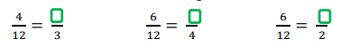
Question 7 (ncetm)
GDS
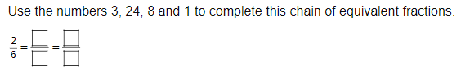

Question 8  GDS  Finish the sequence..  ½....2/4 ...4/8....8/16....?......?.......? | Question 9  GDS  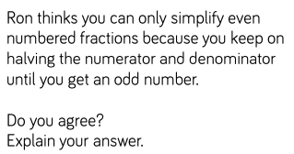
Question 10 (ncetm)  GDS  Draw lines to match the unit fractions on the left to their equivalent fractions on the right.  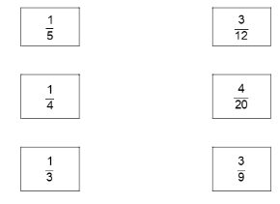 | Question 11  GDS  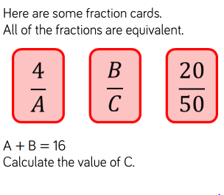
Question 12 (ncetm)
GDS
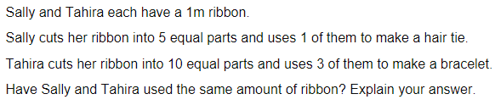

Question 13 (ncetm)
GDS