W/C: 12.10.20 Learning Project – People Who Help us
Age Range: EYFS
Weekly Reading Tasks | Weekly Phonics Tasks
Monday- Charlie the Firefighter (twinkl ebook) | Monday- RWI introduce the sound c  Recap m a s d t i n p g  Fred talk dig, din, got, dog, sad
Tuesday – Show Maisie, Charley and the wobbly tooth (youtube story)  https://www.youtube.com/watch?v=L1j8lELuQjc | Tuesday- RWI introduce the sound k  Recap m, a, s, d, t, I n p g c  Fred talk cat pig cod tap dog
Wednesday – Topsy and Tim go to the hospital  https://www.slideshare.net/bichvanchau/hospital-48213010 | Wednesday- RWI introduce the sound u  Recap m, a , s, d, t, i, n, p, g, c, k  Fred talk bpg, pop, cot, kit,
Thursday- Paula the Vet a story by Julia Donaldson  https://www.youtube.com/watch?v=gPjtnWMaYh4 | Thursday- RWI introduce the sound b  Recap m a s d t i n p, g, c, k, u  Fred talk pat, tan, tap, top, cup, kip,
Friday- Big Book about People who help us? | Friday- RWI introduce the sound f  Recap m a s d t i n p g c k u b  Fred talk pan, tin, sad, mat, tip, big, pat
Weekly Writing Tasks | Weekly Maths Tasks
Monday- Sorting activity – People who help us Rectangles  Writing their name daily  Writing the sound of the day  Writing labels for their models | Monday- https://www.bbc.co.uk/iplayer/episode/b08cr24d/numberblocks-series-1-how-to-count  https://www.ncetm.org.uk/media/bu0fvnpz/series_01_episode_10_numberblocks-support-materials_how_to_count_august_2018.pptx  Circles  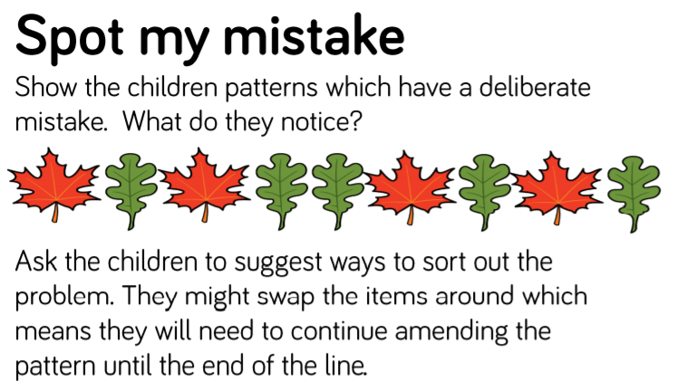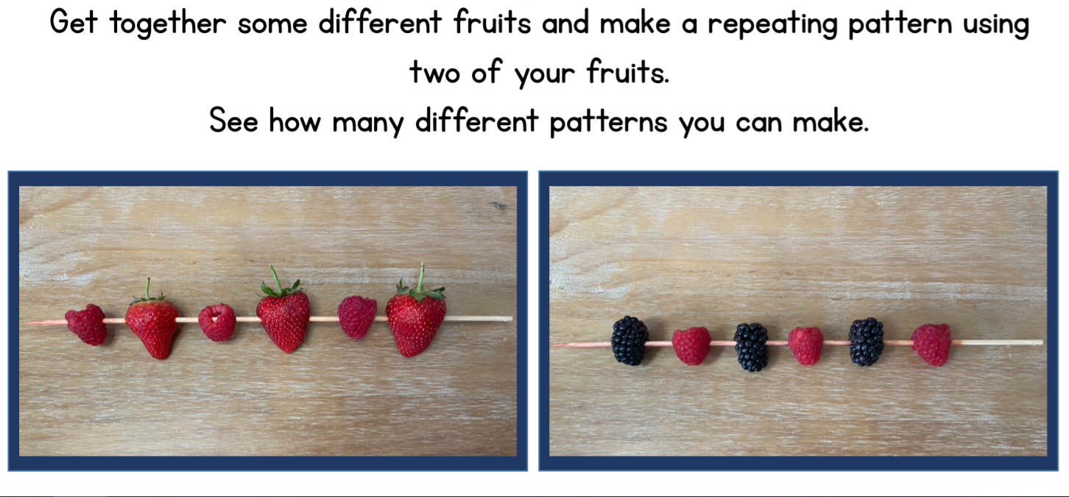
Tuesday- Sorting activity – People who help us Triangles  Writing their name daily  Writing the sound of the day  Writing labels for their models | Tuesday- https://www.bbc.co.uk/iplayer/episode/b08dnngm/numberblocks-series-1-stampolines  https://www.bbc.co.uk/iplayer/episode/b08dnngm/numberblocks-series-1-stampolines  Patterns Spot my mistake and fruit patterns?  Squares
Wednesday- Sorting activity – People who help us Squares  Writing their name daily  Writing the sound of the day  Writing labels for their models | Wednesday Maths activities in busy time due to PPA
Thursday- Sorting activity – People who help us Circles  Writing their name daily  Writing the sound of the day  Writing labels for their models | Thursday- https://www.bbc.co.uk/iplayer/episode/b08dr1l3/numberblocks-series-1-the-whole-of-me  https://www.ncetm.org.uk/media/2s1iniu3/series_01_episode_12_numberblocks-support-materials_the_whole_of_me_september_2018.pptx  Patterns Spot my mistake and fruit patterns?  Rectangles
Friday- Funky Finger Friday | Friday- https://www.bbc.co.uk/iplayer/episode/b08dr1l3/numberblocks-series-1-the-whole-of-me  https://www.ncetm.org.uk/media/2s1iniu3/series_01_episode_12_numberblocks-support-materials_the_whole_of_me_september_2018.pptx  Patterns Spot my mistake and fruit patterns?  Triangles

Busy Time - to be done throughout the week
Enhanced Continuous Provision Plan for Reception (‘Busy Time’) - Week Beginning: 12.10.20
Builders, Postman, Firemen, Hospital, Hairdressers

AREA | OBJECTIVE | ENHANCEMENT
Small World Area | AOL: Communication and language: Speaking  EAD Being imaginative  OBJ: I am learning to introduces a storyline or narrative into their play.  I am learning to use available resources to create props to support role play.  FOCUS: At the Builders – children create a building site using diggers, blocks, stones, pebbles. Have builders hats to wear when using this area. (3 children)
Malleable | AOL: Physical Development: Moving and handling  OBJ: I am learning to handle tools, objects, construction and malleable materials  safely and with increasing control.  FOCUS: Have mouths with different numbers on. Children make the correct amount of teeth to go inside the mouth.  Playdough face and bodies – using pasta, pipecleaners, beads, googly eyes etc.. to make faces and clothes for different people.
Writing area  linked from Assessment. | AOL: Literacy: Reading  OBJ: Recognises familiar words and signs such as own name and advertising logos.  I am learning to use one-handed tools and equipment  FOCUS: Cut out outfits for different people who help us and stick on people.  Write some sounds or words onto white paper using white wax crayons. Invite children to become police officers and look for clues to read the sounds or words by painting over the top with watery paint.  Using Magnifying glasses to read small words and copy them onto whiteboards.
Creative Table  Linked from child interest – | AOL: EAD Exploring and using media and materials  OBJ: I am learning to manipulate materials to achieve a planned effect.  I am learning to experiment to create different textures.  FOCUS: Hairdresser craft – cut the hair of the person and add the face  Paint different vehicles Ambulance, police car.  5 little fireman handprint
Maths area  Linked from  Assessment – | AOL: Mathematics: SSM  OBJ: Uses familiar objects and common shapes to create and recreate patterns and build models.  FOCUS:
Role Play  Home Corner | AOL:EAD Being Imaginative  OBJ: I am learning to engage in imaginative role-play based on own first-hand  experiences.  FOCUS: Toy Hospital. Have different types of toys that need looking after.  Have bandages, stethoscope, and other dr kit objects.  Have paper on clipboards to record what toys come into the hospital.
KUW | AOL: PSED health and self care  OBJ: Shows some understanding that good practices with regard to exercise, eating, sleeping and hygiene can contribute to good health.  FOCUS: Sort different foods into health lunchboxes – healthy and not healthy.  DO follow up activity – sticking food in different
ICT  Link with Maths | AOL: KUW:Technology and Mathematics  I am learning to counts objects to 10, and beginning to count beyond 10.  OBJ: I am learning to operate simple equipment.  FOCUS: Topmarks games | IPADs  Topmarks
Outside | AOL: EAD Being Imaginative  OBJ: I am learning to introduce a storyline or narrative into my play.  FOCUS: Use planks, foam bricks, cement mixer, hard hats, signs and wheelbarrows to make a building site. Clipboards to draw plans of what they are building.  Create an obstacle course around the outside area for children to complete their ‘firefighter training’ using the bikes.
Music | AOL: EAD Exploring and using media and materials  OBJ I am learning to sing a few familiar songs.  FOCUS: Listening to traditional songs on the CD player  Playing with the musical instruments on the stage | Cd Player  Songs

STEM Learning Opportunities #sciencefromhome

