Summer Term Homework challenges
Homework will be given out on a Tuesday and returned by the following Monday.
The children will receive Maths and Spellings each week.
This will be based on the work that the children have done during the week.

Castles- Changes to daily life
During this term, please complete as many of these tasks as you would like.
When you complete one, either stick it in your homework book (pictures/photos) or bring in something to show us! Once a challenge is complete, ask an adult to sign it.

Use the internet to find a picture of the castle of your dreams!  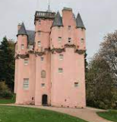 | Make or copy a maze for a mouse to find the cheese in the middle.  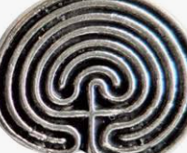 | Can you list all the castles in Cornwall?  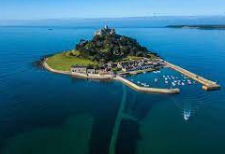
Design and make a shield with a symbol to represent your family.  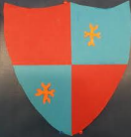 | Find out about your family history. Draw a simple family tree. | Bring in your favourite book which has a castle in it.  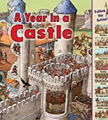
Think of a nasty recipe to feed your enemies! Give it a name and list the ingredients. | Make a crown for you to wear in our Royal Cafe.  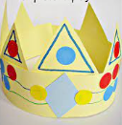 | Make a sandcastle on the beach and send a photo into school.  