LO: I am learning to simplify fractions

Question 1  What does simplify a fraction mean?  Full mathematical sentences | Question 2  Lowenna thinks that 4/6 in its simplest form is 1/1.5  Is Lowenna correct?  Explain your answer.
Question 3
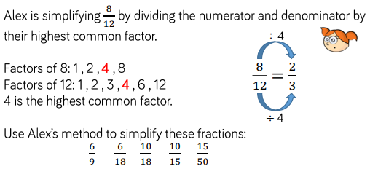

Question 4  Is a simplified fraction always equivalent to the original fraction?  Prove it | Question 5  Simplify the following fractions:  a, 14/24 b, 12/16  c, 6/15 d, 20/45  d, 72/? = 9/10 e, ?/24 = ¾
Question 6  Which fraction can be simplified to 5/8 and has a denominator of 40?  Show me | Question 7  Circle the fraction that is not equivalent to the other fractions  - 5/15 15/45 10/20 20/60  - 12/18 120/180 18/24 24/36
Question 8
GDS
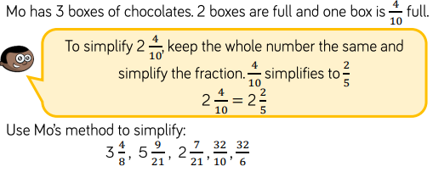
Question 9  GDS  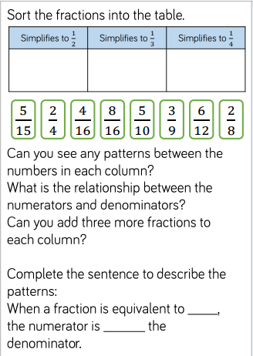 | Question 10  GDS  Calculate the missing values, simplify if you can?  2 + ? = 2/3  3 + 12  2 + 8 = 2/5  3 + ?  5 + ? = ¾  3 + ?  2 + 14 = ?/?  3 + 17

