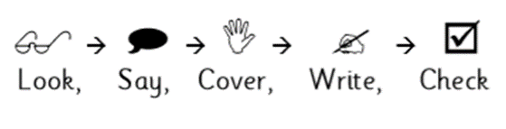
Weekly Spelling

Date: | Monday | Tuesday | Wednesday | Thursday | Friday
doubt
island
lamb
thistle
knight
ghost
whole
wrap
Sneaky silent letters
Weekly Spelling

Date: | Monday | Tuesday | Wednesday | Thursday | Friday
preferred
preffering
transfer
transferred
offer
offering
prefer
transferring
Suffixes- fer
Weekly Spelling

Date: | Monday | Tuesday | Wednesday | Thursday | Friday
aggresive
available
familiar
profession
soldier
interfere
desperate
equipment
Word list
Weekly Spelling

Date: | Monday | Tuesday | Wednesday | Thursday | Friday
absense
fluency
efficiency
vacancy
fragrance
confidence
excellence
frequency
ant, –ance/–ancy, –ent, –ence, –ency
Weekly Spelling

Date: | Monday | Tuesday | Wednesday | Thursday | Friday
believeable
adoreable
considerable
responsibly
reliable
gullible
inflatable
flexibly
able and ible
Weekly Spelling

Date: | Monday | Tuesday | Wednesday | Thursday | Friday
cried
replied
exclaimed
whispered
muttered
murmerred
sighed
complained
Synonyms for ‘said’
Weekly Spelling

Date: | Monday | Tuesday | Wednesday | Thursday | Friday
entrance
exit
exterior
interior
arrogant
humble
afraid
confident
Antonyms
Weekly Spelling

Date: | Monday | Tuesday | Wednesday | Thursday | Friday
government
frequently
harass
programme
necessary
temperature
signature
rhyme
Word list
Weekly Spelling

Date: | Monday | Tuesday | Wednesday | Thursday | Friday
vehicle
thorough
vegetable
stomach
rhythm
leisure
language
especially
Word list
Weekly Spelling

Date: | Monday | Tuesday | Wednesday | Thursday | Friday
morning
afternoon
together
communicate
identity
intermediate
children
outside
High frequency and word list
Weekly Spelling

Date: | Monday | Tuesday | Wednesday | Thursday | Friday
intermediately
birthday
follow
environment
between
began
after
before
High frequency and word list
Weekly Spelling

Date: | Monday | Tuesday | Wednesday | Thursday | Friday
garden
goes
gone
heard
together
sister
brother
family
High frequency

