29.3.21  LO: I am learning to compare numbers  using <, > and =.  1. Write the missing phrase.  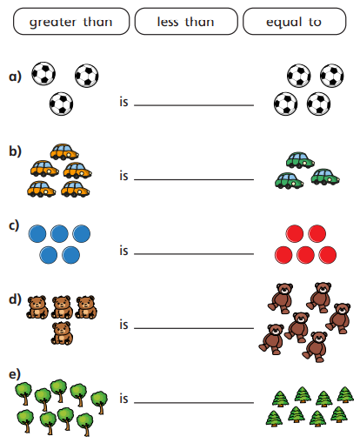 | 4.  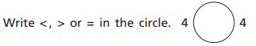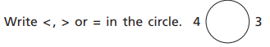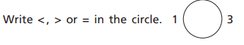
5.
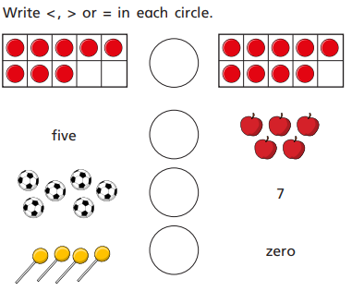
2. Write < > or = between the cubes.  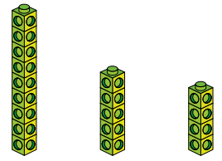 | 6. Jenna thinks this picture shows  5 < 6.  Is she correct?  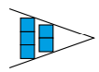  Draw the correct picture to explain why.
3. True or false?  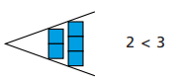___________  8. GDS  Circle all the numbers that cannot go in the box. Explain why.  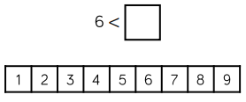 | 7. Circle the true statement. Then make the others correct.  7+3 > 10 2+8 = 6+4 10-2 < 6+2
8. GDS
Circle all the numbers that cannot go in the box. Explain why.
8. GDS  Circle all the numbers that cannot go in the box. Explain why. | 8. GDS  Circle all the numbers that cannot go in the box. Explain why.
8. GDS  Circle all the numbers that cannot go in the box. Explain why. | 8. GDS  Circle all the numbers that cannot go in the box. Explain why.
8. GDS  Circle all the numbers that cannot go in the box. Explain why. | 8. GDS  Circle all the numbers that cannot go in the box. Explain why.

30.3.21  1NPV–1 LO: I am learning to count backwards within 100, starting with any number.  1. Count backwards from 9.  Use the counters to help you.  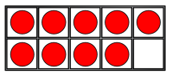  9 | 4. Complete the number tracks.  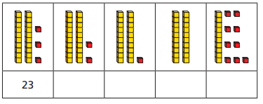  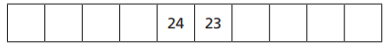
2. Samuel has some dominoes.  Fill in the missing numbers.  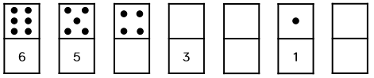 | 5. Sam is counting.  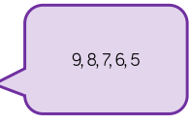  How do you know he is counting backwards?
3. Count backwards from this number.  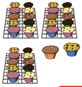  29 32 | 6. Reuben is counting backwards from 103.  Circle his mistakes and write the correct number track below.  103 112 111 100 99 89 97 96 95
8. GDS  Put these numbers in order from largest to smallest.  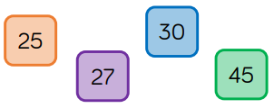  largest_________________smallest  Which number is the odd one out? Why? | 8. GDS  Put these numbers in order from largest to smallest.  largest_________________smallest  Which number is the odd one out? Why?
8. GDS  Put these numbers in order from largest to smallest.  largest_________________smallest  Which number is the odd one out? Why? | 8. GDS  Put these numbers in order from largest to smallest.  largest_________________smallest  Which number is the odd one out? Why?
8. GDS  Put these numbers in order from largest to smallest.  largest_________________smallest  Which number is the odd one out? Why? | 8. GDS  Put these numbers in order from largest to smallest.  largest_________________smallest  Which number is the odd one out? Why?

31.3.21  1NPV–1 LO: I am learning to count forwards within 100, starting with any number.  1. Complete the number tracks.  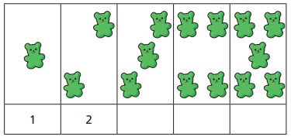  6 8 | 4. Order these numbers from smallest to largest.  14 48 114 84 103  _______, ______, _______, ______, _____
2. Finish the sequence.  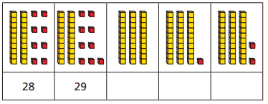  33 35 | 5. Parker counts backwards from 50 in 2s.  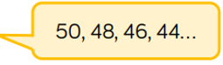  Ella counts forwards from 12 in 2s.  Who will get to 30 first? _________
3. Count forwards to complete the number track. | 6. Isabelle is counting forwards in twos.  4 8  Will she say 25?  Explain your answer.  7. GDS.  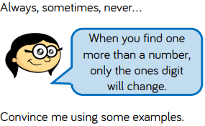
7. GDS.
7. GDS. | 7. GDS.
7. GDS. | 7. GDS.
7. GDS. | 7. GDS.

18.3.21
LO: I am learning to read and write
numerals to 20 in words.
1.  Write these numbers in words. 3_______________  13_______________  Which is the biggest? How do you know? | 5. Miss Adler says that twenty-one is less than 12.  Is she correct?  Draw Base 10 to prove it.
2. Order these numbers from smallest to largest.  thirteen, one, ten,  ___ ___ ___ | 6. Write these numbers in words.  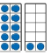  16
3. Write these numbers in words  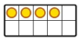_________  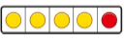___________  ___________ | GDS  Which is the odd one out?  14  eighteen  fourteen  19  Is there more than one answer?
4. Tick the numbers that match.  nineteen  9  seventeen  19 | GDS:  Draw these numbers using Base 10 and tens frames.  17 11 12 20 16

Tues
1  Make these numbers using place value counters.  Draw the counters you have used.  136  315  505 | 5.  True or False?  842 - 200 = 722 - 100  Show your workings out.
2.  Draw this number as Base 10  One hundred and sixty three  Write it as a number.  If you added 100, how much would you then have? | 6 Sophie has been ordering some numbers .  Is she correct?  345 456 464 752 725
- Complete this grid so that it shows 847  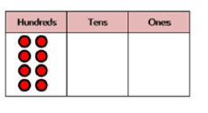  If you took 23 away what would you have? | GDS  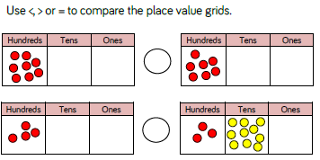
- Mrs Dyer says this is 301. Is she correct? Explain your answer.

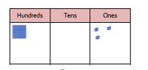

WED
- Ethan has been ordering some numbers.  71 117 171 701 771  Is he correct? Explain your answer | 5  Which is the most?  415  Seven hundred and eighty two  Four hundreds  852  Show your workings out.
- Use place value to counters to make these numbers  351  234  679 | - 6 Mrs Wick thinks this is 642.  Is she correct?  Prove it.
- This number is 456  Five hundred and sixty five  True or false?  Show your workings out. | GDS  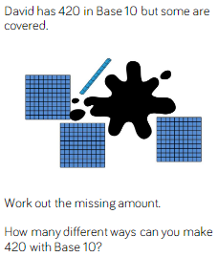
- Jenson says this grid shows 800. Ania says it has 80 in.

Who is correct?

How do you know?

WED
- Riley has been ordering some numbers.  116 161 16 160 601 106  Is he correct? Explain your answer | 5  Which is the most?  742  Three hundred and eighty one  Five hundreds  452  Show your workings out.
- Use place value to counters to make these numbers  521  248  189 | 6 Ania thinks this is 932.  Is she correct?  Prove it.
- This number is 673.  Six hundred and thirty seven  True or false?  Show your workings out. | GDS  Sophie has 6 coins in her money box.  How much could she have?  What is the most?  What is the least?  Draw as many different amounts as you can.
- Complete the grid so it shows 836

How much would you have if you took 300 away?

How do you know?

