W/C: 16.11.20 Learning Project – Diwali
Age Range: EYFS
Weekly Reading Tasks | Weekly Phonics Tasks
Monday- Read the story of Rama and Sita from Twinkl  https://www.twinkl.co.uk/resource/t-t-14391-the-story-of-rama-and-sita-ebook  Who are Rama and Sita?  How many heads did Ravana have?  Who helped Rama find Sita? | Monday- RWI introduce the sound ‘ng’  Recap m a s d t i n p g c k u b f e l h  Fred Talk thing sing wing king
Tuesday – Watch the CBeebies animation of Rama and Sita  https://www.bbc.co.uk/cbeebies/stories/lets-celebrate-diwaliperformance?scrlybrkr=c77e420f  Talk about their favourite parts. | Tuesday- RWI introduce the sound nk  Recap m a s d t i n p g o c k u b f e, l, h, sh  Fred talk think sink wink stink
Wednesday – Look at the EYFS Diwali ppt. Link Diwali with Rama and Sita and why the story is important.  https://www.twinkl.co.uk/resource/t-t-12337-eyfs-diwali-powerpoint | Wednesdays - RWI phonics  Group 1 KL sounds m a s d t  Group 2 NP sounds practice m a s d t 1.1 word time magnetic letters  Group 3 KL sounds practice ma s d t 1.1. word time read words.
Thursday- Reread the story of Rama and Sita from Twinkl  https://www.twinkl.co.uk/resource/t2-r-101-the-story-of-rama-and-sita-powerpoint  Who are Rama and Sita?  How many heads did Ravana have?  Who helped Rama find Sita? | Wednesdays - RWI phonics  Group 1 KL sounds m a s d t  Group 2 NP sounds practice m a s d t 1.1 word time magnetic letters  Group 3 KL sounds practice ma s d t 1.1. word time spell words.
Friday- Read Dipal’s Diwali  https://www.twinkl.co.uk/resource/dipals-diwali-ebook-t-or-2028  Talk about the story  What have they learnt about Diwali? | Wednesdays - RWI phonics  Group 1 KL sounds m a s d t  Group 2 NP sounds practice m a s d t 1.2 word time magnetic letters  Group 3 KL sounds practice ma s d t 1.2. word time spell words.
Weekly Writing Tasks | Weekly Maths Tasks
Monday  Red Group  Rama and Sita  L.O: I am learning to sequence a story.  As a group order the four pictures on a large sheet of paper. Talk about the story. Which picture would come first? Then what happens?  Talk a photo and stick in English books. Number the pictures 1 - 4 | Monday- Watch Numberblocks Episode – Series 1 four  Give each child 4 multilink. How many ways can they make 4. Give them time to explore all the different ways.  Purple group –  How many different ways can you make octoblock? Explore all the different ways. Check with their partner. See if they have made the same shape by moving it around.
Tuesday-  Blue Group  Rama and Sita  L.O: I am learning to sequence a story.  As a group talk about the story of Rama and Sita. Show them the 4 pictures. What picture came first in the story? Then what happened? What happened at the end?  Children then cut out the pictures and put them in order in their English books.  T to number the pictures 1 - 4 | Tuesday – Watch Numberblocks Episode- Series 1 off we go  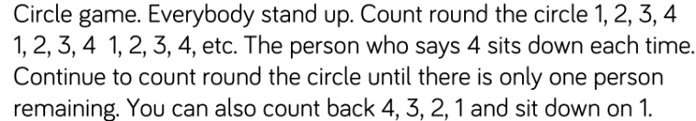  Green Group –  How many different ways can you make five out of multilink?  Explore all the different ways. Check with their partner and see if they have made the same shape by moving it around.
Wednesday-  Green Group  Rama and Sita  L.O: I am learning to sequence a story.  As a group talk about the story of Rama and Sita. Show them the 4 pictures. What picture came first in the story? Then what happened? What happened at the end?  Children then cut out the pictures and put them in order in their English books.  Children to number the pictures 1 – 4  Model the language of first, then, next, in the end. | Wednesday - Watch Numberblocks Episode – Series 1 How to count
Thursday-  Purple group  Rama and Sita  L.O: I am learning to sequence a story.  Rama and Sita  L.O: I am learning to sequence a story.  As a group talk about the story of Rama and Sita. Show them the 4 pictures. What picture came first in the story? Then what happened? What happened at the end?  Children then cut out the pictures and put them in order in their English books.  Children to number the pictures 1 – 4  Model the language of first, then, next, in the end.  Can they write a word for each picture?  Can Maia write a short sentence? | Thursday- Watch Numberblocks Episode – Series 1 Five  Five  Sing 5 little men in a flying saucer  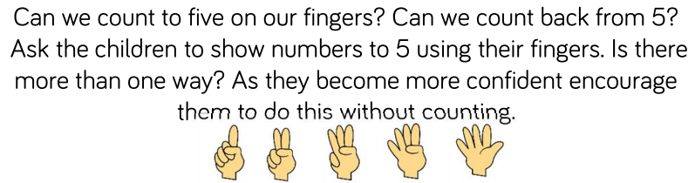  Blue group Yellow  How many different ways can they make 5 out of multilink?  Explore all the different ways. Check with their partner and see if they have made the same shape by moving it around.
Friday-  Yellow Group  Rama and Sita  L.O: I am learning to sequence a story.  As a group talk about the story of Rama and Sita. Show them the 4 pictures. What picture came first in the story? Then what happened? What happened at the end?  Children then cut out the pictures and put them in order in their English books.  T to number the pictures 1 - 4  Funky Finger Friday | Friday- Watch Numberblocks Episode – Series 1 Hide and seek  Five  Have a feeling bag filled with cubes. Ask the children to predict how many cubes you can collect with one handful. Grab a handful and then lay them down one by one so the children can see how many.  Ask who else would like to try. Can they hold the same as you? Try again. Do they get the same amount each time?  Red group  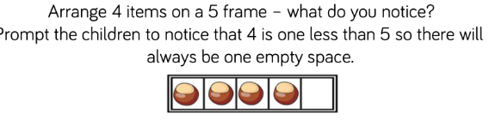  Try now with 5 objects. How do we know there are 5 objects?

Enhanced Continuous Provision Plan for Reception (‘Busy Time’) - Week Beginning: 16/11/20 India (Diwali)

AREA | OBJECTIVE | ENHANCEMENT
Small World Area | AOL: Communication and language: Speaking  EAD Being imaginative  OBJ: I am learning to introduces a storyline or narrative into their play.  I am learning to use available resources to create props to support role play.  FOCUS: Have stick puppets and puppet theatre to act out the story | 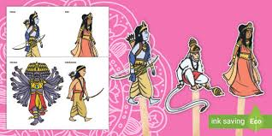
Malleable | AOL: Physical Development: Moving and handling  OBJ: I am learning to handle tools, objects, construction and malleable materials safely and with increasing control.  FOCUS: Add some small world monkey toys to a tray full of gloop. Challenge children to rescue the monkeys using large tweezers. | - Gloop and Monkeys  - Tweezers
Writing area  linked from Assessment. | AOL: Literacy  OBJ: I am learning to hear and say the initial sound in words.  FOCUS: Write Diwali cards using templates – draw pictures of lamps on the front  Writing menus in the restaurant  Sorting objects and magnetic letters into different sounds.  M,a,s,d,t, I, n, p,g,o  Draw some lines and patterns onto paper and challenge children to place pom-poms, stickers or coloured gems along the lines as a path for Rama to follow to find Sita. | Diwali card templates and words  Blank Menus in restaurant  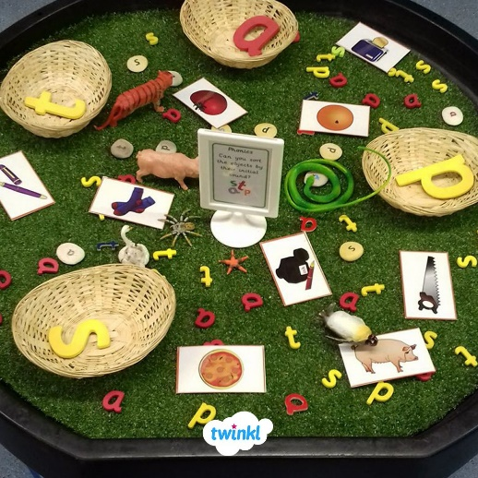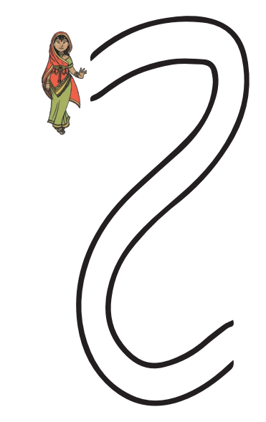
Creative Table  Linked from child interest – | AOL: EAD  OBJ: I am learning to experiments to create different textures.  I am learning to understand that different media can be combined to create new effects.  FOCUS: Diva Lamps – made from salt dough, leave to dry and then paint and glue glitter and gems on them.  Mehndi hand patterns, Rangoli pattern sheets to colour in  Rangoli patterns – mix salt and different coloured paints together – leave to dry. Then on a plain white plate cover with glue and sprinkle coloured salt on different sections to make patterns. | 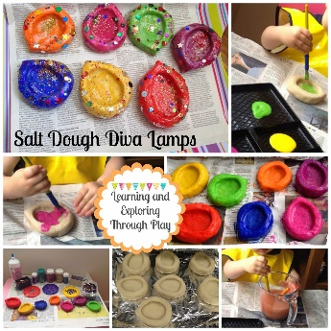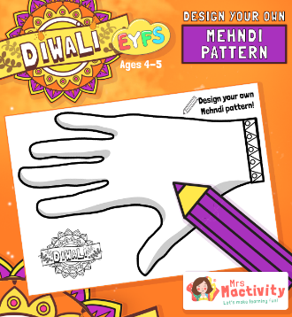  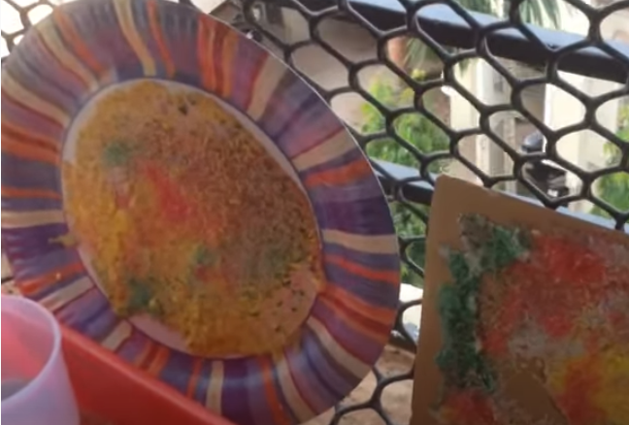
Maths area  Linked from  Assessment – | AOL: Number  OBJ: I am learning to recognises numerals 1 to 5.  I am learning to count up to three or four objects by saying one number name for each item.  FOCUS: How many ways can you make 4 or 5 using multilink.  Make birthday cakes using playdoh and put 1-5 candles on and find the correct number card to go with. | 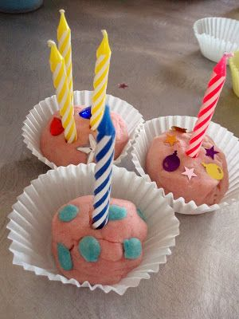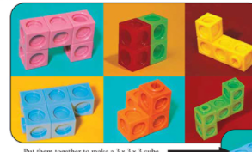
Role Play  Home Corner | AOL:CLL  OBJ:I am learning to introduce a storyline or narrative into their play.  FOCUS: Indian Restaurant  Take orders, cook food, set the table, make menus, | 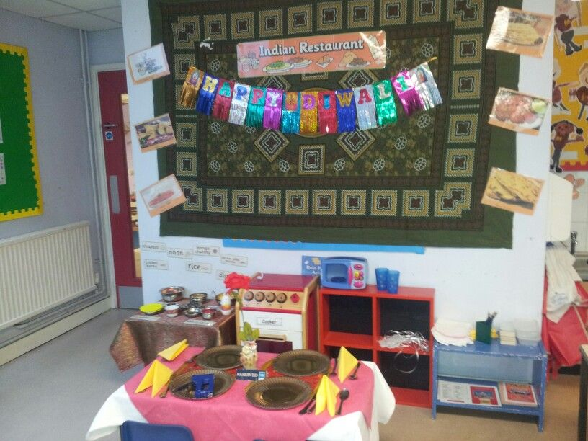
Construction | AOL: KUW CLL  OBJ:FOCUS: Children use a variety of sturdy blocks to build a bridge just like the animals did in the Rama and Sita story | Wooden blocks in the outside area.
Funky Fingers | AOL: PD  OBJ:  FOCUS: Using Pasta and rice to create pictures of Rangoli patterns. Draw on a tuff spot with chalk – either children draw their own or adult draw for them to fill in.  Using pegboard to recreate patters on the boards – Rangoli patterns | 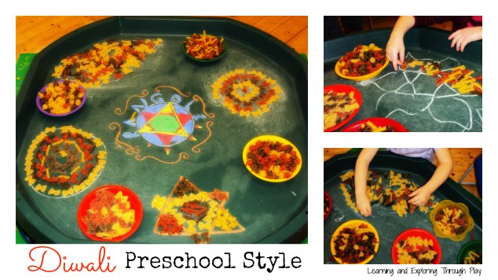  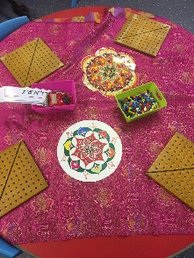
ICT  Link with Maths | AOL: KUW: Technology  OBJ: I am learning to interact with age-appropriate computer software  FOCUS: Caterpillar numbers | 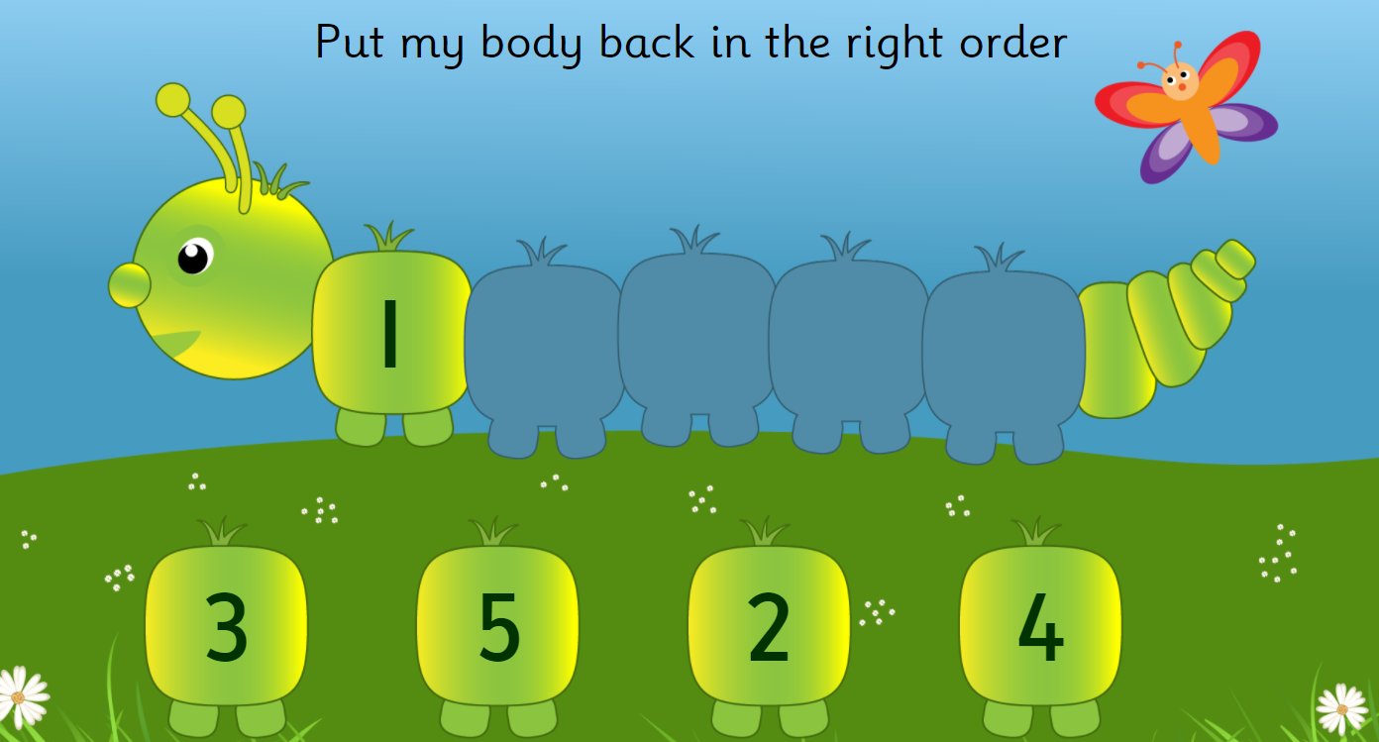
Outside | AOL: KUW, Mathematics  OBJ:  FOCUS: Using Chalk to draw rangoli patterns on the floor.  In water tray have water beads and different sized containers to fill up.
Music | AOL: EAD: Exploring and using media and materials  OBJ I am learning to explores the different sounds of instruments.  FOCUS: Listen to Indian music and play xylophones and bells

