Day 0ne Fact families + and – bonds to 20
- Solve these sums.  10 + 2 =  6 + 6 =  10 + 3 =  5 + 5 =  7 + 6 =  - + 2 = | 5. Complete the number sentences for the part part whole model.  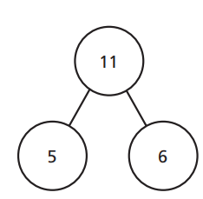  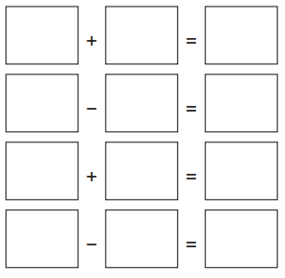
- Solve these sums.
10 - 1 =
6 - 3 =
10 - 3 =
15 - 5 =
17 - 6 =
19 - 2 =
- Complete the calculation.  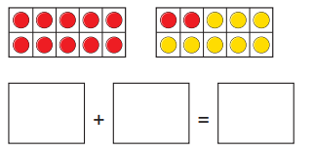 | 6. Circle any incorrect calculations.  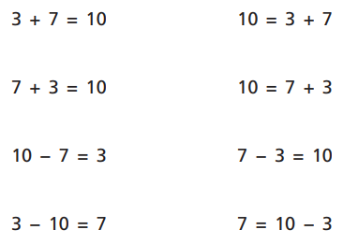  Write in the correct answers.
- Write four calculations using these counters. 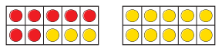 | GDS  The answer is 20.  What could the sum be?  Write as many as you can.

7.10.20
LO: I am learning to check calculations in
addition and subtraction.
- Solve these calculations. Remember to check your answer.  11 + 2 =  8 + 6 =  12 + 3 =  5 + 10 =  - + 4 = | - Sarah has a bag of sweets. 8 are red and 3 are yellow.  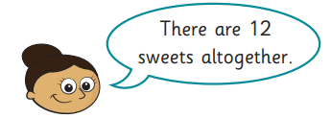  Is Sarah correct?  How do you know?
2.Mrs Edwards has been doing some sums. Mark her work.  16 + 2 = 18  7 + 6 = 12  17 + 3 = 20  15 - 10 = 5  16 - 4 = 11  Correct any answers that are wrong. | - Mrs Edwards has written some sums using this bar model. Is she correct?  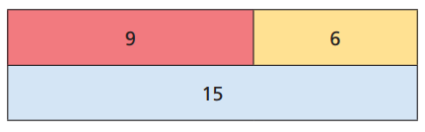  9 – 6 = 15 9 + 6 = 15  15 – 6 = 6 15 – 9 =6  Make any corrections that are needed.
- Draw counters to check this calculation.  14 + 5 = 19  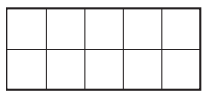 | GDS  Explain how you could check these calculations.  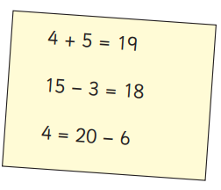
- True or false?
18-4 = 14
Explain how you know.

8.10.20  LO: I am learning to solve addition and subtraction problems using concrete resources.  1. Solve these calculations:  10 + =20  13 + =20  15 + =20  11 + =20  12 + =20  2. Solve these calculations:  20 – 8 =  20 – 11 =  20 – 6 =  20 – 13 =  20 – 4 = | - Sarah has a bag of sweets. 8 are red and 3 are yellow.  Is Sarah correct?  How do you know?
3. 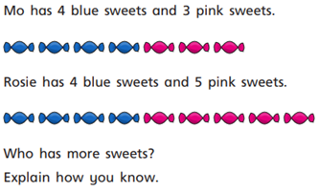 | - Mrs Edwards has written some sums using this bar model. Is she correct?  9 – 6 = 15 9 + 6 = 15  15 – 6 = 6 15 – 9 =6  Make any corrections that are needed.
4. | GDS  Explain how you could check these calculations.
- True or false?
18-4 = 14
Explain how you know.

