LO; I am learning to convert improper fraction to mixed numbers R
And mixed numbers to improper fractions
Question 1  What is an improper fraction?  What is a mixed number?  Explain fully using examples | Question 2  True or False  I have 4 ¾ cakes. I think that is 18 quarters (18/4).  What do you think?
Question 3
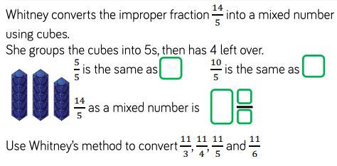

Question 4  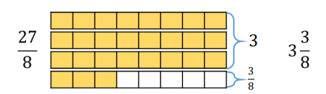  Ollie uses bar models to convert 27/8 which shows the mixed number answer as 3 3/8  Using the same method, what is:  a, 25/8 b, 27/6 c, 18/7  d, 32/4 | Question 5  Mark my work  Mrs Light thinks that 28/3 is less than 37/5 because 28 is less than 37.  Is Mrs Light correct?  Prove your answer
Question 6
GDS
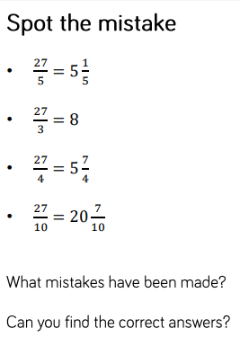
Mixed numbers to improper fractions

Question 1  How many halves, quarters, tenths, and eights are there in a whole? | Question 2  Can you explain the steps in converting an improper fraction to a mixed number? Use mathematical vocabulary; denominator, numerator, add, multiply.
Question 3
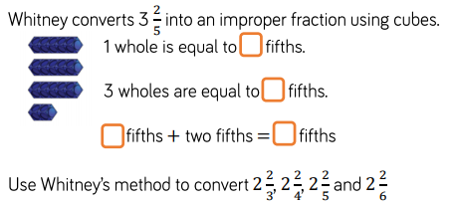

Question 4
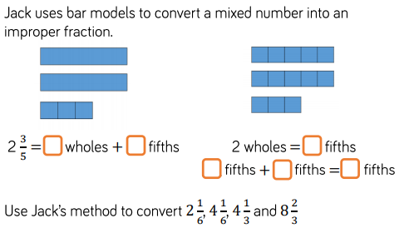

Question 5  GDS  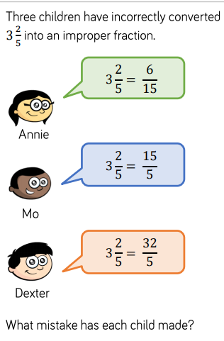 | Question 6  GDS  