Date:_________________
LO: I am learning to solve subtraction facts within 20.  1. Complete these calculations.  20 - 10 =____  20 - 9 =_____  20 - 8 =____  20 – 7 = ____  20 – 6 =_____ | 4.  What is the value of 3 in £38? _______  What is the value of 3 in £83? _______  Write the correct calculation  ______ + _______ =_______
2. Look at the picture.  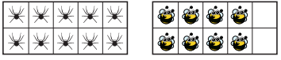  Complete the part-whole model and calculations.  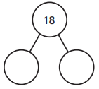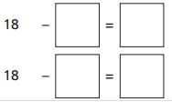 | 5. Mrs Thomas has eleven apples.  Samuel has five apples.  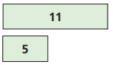  What is the difference between these numbers?  Write the calculation to prove it.
3. Layla baked fifteen cakes. Jacob ate six cakes. How many were left?  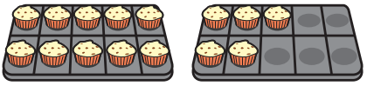  Write a calculation to show your answer. | 6. Joseph has seventeen animals on his farm. There are nine lambs.  The rest of the animals are cows.  How many cows are there?  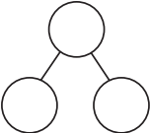  Show the part whole model and calculation.
4. Mason says:  20 – 12 = 7  True or false? | GDS Choose two cards to complete the calculation.  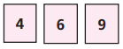  How many different subtractions can you make? Work out the answer to each one
Date:_________________ Date:_________________
LO: I am learning to solve addition facts within 20.  1. Complete these calculations.  10 + 10 =____  9 + ____ = 20  8 + 12 =____  7 + ____ = 20  6 + 14 =_____ | LO: I am learning to solve addition facts within 20.  1. Complete these calculations.  10 + 10 =____  9 + ____ = 20  8 + 12 =____  7 + ____ = 20  6 + 14 =_____
2. Use the bar model to help you complete the additions.  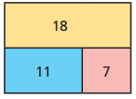  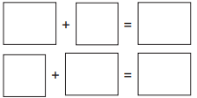 | 2. Use the bar model to help you complete the additions.
3. Complete the bar model.  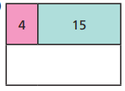  Complete the additions using the numbers in the bar model.  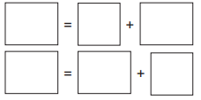 | 3. Complete the bar model.  Complete the additions using the numbers in the bar model.
4. Harry has 14 sweets. Finley has 6 sweets.  How many sweets do they have altogether?  Show the calculation in two ways. | 4. Harry has 14 sweets. Finley has 6 sweets.  How many sweets do they have altogether?  Show the calculation in two ways.

1.  Write these numbers in words.  425 _______________  __________________  880 _______________  __________________  Which is the biggest? How do you know? | 4.  Mrs Ashley says that 345 is more than 543.  Is she correct?  Prove it!
2.  Order these numbers from smallest to biggest.  145 236 713 999 432 10  ___ ___ ___ ___ ___ ___ | 5.  True or false?  268 < 781  Explain your answer.
3.  Use these three numbers how many different 3 digit numbers can you make?  4 7 1  What is the lowest number?  What is the highest? | . GDS  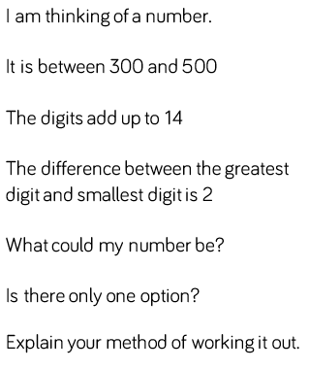

L.O- I am learning to count in 100’s
1.  Complete this sequence.  0 100 ___ 300 ___  500 ____ ____ 800 ___ 1000 | 5.  Convert these amounts from pounds to pence.  £1.00 = _______  £2.00 = _______  £3.00 = _______  £4.00 = _______
2.  What is 100 more than each number?  100 ____  500 ____  600 ____ | 6.  Which would give you more?  345 + 200 or 400 + 256  Show your workings out.
3.  What is 100 less than each number?  300 ____  900 ____  600 ____ | GDS  Amelie has been collecting £1.00 coins. She has 17 in her piggy bank and then is given another £12.00 for her birthday.  How much does she have in total?
4.  Look carefully at these sequences and add in the missing numbers.  200 ___ 400 ___ ___  900 ___ 700 600 ___ | GDS  The answer is 300.  What could the sum be?

1.  Complete this sequence.  0 100 ___ ___ 400  105 ___ 305 ___ 505  ___ 217 317 ___ ___ | 5.  Which would give you the least?  375 - 200 or 689 - 100  Show your workings out.
2.  What is 100 more than each number?  519 ____  214 ____  275 ____ | 6.  If you are counting in hundreds the ones number always stays the same.  True or false?  Explain your answer.
3.  What is 100 less than each number?  565 ____  860 ____  246 ____ | GDS  How many different ways can you find to make £6.00 using only £1.00 and £2.00 coins?
4.  True or false?  456 is 100 more than 446  Explain your answer. | GDS  Sarah has 12 pound coins. She spends £5.00 on ice creams for her family.  How much does she have left?  How many different ways can you draw her change?

Solving problems
1. Write the following set of numbers in order.  345, 278, 301, 287, 368  Explain how you ordered them. | 5.Which is the most?  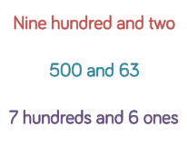  Prove it!
- Which is more? Use < or >  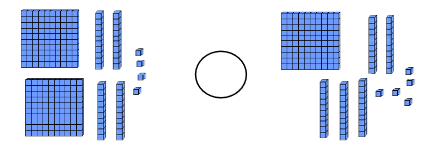Explain your answer. | 6.  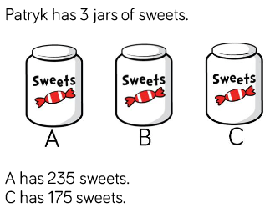  B has less sweets than A and more than C. How many could there be?
3.  Using these three number cards how many different numbers can you make?  5 2 8  What is the lowest number you can make?  What is the highest number you can make? | GDS  Brody has £3.46.  Which coins could he have?  How many different ways can you make the amount?
4.  True or false?  600 + 234 = 400 + 434  Explain your answer | GDS  Mrs Ashley says 500 is more than 456.  Prove it!

1.  Write these numbers in words. 763_______________  __________________  163_______________  __________________  Which is the biggest? How do you know? | 5.  Which would give you the least?  735 - 200 or 625 - 100  Show your workings out.
2.  Order these numbers from smallest to biggest.  875 206 719 129 402 110  ___ ___ ___ ___ ___ ___ | - Mrs Ashley says this is 321.  Is she correct?  Prove it.
3.  Mrs Ashley says that 563 is more than 536.  Is she correct?  Prove it! | GDS  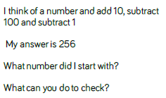
4.  Which would give you the least?  543 - 200 or 443 - 100  Show your workings out. | GDS  Brody has 5 coins in his pocket. How much could he have?  What is the most?  What is the least?

Tues
1  Make these numbers using place value counters.  Draw the counters you have used.  136  315  505 | 5.  True or False?  842 - 200 = 722 - 100  Show your workings out.
2.  Draw this number as Base 10  One hundred and sixty three  Write it as a number.  If you added 100, how much would you then have? | 6 Sophie has been ordering some numbers .  Is she correct?  345 456 464 752 725
- Complete this grid so that it shows 847  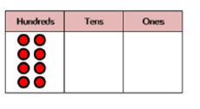  If you took 23 away what would you have? | GDS  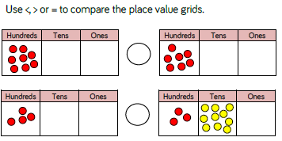
- Mrs Dyer says this is 301. Is she correct? Explain your answer.

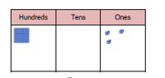

WED
- Ethan has been ordering some numbers.  71 117 171 701 771  Is he correct? Explain your answer | 5  Which is the most?  415  Seven hundred and eighty two  Four hundreds  852  Show your workings out.
- Use place value to counters to make these numbers  351  234  679 | - 6 Mrs Wick thinks this is 642.  Is she correct?  Prove it.
- This number is 456  Five hundred and sixty five  True or false?  Show your workings out. | GDS  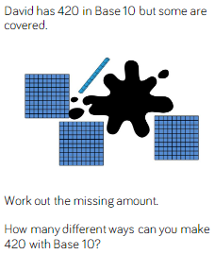
- Jenson says this grid shows 800. Ania says it has 80 in.

Who is correct?

How do you know?

WED
- Riley has been ordering some numbers.  116 161 16 160 601 106  Is he correct? Explain your answer | 5  Which is the most?  742  Three hundred and eighty one  Five hundreds  452  Show your workings out.
- Use place value to counters to make these numbers  521  248  189 | 6 Ania thinks this is 932.  Is she correct?  Prove it.
- This number is 673.  Six hundred and thirty seven  True or false?  Show your workings out. | GDS  Sophie has 6 coins in her money box.  How much could she have?  What is the most?  What is the least?  Draw as many different amounts as you can.
- Complete the grid so it shows 836

How much would you have if you took 300 away?

How do you know?

