Monday 4th January 2021  Topic- Create a character profile about the author Michael Morpurgo. Can you find any interesting facts?  Maths- using the template, fill in the multiplication facts.  Extension- write out 5 times table calculations and complete the inverse operations. | Monday 25th January 2021  Topic- Create a boat model.  Maths- Complete the multiplication/ division word problems. See separate sheet.
Monday 11th January 2021  Topic- re-design the front cover of Kensuke’s Kingdom.  Maths- investigate the completed multiplication grid. Do you spot any patterns? Use full sentences to explain any patterns you can see.  Extension- Create a multiplication/ division triangle and complete three calculations. Use the template provided. | Monday 1st February 2021  Topic- create a character description for Michael from our class story Kensuke’s Kingdom. Remember your adjectives, adverbs, and conjunctions!  Maths- draw five shapes and calculate the area of each shape.
Monday 18th January 2021  Topic- Draw a suitcase with your favourite 10 items in and label them.  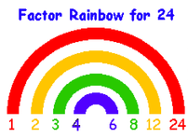  Maths- Create 5 factor rainbows for numbers of your choice. See example below. | Monday 8th February 2021  Topic- Make up a survival kit for being washed up alone on a desert island.  Maths- calculate six equivalent fractions.  e.g.
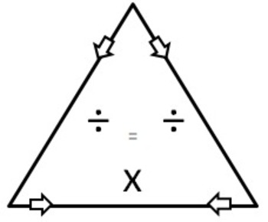
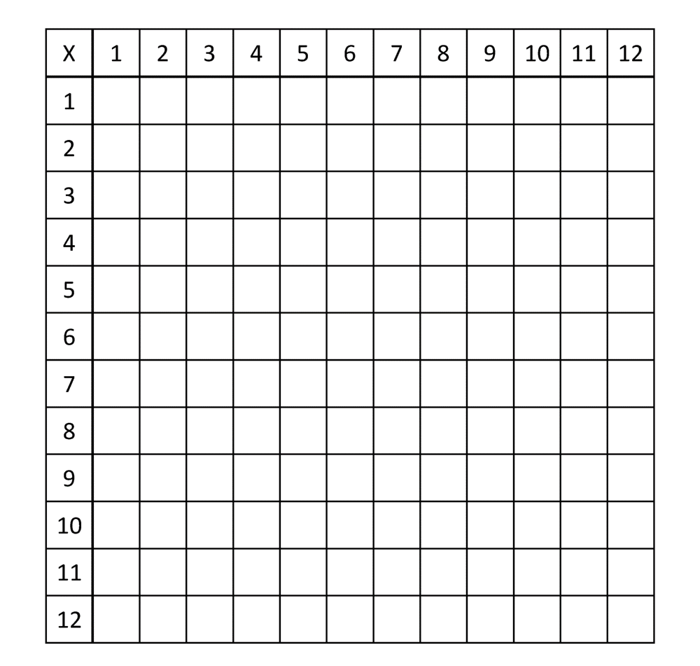
25/01/20
- Jim goes to a movie with his parents and brother. Each movie ticket costs £20. How much in all does Jim pay for the tickets?
- James, a crane operator works on 8 hour shifts every day. If he worked 22 days in a month, how many hours of work did he put in altogether?
- During a practice session, Frank swims an average of 19 laps in an hour. If he were to attend 5 practice sessions, how many laps will he be able to cover on an average?

