Shortlanesend Primary School
PE & SPORT PREMIUM 2020/21

The government has confirmed that the primary PE & Sport Premium will continue at £320 million for the 2020/21 academic year.
This funding is ring fenced and allocated directly to primary schools across England, providing them with a dedicated resource to buy in invaluable expertise and support. Funding is allocated through a lump sum for each school and a per-pupil top-up mechanism. The formula references the number of primary-aged pupils (i.e. children between the ages of 5 and 11).
We want our children to be resilient, empathetic, ambitious and independent. These life skills can be learned through the delivery of quality PE and daily physical activity.
The impact on PE, school sport and physical activity is measured against the 5 indicators:
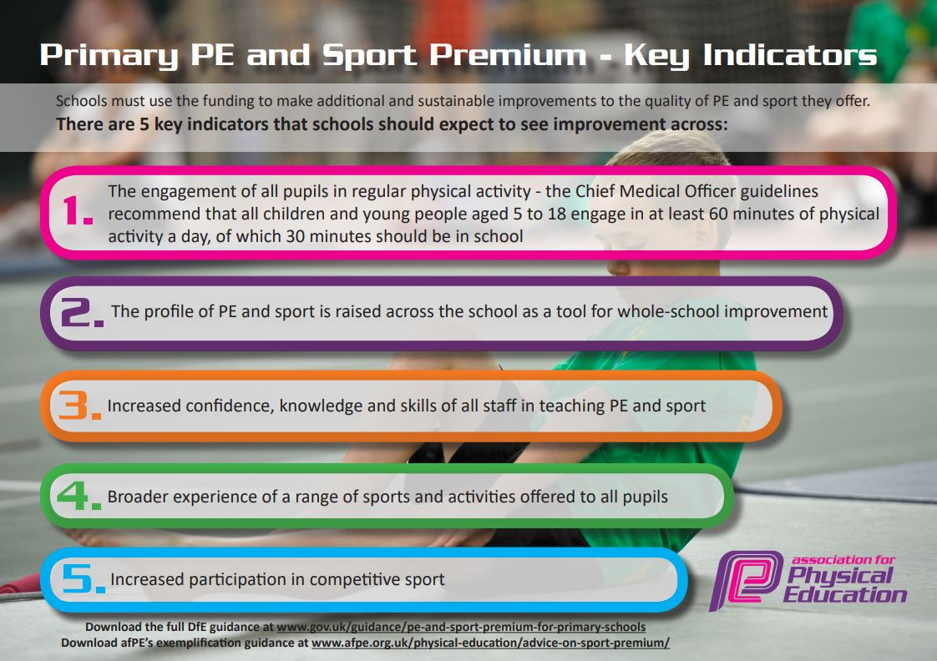

P.E & Sport Premium Projection 2019-2020
School Context
Shortlanesend School is a small primary school on the outskirts of Truro. It currently has 138 pupils on roll and is steadily growing in numbers, year on year.

Swimming
Cohort | Total number of children in year 6. | Number of children achieving end of year expectations. | What percentage of your Year 6 pupils could use a range of strokes effectively (for  example, front crawl, backstroke and breaststroke) when they left primary school  at the end of the last academic year? | What percentage of your Year 6 pupils could perform safe self-rescue in different  water-based situations when they left your primary school at the end of the last  academic year? | Schools can choose to use the Primary PE and Sport Premium to provide additional provision for swimming, but this must be for activity over and above the national curriculum requirements. Have you used it in this way?
2017-2018 | 23 | 22 | 94% | 75%
2018-2019 | 20 | 19 | 95% | 80%
2019-2020 | 19 | 19 | 100% | 90%
2020 -2021 | 19 | 18

Spending Overview
Code | Area | Details | Amount
A | Aspire Membership | Contribution to Aspire Sport Network, including Youth Sport Trust Membership. | £1000
B | Local cluster Membership | Contribution to area membership | £1000
C | Staff Training | Both attending courses and buying in support to develop staff. | £300
D | Resources | Purchasing new equipment and resources to support the delivery of P.E and School Sport. | £500
E | Staffing | Employment of staff member to offer support, CPD and advice to members of staff delivering P.E. lessons and extra-curricular clubs, as well as the administration and facilitation of sporting activities. | £6500
F | Supply Cover | To cover staff attending training or sporting events. | £250
G | Transport | Transporting children to off-site sports activities.  Fuel | £4786  £300
H | Adventurous activities | Provide funding to allow children the opportunity to participate in adventurous activities in and out of school | £500
I
 |  | Total | £15,136

Spending Breakdown
Key indicators | Code | Impact | Sustainability
The engagement of all pupils in regular physical activity – the Chief Medical Officer guidelines recommend that all children and young people aged 5-18 engage in at least 60 minutes of physical activity a day, of which 30 minutes should be in school. | D  C  B | Active engagement of the children who now look forward to the morning activity-teachers agree that the children feel more focused to learn.  Whole school PE philosophy and activity during “lesson time”  Good participation and greater understanding of healthy living-including diet and well-being.  Resources are looked after and respected  Children happily engaged in outdoor learning through a variety of new equipment aimed at increasing physical activity | Ongoing program as part of our 'active lifestyle' philosophy  CPD to further enhance teacher and TA competence  Engage local producers/sellers to become involved  Ongoing equipment purchases to promote and encourage ‘play’ at break times  No initial extra cost but may look to increase provision-climbing play area
The profile of PE and sport is raised across the school as a tool for whole-school improvement. | A, B, C, D, E, F & G | High profile of PE throughout the school- assemblies, website reports, YST quality mark scheme, celebration of achievements, staff/pupil PE kit  Children more engaged and active and involved in a wider range of physical activities, both in the classroom but also clubs and inter school competition
Increased confidence, knowledge and skills of all staff in teaching PE and sport | A, B, C | Higher quality PE lessons taught by highly motivated and skilled teachers and TA’s, as well as professional coaches providing a rich and varied CPD | More assessments to maintain consistently good PE lessons and learning  Continuation of CPD through staff observations and conferencing  Sports premium funding stays at current threshold
Increased participation in competitive sport | B, F, G | Minibus lease to enable transportation to events and involve a greater number of children in sporting activities  Registration in external tournaments  Joining competitive leagues in both football and netball, Swimming gala  Attend a wide range of other sporting activities as and when they arise  festival of rugby at RL school,  ESFA football | Minibus lease is only sustainable as long as sports premium is available.
Broader experience of a range of sports and activities offered to all pupils. | B, D, E, G, H | Increase availability of clubs.  Increase opportunities for other ‘sports

