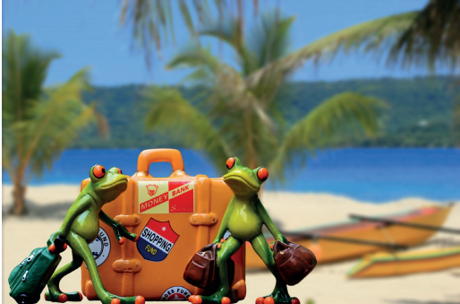

The frogs are off on their summer holiday! Can you write a story about their trip?

