Major  Tasks | Create a postcard showing your favourite place in the UK  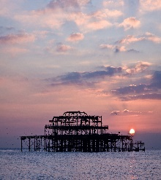  This Photo by Unknown Author is licensed under CC BY-SA | Based on the book, The Animals of Farthing Wood, write the first page of your own animal adventure story(minimum of 400 words). | Create your own person using materials found in the natural environment, for example, a stick man.  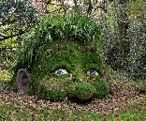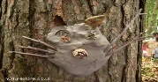  This Photo by Unknown Author is licensed under CC BY-SA-NC  This Photo by Unknown Author is licensed under CC BY-NC-ND | Design and create you own wildlife guide to nature found in your garden or area-use photos and drawings to illustrate what you have found. | Using materials found locally, design and create your own gift wrap, eg, leaf prints, bark rubbings etc  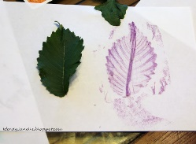  This Photo by Unknown Author is licensed under CC BY-SA-NC
Minor tasks | Create a wordsearch incorporating 15 native animals or birds from the UK.  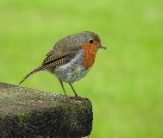  This Photo by Unknown Author is licensed under CC BY-SA | Make your own natural necklace using materials from the wild. | Write a poem about your favourite animal from the UK  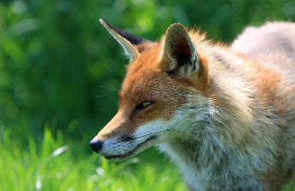 | Using materials from nature, write your name and take a photo……be creative. | If you could be any animal found in the UK, what would it be and why?  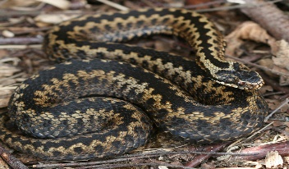  This Photo by Unknown Author is licensed under CC BY-NC-ND
Gannel Class Homework Grid Autumn Term 2021
One task from either major or minor needs to be completed each week and brought into school-pick 3 major and 3 minor. The first task needs to be handed in on Monday 20th September.

Spellings
Spelling’s homework is every week with a spelling quiz every Wednesday. There are 20 words to practise each week.
The first spelling quiz is Wednesday 15th September.
