Monday 10th January 2021  Topic- Recreate a Harry Potter front cover page.  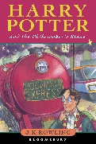  Maths- Times tables poster.  Create a timetables poster designed and presented in a way of which you like.  Include x1, x2, x3, x4, x5, x6, x7, x8, x9, x10, x11, x12 | Monday 31st January 2021  Topic- Write a set of instructions on how to look after the dragon you designed last week.  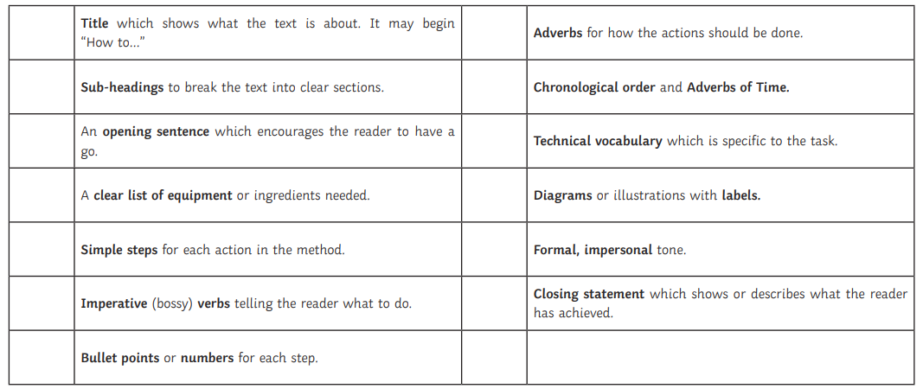  Maths- Sumdog / multiplication activity grid
Monday 17th January 2021  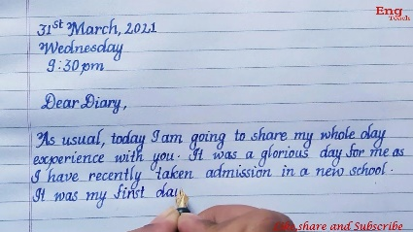  Topic- You are Harry Potter. Write a diary entry. You may want to include events from the story so far or create your own events in the life of Harry.  Maths- TT rockstars / multiplication activity grid | Monday 7th February 2021  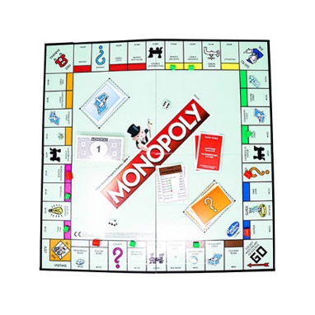  Maths- Magical monopoly. Create your own version of Harry Potter Monopoly – you can use pounds or the money which is used in Harry Potter – Knuts, Sickles and Galleons.
Monday 24th January 2021  Topic- Design/ make your own Dragon. What would it eat? Where’s its habitat?What would its life cycle look like?  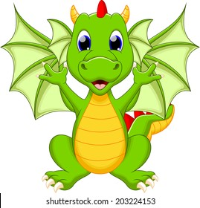 | Monday 14th February 2021  Topic- J.K Rowling fact file. Create a fact file for the author J.K Rowling.  Maths- Ultimate times table test. Give yourself ten minutes and complete as many as possible. Use the times table grid to check your answers.

