Class | Autumn 1 | Autumn 2 | Spring 1 | Spring 2 | Summer 1 | 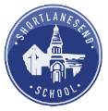  Summer 2
N | Story Dough  Nursery Reading Spine |  | Story Dough  Nursery Reading Spine |  | Story Dough  Nursery Reading Spine
R/1 | RWI  Reception Reading Spine |  | RWI  Reception Reading Spine |  | RWI  Reception Reading Spine
R/1 | RWI |  | RWI |  | RWI
1/2 | 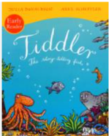  RWI  Cross -Curricular Reading  Looking after ourselves | 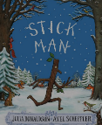  RWI  Cross -Curricular Reading  Habitats | 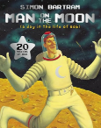  RWI  Cross -Curricular Reading  Space | 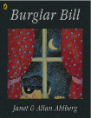  RWI  Cross -Curricular Reading  Explorers | 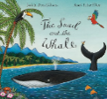  RWI  Cross -Curricular Reading  Sea side | 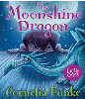  RWI  Cross -Curricular Reading  Coasts
3/4 | 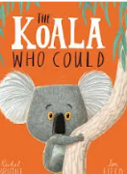  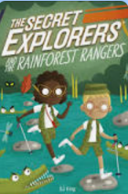  Cross -Curricular Reading  DK Your Body  Predators  Healthy Bodies | 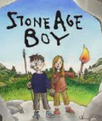  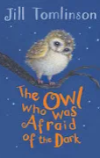  Cross -Curricular Reading  DK Stone Age  The Stone Age  The Iron Age  Food Chains | 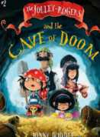  Cross -Curricular Reading  DK Weather  Underwater  Rocks and Fossils | 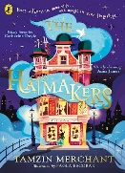  Cross -Curricular Reading  The Romans  DK The Romans  Light | 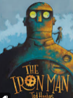  Cross -Curricular Reading  Forces and Magnetism  Angry Earth  DK Planet Earth | 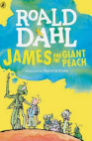  Cross -Curricular Reading  Plants  Countries  The Tudors
4/5 | 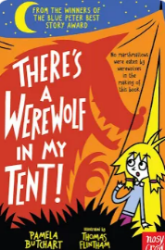  Cross-Curricular Reading  Cornwall  Animals  The ocean depth | 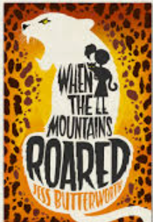  Cross-Curricular Reading  Mountains  Plastic pollution  Explorers | 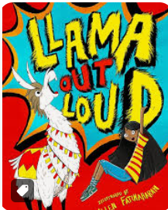  Cross-Curricular Reading  Sound  Coasts  Musical history | 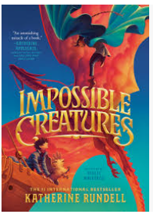  Cross-Curricular Reading The Romans  Female scientists  History of Literature |   Cross-Curricular Reading  Volcanoes and Mountains | 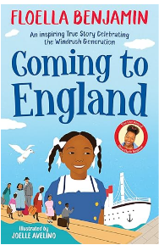  Cross-Curricular Reading  Electricity  The Tudors
5/6 | 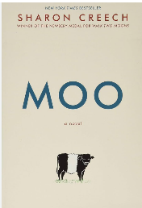  Cross-Curricular Reading  Erosion  The Cornish Coastline  Weathering & Erosion | 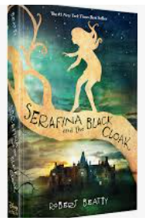  Cross-Curricular Reading  Down the mines  Cornwall | 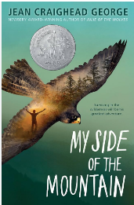  Cross-Curricular Reading  Famous Scientists  Charles Darwin | 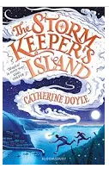  Cross-Curricular Reading  The Romans  Ancient Civilisations |   Cross-Curricular Reading  Volcanoes  Classification | 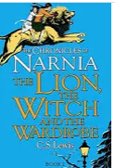  Cross-Curricular Reading  The Tudors Plague

