Dear parent/carer,
Welcome back to Shortlanesend School. I hope you have all had a fantastic, relaxing and fun-filled summer break.
This term, Class 4 is immersing itself in DESERTS. The children will need to stay cool as they explore the deserts of the world and answering a whole host of scorching questions, such as;
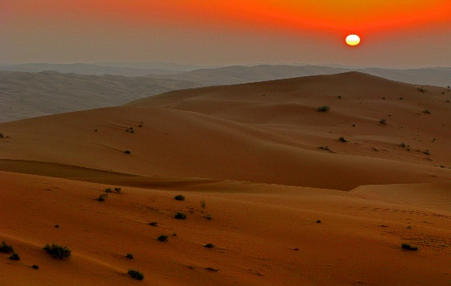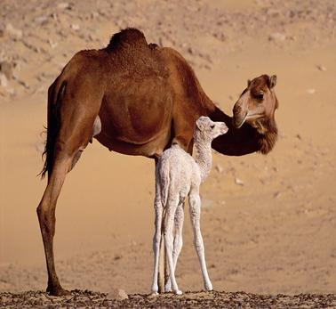

Where are the deserts of the world? Why are they where they are?
What plants and animals inhabit the deserts and how have they managed to do it?
What people and civilisations have conquered these harsh environments and called it their home?
We will be travelling the globe in our search for these answers and information and it is going to be a fantastic and exciting journey.
We will also be cooking some desert cuisine (yummy) and doing some desert art and meeting some real life desert animals and plants.
On top of all this amazing learning and fun there are a few other things the children will be doing;
A, PE will be on Tuesdays and Fridays. Can all children bring their kits in for the entire week-who knows we may run a mile on any day!
B, Homework will be set every Friday. Spellings will be included in this and a spelling quiz will take part every Monday.
C, Friday drop-ins until 4pm. Come and chat to the staff or see your child’s work.
As always, please come and see us if you have any questions,
Kind regards,
Mr. Easter & Mrs. Light

