Dear Parent, Carer,
Welcome back to the Spring term! I hope you have all had a marvellous Christmas and all the very best wishes for the New Year.
This term, Class 4 has been turned into the Northern mystical island of Erkenwald, where things are not as happy as they used to be! The land has been under siege by an imposter who steals voices and only a special child can save the kingdom from eternal darkness and tyranny.
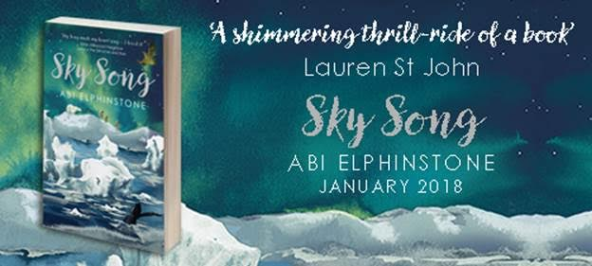
Sky Song brings two unlikely characters together in a quest to save their kingdom and homes by using ancient magic and bringing harmony once more to Erkenwald. Many challenges await, but will the sky song be sung in time and can Class 4 help?
A special message from the author
Hi Mr Easter’s Class,
I hope you all had a brilliant Christmas and New Year. I hear you’re reading my latest book, ‘Sky Song’ - I really hope you enjoy Eska, Flint and Blu’s adventure! And just in case any of you are hoping to become an author one day, here are my Top 3 Tips:
1. Carry a notepad with you everywhere (as an author you are like a detective so watch the world fiercely for the things other people miss because often the very best stories are simply the ideas that nobody else has stumbled across yet)
2. Never underestimate a good daydream; that’s how most stories start
3. Do not be afraid to fail (I had 96 rejection letters from literary agents before I got my first book deal)
Have a great term!
Abi ❄️
Abi Elphinstone

On top of joining the cast of Sky Song on their adventure in Erkenwald in all things literary, we will also be learning more in maths about addition/subtraction, fractions, shape, decimals, multiplication/division, triangles and times tables.
In science we are learning about human digestion and animals of the Arctic and in geography/history/RE, all about the Inuit people of the polar circle-their lifestyles and beliefs.
As always, if you have any questions please do not hesitate to come and see us.
Thank you for your continued support,
Kind regards,
Mr M Easter

